# Real estate listing

## Description

**Luxurious Paris Apartment for Sale - €7.2 Million**  
  
**Location:**   
- Situated in the heart of Paris, just 100 meters from the iconic Champs-Élysées, this exquisite apartment offers breathtaking views of the Eiffel Tower and is surrounded by stunning architecture and vibrant urban life.  
  
**Property Overview:**   
- Size: 220 square meters   
- Bedrooms: 3   
- Bathrooms: 3   
- Terrace: 12 square meters   
- Price: €7.2 million   
  
**Property Features:**  
  
**Interior Design:**   
- Elegantly designed with a blend of modern aesthetics and classic Parisian charm, the apartment showcases high-end finishes and luxurious materials throughout.  
- Spacious living area with large windows that allow natural light to flood the space, creating an inviting atmosphere.  
- Stylish furnishings include a plush sofa, elegant armchairs, and a chic coffee table, perfect for relaxation or entertaining guests.  
- Sophisticated dining area with a modern oval table that accommodates up to six diners comfortably, enhanced by exquisite gold accents and a contemporary lighting fixture.  
  
**Kitchen:**   
- Gourmet kitchen designed by architect Laura Gonzales, featuring sleek cabinetry, high-end appliances, and a beautiful marble backsplash.  
- Spacious layout with ample counter space, making it ideal for culinary enthusiasts.  
- A cozy dining nook adjacent to large windows provides a perfect setting for casual meals.  
  
**Bedrooms:**   
- The apartment includes three beautifully designed bedrooms, each featuring king-sized beds, large windows, and ample storage solutions.  
- The master suite boasts access to a private terrace with views of the serene interior courtyard.  
- Each bedroom is adorned with stylish decor and modern lighting fixtures, creating a luxurious and relaxing environment.  
  
**Bathrooms:**   
- Three luxurious bathrooms featuring high-end fixtures, elegant tile work, and stunning marble finishes.  
- The master bathroom includes a spacious shower with a seating area and a lavish bathtub, providing a spa-like retreat.  
- Thoughtful design elements include double sinks, large mirrors, and sophisticated lighting fixtures that enhance the sense of space and luxury.  
  
**Outdoor Space:**   
- A stunning balcony that offers picturesque views of the Parisian skyline, including the Eiffel Tower, making it an ideal spot for morning coffee or evening relaxation.  
- The balcony is spacious enough to accommodate outdoor furniture, adding to the apartment's charm and inviting atmosphere.  
  
**Building and Location:**   
- The apartment is located in a well-maintained building with intricate architectural details, reflecting the premium quality of construction.  
- The vibrant neighborhood surrounding the apartment offers a blend of upscale shopping, fine dining, and cultural landmarks, embodying the sophisticated lifestyle of Paris.  
  
**Additional Features:**   
- Sold fully furnished, allowing for immediate occupancy.  
- Elegant hallway leading to various parts of the property, accentuated by tasteful wall decor and soft lighting.  
- Modern lighting fixtures throughout the apartment, enhancing the ambiance and overall aesthetic.  
  
**Conclusion:**   
This luxurious Paris apartment is a rare opportunity to experience high-end living in one of the world's most iconic cities. With its prime location near the Champs-Élysées, breathtaking views, and exquisite interior design, it promises a lifestyle of elegance and sophistication. Contact District Immobilier for a private viewing and to make this dream home your own.

## Images

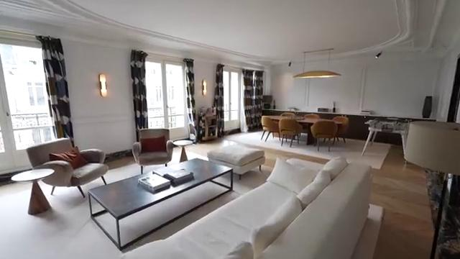

### Single image description

The image features a stylish, spacious modern living room with elegant furniture, large windows, and a contemporary dining area.

### Detailed image description

The image showcases a spacious and elegantly designed living area. It features large windows adorned with stylish curtains that allow natural light to flood the room.   
  
In the center, a modern white sectional sofa is placed next to a sleek black coffee table, which holds a few decorative items.   
  
To one side, a cozy seating arrangement includes two armchairs, one of which has a deep red cushion, adding a pop of color to the neutral palette.   
  
A dining area with a round table surrounded by brown chairs is positioned towards the back, complemented by a minimalist light fixture hanging above.   
  
The overall aesthetic combines contemporary furnishings with classic architectural details, creating a warm and inviting atmosphere.

### Tags and emojis

**Keywords and Tags:**  
- Modern Living Room  
- Interior Design  
- Open Space  
- Elegant Furniture  
- Natural Light  
- Stylish Décor  
- Cozy Atmosphere  
- Dining Area  
- Minimalist Style  
- Chic Curtains  
  
**Emojis:**  
🛋️✨🏡🎨🪑🍽️💡🌿

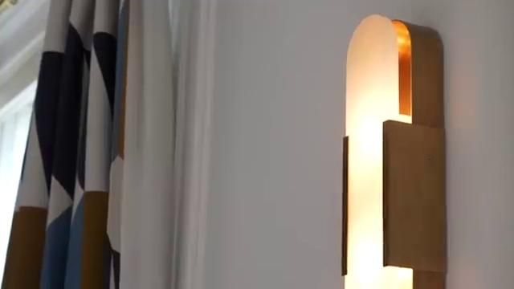

### Single image description

The image features a stylish wall sconce casting a warm glow, complemented by patterned curtains in the background.

### Detailed image description

The image features a stylish wall sconce mounted on a white wall. The sconce has a modern design with a curved top and a warm glow emanating from behind a frosted glass panel.   
  
To the left, there is a glimpse of colorful curtains with geometric patterns in shades of blue, brown, and cream, adding a vibrant touch to the scene.   
  
The overall aesthetic combines contemporary lighting with a cozy ambiance, suggesting a well-decorated living space. The combination of textures and colors creates a harmonious and inviting atmosphere.

### Tags and emojis

**Keywords:** Wall Sconce, Lighting, Interior Design, Decorative, Modern, Home Decor, Curtains, Geometric Patterns  
  
**Tags:** #InteriorDesign #HomeDecor #Lighting #WallSconce #ModernStyle #Curtains #Geometric #CozyAmbiance  
  
**Emojis:** 🕯️💡🏡✨🖼️🎨

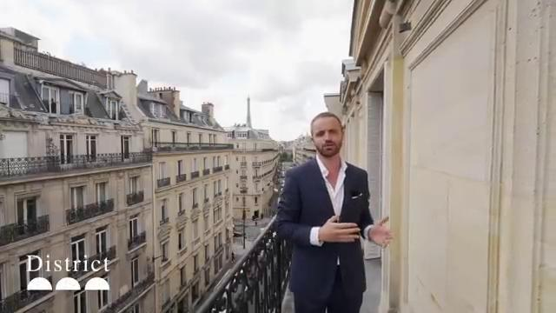

### Single image description

The image showcases a man in a suit standing on a balcony with a view of Parisian architecture and the Eiffel Tower in the background.

### Detailed image description

The image showcases a stunning view of a Parisian street from a balcony. The architecture features classic Haussmannian buildings with elegant façades and balconies adorned with wrought iron railings. In the background, the iconic Eiffel Tower can be seen peeking above the rooftops, surrounded by a partly cloudy sky. The setting conveys a sense of sophistication and charm, characteristic of the vibrant atmosphere in Paris. The person on the balcony appears to be dressed in a smart outfit, likely engaged in a presentation or discussion about the surroundings. The presence of the logo "District" in the corner hints at a real estate or tour-related context.

### Tags and emojis

**Keywords and Tags:**   
Paris, balcony, real estate, cityscape, architecture, lifestyle, luxury, urban, travel, view, skyline  
  
**Emojis:**   
🏙️🇫🇷✨👔🗼🌤️

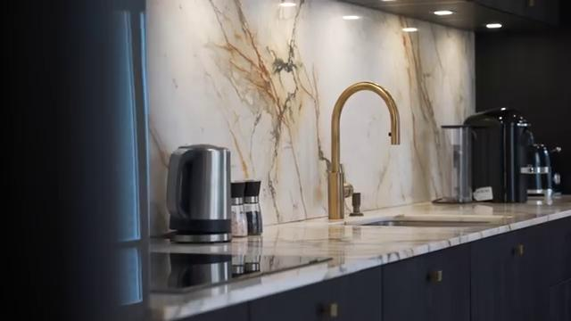

### Single image description

The image features a modern kitchen with a marble backsplash, a sleek gold faucet, and various kitchen appliances, creating an elegant and stylish atmosphere.

### Detailed image description

The image showcases a modern kitchen with a striking marble backsplash that features intricate veining in warm tones. Prominently displayed is a sleek gold faucet that adds a touch of elegance to the space.   
  
In the foreground, there is a stainless steel kettle alongside a set of salt and pepper shakers, emphasizing a blend of functionality and style. The countertop is polished and reflects the soft lighting from recessed fixtures above, enhancing the overall ambiance.   
  
To the right, various appliances, including a coffee maker, are neatly arranged, contributing to the contemporary aesthetic of the kitchen, which is designed with dark cabinetry for a stylish contrast.

### Tags and emojis

**Keywords:** Modern kitchen, marble backsplash, gold faucet, sleek design, coffee maker, kettle, contemporary decor, elegant finishes.  
  
**Tags:** #InteriorDesign #KitchenInspiration #ModernHome #Marble #GoldAccents #HomeDecor #KitchenStyle  
  
**Emojis:** 🏡✨🍽️☕️🔪💧

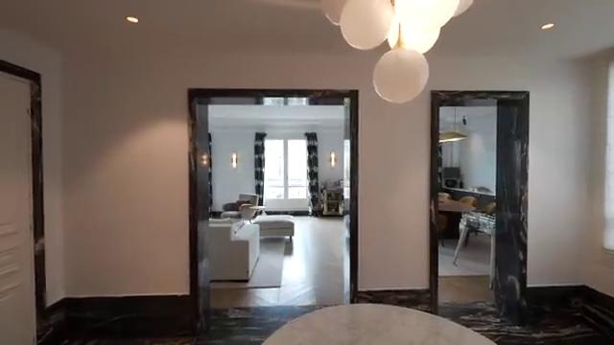

### Single image description

The image showcases a modern, elegantly designed interior with multiple doorways leading to distinct living spaces, highlighted by marble accents and contemporary furniture.

### Detailed image description

The image presents a modern interior space with a sleek and elegant design. At the forefront, there is a round marble table that adds a touch of sophistication to the setting.   
  
Through two open doorways, different living areas are visible; one leads to a bright room with large windows adorned with dark curtains, showcasing a comfortable seating arrangement.   
  
The other doorway reveals a workspace with a stylish desk and a modern chair, hinting at a functional yet aesthetically pleasing environment. The walls are painted in a neutral tone, and the ceiling features a unique light fixture, enhancing the contemporary feel of the space.

### Tags and emojis

**Keywords and Tags:**  
- Modern interior  
- Open space  
- Elegant design  
- Bright lighting  
- Minimalist decor  
- Contemporary furniture  
- Living room  
- Dining area  
- Textured walls  
  
**Emojis:**  
🏠✨🛋️🖼️🪴💡🖤