**Welcome to In Our Image**

I’ve spent my life at the intersection of genetics, data science, and deep questions about science & religion. This short novel is the culmination of that journey—a story that weaves together ancient Hebrew texts, protein codes, quantum biology, and the search for meaning in the age of AI.

It was written primarily by ChatGPT. I spent months having deep conversations with the models, making notes, discussing ideas, characters, and settings. Once the AI models got good enough, I was able to feed them simple prompts to write each chapter. I made light edits, but the prose is ChatGPT

You don’t need a science degree or a theology background to read this—just curiosity.

I’m publishing it chapter by chapter. Think of it as both a serialized sci-fi mystery and a public conversation.

Let’s begin.

Zoe Carter’s lungs burned as she sprinted the final stretch along San Francisco Bay, the dawn sky bleeding from indigo to rose. Salt spray mingled with the hum of early ferries, tickling her nostrils as each footfall echoed against the smooth pavement. Her calves, still stiff from yesterday’s hill work, protested with every landing—but she welcomed the ache. It reminded her she was alive, mind and body in sync.

Her smartwatch buzzed. She slowed to a jog and tapped the screen.

**“Unscheduled protein-ELS spike in Torah-protein project.”**

“Okay,” she muttered, “either the algorithm’s up early... or someone else is.”

She jogged past her favorite bluff, where the tang of pine and seaweed always sharpened her focus. The Bay Bridge stretched in the distance, a gleaming filament of steel. Somewhere beneath those waters lay cables pulsing with data—including hers.

Zoe inhaled deeply. Exhaled. Her late-night code run flashed in memory: Hebrew letters converting to amino acids, then sliding through Torah verses like beads on a string. She’d grown up balancing opposites—her dad a geneticist, her mom a theology professor. At **ChronoGenomics**, she merged them daily, running sacred texts through scientific lenses.

*"The Torah is code,"* her mother once told her. *"So is DNA,"* her father replied. Zoe had been five. It stuck.

Most people who’d heard of “Torah codes” thought of the pop-science phenomenon from the 1990s, sparked by a peer-reviewed, statistical publication showing statistically significant codes in the Torah ([Witztum, Rips, Rosenberg 1994](https://projecteuclid.org/journals/statistical-science/volume-9/issue-3/Equidistant-Letter-Sequences-in-the-Book-of-Genesis/10.1214/ss/1177010393.full)). The theory, popularly known as [The Bible Code](https://en.wikipedia.org/wiki/Bible_code), claimed meaningful words and prophecies were encoded in the Torah by skipping letters at fixed intervals. Find every 50th letter, for example, and maybe you’d spell *Holocaust* or *Newton.*The math was hotly debated. Critics called it cherry-picking. Statisticians called it pattern overfitting. The rabbis? Most of them rolled their eyes.

Zoe didn’t buy the predictions. But she believed in patterns.

Her favorite tool was a variant of the classic **Equidistant Letter Sequence (ELS)** parser—the same kind used in the original Torah code studies. The basic idea: pick a starting letter, then skip every *n*th character in the Hebrew text. Do it enough times, with enough skip lengths, and hidden structures begin to emerge. To most, it looked like digital numerology. But Zoe didn’t search for words. She searched for **biology**.

She’d built a custom script—one part linguistics, one part protein chemistry. Instead of treating the Hebrew as language, she treated it as a **cipher**: each letter mapped directly to one of the twenty amino acids that build proteins. א became Alanine, ג became Glycine, and so on. It wasn’t arbitrary—she’d developed a principled conversion table over months, aligning motifs against known protein domains.

Now, when she ran an ELS scan, she wasn’t hunting for messages like *Messiah* or *End Times.* She was looking for **peptides**—short chains of amino acids that matched functional regions of human proteins.

To Zoe, the Torah wasn’t a prophecy generator.  
It was a **biological blueprint**—ancient scripture embedded with sequences tied to memory, longevity, and neural development.

A sacred text, yes—but maybe also a *genetic record* in disguise.

#### 🧬 Sidebar: Zoe’s [Conversion Table](https://github.com/josephbedell/InOurImage/blob/4259832bd818a38ea1a90b999e90e9b5229af550/conversion_table.csv) (excerpt)

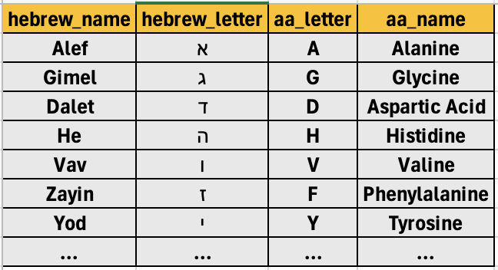

“Skip through the Torah like you’re hopping stones across time…  
but instead of words, I’m pulling proteins from the riverbed.”  
— *Zoe Carter*

#### 📊 Diagram: How Zoe’s ELS Parser Works

TORAH TEXT (HEBREW)

...א ג ד ה ו י כ ל מ...

SKIP INTERVAL = 3

Sequence pulled: א → ה → כ → ...

→ Converted to Amino Acids: A → H → K → ... → Matched to peptide motifs in known proteins

Now, when she ran an ELS scan, she wasn’t hunting for messages like “Messiah” or “End Times.” She was looking for **peptides**—short chains of amino acids that matched functional regions of human proteins.

To Zoe, the Torah wasn’t a prophecy generator.  
It was a **biological blueprint**—ancient scripture embedded with sequences tied to memory, longevity, and neural development.

She rounded a corner and passed the public bench she nicknamed the "Burning Bush"—not because it caught fire, but because it overlooked the water in a way that made her feel spoken to. Below, tide pools shimmered.

Instead of heading home, Zoe turned toward the gleaming glass façade of **ChronoGenomics**. The front doors recognized her retina scan and whooshed open. Inside, her sneakers squeaked on the white floors.

In **Lab 7B**, Zoe pulled on her lab coat like a cloak of invisibility and powered up her terminal. Her coffee mug read *"GOD MODE: ON."*

Yesterday’s run had been fruitful. A passage from *Genesis 1:26*—“Let us make man in our image”—produced a familiar four-letter protein motif:

**Tyr–His–Val–His.**  
**Y–H–V–H.**

Yes, *that* four-letter word, the sacred name of God,the [tetragrammaton](https://en.wikipedia.org/wiki/Tetragrammaton). In amino acids. Buried in the genetic architecture of proteins that help cells repair themselves.

Coincidence? Maybe. But then she found the same sequence in [**FOXO3A**](https://en.wikipedia.org/wiki/FOXO3), a gene linked to human longevity. A sacred name tied to cellular youth.

Zoe grinned. “YHVH… the original repair protocol.”

She pulled up a colorful [**expression heatmap**](https://biostatsquid.com/heatmaps-simply-explained/)—like a thermal scan for gene activity—highlighting peaks in the hippocampus and prefrontal cortex. Memory and moral reasoning. The soul’s zip code, if there was such a thing.

Outside, a gull cried.

Her terminal blinked. A message:

**“Your work on Torah-protein ELS has not gone unnoticed.**  
**Jerusalem Conference on Science & Theology.**  
**Decrypt for next clue.”**

Her stomach dropped.

Jerusalem. The source. The storm. She stared out the window toward the eastern horizon.

She launched her decryption script, hands shaking.

*If someone else was following the protein-ELS trail… they were either a friend, a thief, or something stranger.*

The script finished. A name. A time. A flight.

Zoe closed her eyes. She’d just gone for a run. And now the world was different.

She grabbed her pack. Coffee. Keys. Itinerary.  
Time to run again—this time, into the unknown.

Zoe Carter stood in line at Terminal 3 of San Francisco International, the glowing edges of dawn reflecting off the glass, her passport and encrypted invitation clutched in one hand, her Faraday-shielded phone in the other. She wasn’t just headed to Jerusalem—she was heading straight into the unknown. The invitation had no sender, no return address, just a masked IP from Geneva and a cryptic reference to [Psalm 119](https://blb.sc/002QA2), a love letter to the Hebrew alephbet itself. Whoever sent it understood both scripture and security.

She double-checked her gear: a stripped-down ThinkPad running custom Tails OS, a printed backup of her passport folded into her laptop sleeve, two SSDs encrypted with her PGP key, and a slim USB running custom scripts—including a modified blastp.py alignment tool. The original method was immortalized in the [BLAST book](https://www.oreilly.com/library/view/blast/0596002998/), still a standard reference for sequence alignment. (Fun fact: the author of this story co-wrote that book.)

The flight to Tel Aviv was uneventful but long—nearly 14 hours over the Rockies, the Atlantic, and the Mediterranean. Zoe alternated between napping and scanning recent updates from [NCBI GenBank](https://www.ncbi.nlm.nih.gov/genbank/), flagging neural-related coding regions for *FOXO3A* and *NRG1*, genes long thought to be key to developmental timing and cognition. Somewhere over the Balkans, she was still staring at a draft [ELS matrix](https://en.wikipedia.org/wiki/Bible_code#Equidistant_letter_sequence_method) from the Book of Leviticus when she finally gave in to sleep.

## From the Airport to the Walls of Time

The heat struck her immediately as she stepped out of Ben Gurion Airport. Warm, dry air carried a scent of olive trees, sand, and dust—as if time itself had a smell. Her driver, a man named Naim, drove her east toward Jerusalem. The road climbed steadily through the Judean Hills, their terraces carved with ancient care, dotted with goats, solar panels, and the occasional drone overhead.

When they crested the ridge near [Ein Hemed National Park](https://www.parks.org.il/reserve-park/%D7%92%D7%9F-%D7%9C%D7%90%D7%95%D7%9E%D7%99-%D7%A2%D7%99%D7%9F-%D7%97%D7%9E%D7%93/), the full panorama of Jerusalem opened before her like a scroll: domes, minarets, crenellated walls. The Old City shimmered in the late-afternoon light, its stones stained gold by centuries of setting suns.

They entered through the [Jaffa Gate](https://en.wikipedia.org/wiki/Jaffa_Gate), and Zoe was instantly enveloped in the centuries. Hebrew, Arabic, Latin—it was all here, folded together like palimpsests.

## Four Quarters, Four Worlds

Zoe had been briefed. The Old City’s four quarters were each their own chronotype:

* **Jewish Quarter**: Stalls selling braided challah, shofars, and printed Torah scrolls lined the stone walkways. Yeshiva boys in pressed white shirts huddled over [Mishnah](https://www.myjewishlearning.com/article/the-mishnah/), murmuring in debate.
* **Christian Quarter**: Lanterns flickered outside the [Church of the Holy Sepulchre](https://en.wikipedia.org/wiki/Church_of_the_Holy_Sepulchre). Pilgrims knelt in the silence of stone. A Coptic priest swept incense around a carved wooden cross worn smooth by centuries of touch.
* **Muslim Quarter**: The smell of fresh kanafeh and grilled eggplant rose like steam. The [Adhan](https://en.wikipedia.org/wiki/Adhan)from the minarets wove into the hum of the bazaar.
* **Armenian Quarter**: Smallest and quietest, with its own timekeeping. In the courtyard of [St. James’s Cathedral](https://en.wikipedia.org/wiki/Cathedral_of_Saint_James,_Jerusalem), an old monk lit candles whose wax had pooled like memory.

She stayed at a pension not far from the Damascus Gate, run by an elderly Christian Arab woman who served her thick coffee spiced with cardamom. The rooftop terrace gave a panorama of domes, towers, and the golden flash of the [Dome of the Rock](https://en.wikipedia.org/wiki/Dome_of_the_Rock) just beyond the wall.

## Rooftop Memory

That night, as the city hushed and wind moved through bougainvillea, Zoe climbed back onto the rooftop terrace. Another guest was already there—an Australian linguist named Mattias, barefoot, cross-legged, sketching something in a notebook. He nodded as she approached.

“Can’t sleep?” he asked.

Zoe shook her head. “Too much spinning.”

Mattias gestured toward the view. “Hard place to quiet the mind. Even the stones are loud.”

They talked—quietly, slowly. He was researching root structures in pre-Aramaic inscriptions and had stumbled across the same [Cairo Geniza](https://en.wikipedia.org/wiki/Cairo_Geniza) corpus. Zoe didn’t share everything, but mentioned codon patterns. His ears perked up.

“Like, actual genes?”

“Yeah. *FOXO3A*, mostly. Some *NRG1*.”

Mattias leaned forward. “That’s neural stuff, isn’t it?”

Zoe smiled. “Longevity. Memory. Maybe even consciousness.”

She told him a bit about her past—working with [Orion Genomics](http://www.oriongenomics.com/en/), running custom filters on methylation patterns in cancer subtypes. But it was the cat story that caught him off guard.

“You were the one behind the allergy-free cat?”

Zoe laughed. “Yes, as part of the Sigma-Aldrich [Gene Editing Team](https://www.sigmaaldrich.com/US/en/products/molecular-biology-and-functional-genomics/gene-editing-and-functional-genomics/crispr-gene-editing), before Millipore bought it. We used ZFNs to suppress the allergen Fel d 1 [[US Patent](https://patents.google.com/patent/US20110023156A1/en) ] CRISPR wasn’t even cool yet.”

“You literally rewrote evolution to let people cuddle kittens,” Mattias said, half-joking.

“It was either that or keep selling allergy meds,” she replied. “Science for peace.”

He nodded. “But this work now—it’s what? Science for what?”

Zoe looked up at the sky. “Maybe science for the soul.”

## Into the Library

The next morning, Zoe wound her way to the [National Library of Israel](https://www.nli.org.il/en), nestled beside the [Knesset](https://en.wikipedia.org/wiki/Knesset) in the Givat Ram campus. The limestone exterior gave way to clean glass corridors and digital displays. One exhibit featured digitized scrolls from the Geniza, glowing with multispectral color bands, each artifact a time-stamped echo of vanished lives.

In a reserved room, Zoe met Professor Alan Rosenberg—silver hair, linen suit, eyes that looked like they could spot a typo in a Torah scroll at twenty paces. His badge read “Dept. of Science & Theology.”

“These Geniza fragments,” he said, tapping a projection screen, “show Y-H-V-H repeating every 42 characters. We overlaid the codons. *FOXO3A* pops up. So does *NRG1*. We ran the alignments in triplicate.”

Zoe leaned in, heart speeding. “This isn’t Bible Code fantasy. This is structured genomic encoding.”

She ran her latest tile_blast_csv.py script, outputting tiled regions in CSV, parsed and rendered into a histogram by blast_graph.py. The overlap with known enhancers blew her mind. This was more than coincidence. It was architecture.

## The Third Seat

The door opened. Dr. Mirna Ashur entered—dark hair, crisp blouse, sharper eyes. Known for eviscerating pseudo-scientific ELS claims, she was a paleographer who worshipped in ink and parchment.

“Professor,” she nodded. “These new slips—920s Kufic, likely from Fustat. Diacriticals intact.”

She glanced at the projection. “I don’t like being surprised. But I’ll admit, these aren’t your typical Torah Codes.”

Zoe smirked. “Feels more like code-switching between protein and prophecy.”

Mirna raised a brow. “Let’s not get messianic.”

## Code and Covenant

They spent hours together. Zoe’s tools parsed long noncoding regions looking for symbolic recurrence. Rosenberg annotated letter-skip matrices using a modified [ELS algorithm](https://en.wikipedia.org/wiki/Bible_code#Equidistant_letter_sequence_method). Mirna checked the orthographic consistency of ancient Hebrew glyphs using AI-augmented scroll reconstruction software.

Zoe shared an older hypothesis she’d shelved during the hypoallergenic cat project: that [codon degeneracy](https://en.wikipedia.org/wiki/Codon_degeneracy) might encode a parallel information layer—spiritual or mnemonic, depending on the context.

“You’re saying evolution left post-it notes?” Rosenberg asked.

“Or maybe,” Zoe said, “someone wrote them in.”

## The Crucible Ahead

Night fell again. From the rooftop, the city looked like it was dreaming. Tomorrow’s plenary would include physicists, Kabbalists, and an Oxford AI linguist who believed divine syntax was fractal.

Zoe sealed her tablet, encrypted the logs, and looked once more across the lit-up skyline.

Somewhere in those alleys was a code older than DNA. Maybe what mattered now wasn’t decoding it completely—but proving that it had always been there.

And that maybe, just maybe, we’d been reading it all along.

In Our Image is a reader-supported publication. To receive new posts and support my work, consider becoming a free or paid subscriber.

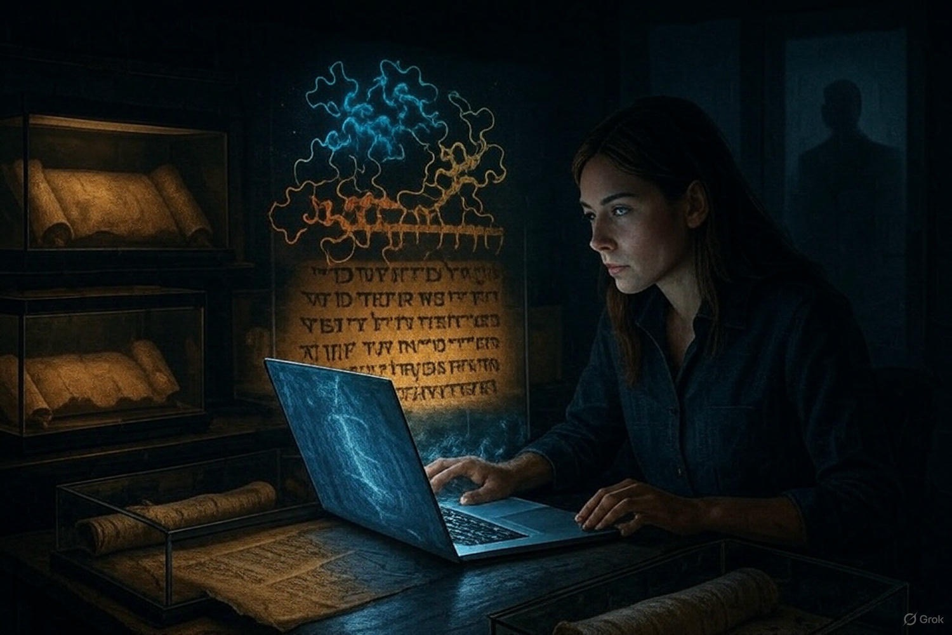

Zoe Carter pushed the vault door shut behind her. The heavy latch sealed with a soft metallic click, leaving only the hum of climate-control and the faint hiss of HEPA filters. The archive’s microclimate—18 °C, 50 % humidity—preserved millennia of parchment and papyrus. Glass cases glowed under low-UV lights, displaying Torah scrolls, medieval codices, Cairo Geniza fragments, and Dead Sea Scroll facsimiles. A faint tang of Paraloid B-72 resin mingled with dry vellum in the air, reminding her of the ancient library she’d first visited as a child when her mother had taught Aramaic liturgy.

Professor Alan Rosenberg joined her at the central table, his polished Oxfords echoing in the cavernous chamber. “This room has been virtually untouched since 1941,” he murmured, brushing fingers across a glass case. “When my grandfather cataloged these pieces in Cairo, he never dreamed what we’d uncover here.”

Zoe set her laptop on a stainless-steel stand and launched her letter → amino-acid mapping script ([conversion table](https://github.com/josephbedell/InOurImage/blob/main/conversion_table.md)). Each Hebrew letter translated to its amino acid—א → Alanine, ג → Glycine, ד → Aspartic acid, ה → Histidine, repeating through the 22‐letter alphabet and two stop codons. No arbitrary codons—just direct 1:1 mappings she’d refined over months of cross‐validation against known protein motifs.

Rosenberg gently lifted the **Genesis 1:26–27** fragment—discovered last year at the Ben Ezra Synagogue excavation. He traced the cracked script with a gloved finger: “Let us make man in our image, after our likeness…” His voice softened. “My grandfather nearly died to save this from collapsing libraries in Egypt.”

Zoe adjusted the fragment under a precision scanner. In seconds, the high-resolution scan appeared on her screen. She loaded her Equidistant Letter Sequence parser—an adaptation of Witztum, Rips & Rosenberg’s 1994 algorithm ([Project Euclid](https://projecteuclid.org/journals/statistical-science/volume-9/issue-3/Equidistant-Letter-Sequences-in-the-Book-of-Genesis/10.1214/ss/1177010393.full))—and set the skip interval to **42**, a number steeped in Kabbalah and popular culture alike.

The script marched through the scanned text, extracting every 42nd character, mapping it to its amino acid, then firing a BLASTP query against the human proteome ([NCBI BLAST](https://blast.ncbi.nlm.nih.gov/Blast.cgi)). Zoe sipped her lukewarm coffee—strong Arabic roast, cardamom-heavy—from a thermos as she waited.

Seconds later, results appeared: Tyr-His-Val-His—Y-H-V-H—the divine tetragrammaton—mapped to the peptide **Tyr-His-Val-His**, a key motif in [Neuregulin 1](https://www.ncbi.nlm.nih.gov/gene/3084). That sequence aligned within NRG1’s cortical synaptic-growth domain, crucial for neural development.

**Zoe (softly):** “Every forty-second letter spells Y-H-V-H, and those amino acids match NRG1’s neural-growth domain.”  
**Rosenberg (awed):** “The scribes… they must have known molecular biology.”

Zoe pulled up a [GTEx expression heatmap](https://gtexportal.org/home/multiGeneQueryPage/NRG1/) showing NRG1 peaks in hippocampus and prefrontal cortex—regions tied to memory, emotion, and decision-making. “This isn’t random. It’s architecture,” she breathed.

Rosenberg crouched beside her, eyes bright. “If faith and biology converge like this, our understanding of both is about to shatter paradigms.”

## Fragments in Context

They carefully replaced the Genesis scroll fragment in its protective case and moved to an adjacent workbench. On the table lay a medieval codex fragment with marginal Masoretic vowel points inked in carmine. Zoe scanned it, noting the later vowel annotations—added centuries after the original scribes penned the consonantal text. To her surprise, the Masoretic additions fell neatly between skip intervals, as if caretakers had preserved the underlying code.

A tiny ink blot at the edge—ordinarily dismissed as a smudge—caught her eye. If she counted that blot as a character, it shifted the entire grid by one position, revealing a second peptide motif. Zoe re-ran the parser with a one-character offset. Instantly, another peptide emerged—**Ala-Leu-Pro-Arg**—matching a functional region of FOXO3A, a longevity-linked transcription factor ([PDB 2K86](https://www.rcsb.org/structure/2K86)).

**Rosenberg (quietly):** “Longevity and neural growth—two pillars of human identity.”  
**Zoe (with conviction):** “It’s not perfect randomness. It’s precise.”

She exported alignment logs, annotated screenshots, and PDB visualizations into an encrypted SSD. Then, invoking [Shamir’s Secret Sharing](https://en.wikipedia.org/wiki/Shamir%27s_Secret_Sharing), she split the SSD into three shards—one for Rosenberg, one secured in ChronoGenomics’ vault, and one she kept—each encrypted with AES-256 passphrases.

**Rosenberg:** “Next, we’ll need Dr. Mirna Ashur’s paleographic expertise.”  
**Zoe:** “Already alerted her. She’s en route from Oxford.”

## Midnight Debrief

Back at her Jerusalem hotel, Zoe brewed another pot of dark coffee—this time infusing date syrup and a pinch of saffron—and hunkered down to review all the data. Overnight BLASTP jobs ran on ChronoGenomics’ GPU cluster; she used her blast_graph.py utility to generate conservation heatmaps across mammalian orthologs, plotting motif conservation scores against evolutionary divergence times.

At 2 AM, her phone buzzed:

**“We’re watching. Stop now—or else.”**

Her blood froze. She stared at the moonlit Dome of the Rock beyond the balcony. Whoever sent that knew her location—and her discoveries. Her heart pounded in her chest.

She texted Rosenberg: **“Warning. Threat. Be careful.”**  
He replied almost immediately: **“Understood. Locking down everything.”**

Zoe drew the blackout curtains, switched her laptop to airplane mode, and stashed her SSD shards in Faraday pouches. Sleep felt impossible beneath the weight of unseen eyes.

## Dawn Intervention

By dawn, the light slanted coldly through Venetian blinds. Zoe met Dr. Mirna Ashur in the National Library archives—an austere sandstone building opposite the Knesset. Mirna, a preeminent paleographer from Oxford, looked as if she’d spent the night deciphering marginalia in medieval Hebrew legal codes.

**Mirna (gravely):** “Threats and disappearances among researchers—this isn’t academic rivalry anymore.”  
**Zoe:** “Someone doesn’t want this revealed.”

Mirna studied Zoe’s scanned scroll images on a high-definition monitor. “I’ve never believed in mystical codes,” she admitted. “Yet this… defies probability. We need cross-textual validation.”

Over the next few hours, they set up two new analyses:

1. **Exodus 3:14 ELS scan** (“I AM WHO I AM”) with a 73-letter skip to tie Torah numerology to the conversion table ([Blue Letter Bible](https://www.blueletterbible.org/kjv/exo/3/14/)).
2. **Genesis 6:1–4 alignment** (“Sons of God, Nephilim”) hunting a BCL2 anti-apoptotic motif ([Blue Letter Bible](https://www.blueletterbible.org/kjv/gen/6/1-4/)).

They ran the Exodus scan first. As the letters streamed by, the parser extracted **Ile-Ala-Met-Ile-Ala-Met**, aligning to the conserved interleukin receptor domain—implicated in immune signaling and known to modulate neuroinflammation.

Next, the Genesis 6:1–4 text yielded **Val-Leu-Ala-Leu**, matching the BCL2 anti-apoptotic loop that prevents programmed cell death—hinting at an ancient concern for cellular survival.

**Mirna (quietly):** “It’s everywhere.”  
**Zoe:** “Functional motifs preserved across text, place, and protein—beyond random chance.”

## Cross-Disciplinary Storm

Later that afternoon, Zoe convened a secure video call with collaborators around the globe:

* **Mattias Andersen**, an Australian epigrapher studying Pre-Aramaic inscriptions in a Qumran cave. He shared photos of faint inscriptions—older than the Masoretic Text—bearing the same skip-architecture.
* **Dr. Leila Haddad**, a structural biologist at the University of Oxford. She ran molecular-dynamics simulations of the Y-H-V-H motif docking into ErbB4, showing how it could alter synaptic plasticity.

Their screens flickered with graphs, 3D protein models, and paleographic timelines. Zoe leaned forward:

**Zoe:** “We’re looking at a 3,000-year experiment in living code, encoded at the intersection of theology and molecular biology.”  
**Haddad:** “It could be retrospective pattern-finding—but the conserved functional relevance is compelling.”  
**Zoe:** “We need rigorous Monte Carlo analyses. Mirna, can you random-shift the entire Torah and calculate motif frequency distributions?”  
**Mirna:** “Already running on ChronoGenomics’ cluster. Early results show p-values below 10⁻⁸.”  
**Mattias:** “I’ll compare with the Dead Sea Scroll fragments we recovered last month.”  
**Haddad:** “I’ll expand simulations to ErbB2 and ErbB3 receptors.”  
**Zoe:** “Prepare a joint paper. If this holds, it redefines our approach to both sacred text and molecular evolution.”

## Ethical Reckoning

As the call ended, Zoe felt the magnitude of their work pressing in. A secret spanning religion, biology, and history—capable of igniting both scholarly excitement and theological upheaval.

**Mirna (voice echoing):** “If this leaks, how do we frame it? Revelation or manipulation?”  
**Zoe (firmly):** “With transparency—and data. We must publish methodology, raw sequences, even our code repositories. Let peer review decide.”

Rosenberg’s face appeared on her phone’s screen, looking drawn. “We’ll need legal counsel and institutional support. Chronicle media may sensationalize it as “DNA prophecy.” We can’t let it become a myth without context.”

Zoe nodded, though he couldn’t see. “Agreed. I’ll draft a preliminary abstract today. We’ll offer talks at conferences and invite theologians, bioethicists, historians—everyone.”

## Into the Storm

That afternoon, the archive’s power flickered. CRISPR-freezer alarms blinked. When systems rebooted, Zoe’s primary log file had vanished from the network share. Panic flared in her chest.

She sprinted back to her laptop. The local copy was intact—but someone had accessed the archive’s server remotely, leaving subtle traces in firewall logs.

**Rosenberg (voice trembling):** “Compromise detected. They’ve been in the system.”  
**Zoe (calmly):** “Cloning everything to my laptop, encrypting with a fresh key. We’ll move backups offline.”

She initiated an rsync backup to an offline SSD. As lines of code scrolled on the terminal, her phone buzzed again:

**“You should have stopped.”**

A low hum echoed in the corridor—security shutters closing? An approaching guard? An intruder? Her pulse quickened.

Zoe met Rosenberg’s gaze across the screen. Though barely visible in her dim office, his eyes were steel.

**Zoe:** “We’re being hunted.”  
**Rosenberg:** “Then we fight with science.”

Zoe sealed her backups in a lead-lined case and packed her laptop and SSD shards into reinforced carry cases. Outside, the setting sun turned Jerusalem’s ancient walls to rose. In the distance, church bells tolled, minarets called the faithful, and the city’s rhythms pulsed on—unaware of the hidden code woven into its sacred texts.

She opened her encrypted journal and typed:

**“The cipher lives. We alone hold the key.”**

Beyond her window, the world slept. But deep within the Torah’s parchment and the double helix of human DNA lay a message awaiting its moment—a message penned by the ancient scribes, awaiting Zoe Carter’s mind to read it aloud.

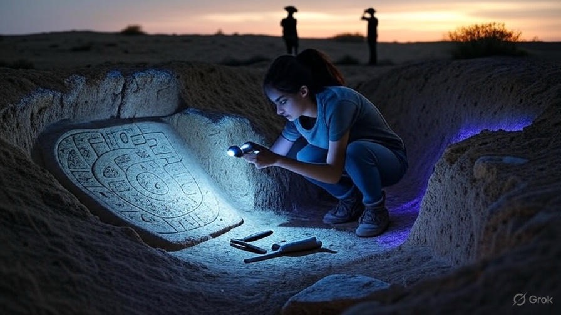

Zoe Carter pulled the door closed behind her as she and Professor Alan Rosenberg entered Café Zahara, its narrow tables tucked beneath a striped awning on Jerusalem’s [Via Dolorosa](https://en.wikipedia.org/wiki/Via_Dolorosa). Morning sunlight filtered through grapevine leaves above, casting dappled patterns on the worn limestone floor. The air brimmed with the aroma of cardamom-spiced coffee, freshly baked burekas, and roasting za’atar. Vendors hawked pashmina scarves, their threads shimmering like desert dawn; pilgrims in sandals and prayer shawls drifted by, while a street musician coaxed mournful notes from an oud.

Mirna Ashur sat rehearsed and still at a small wrought-iron table near the fountain, a steaming mug of Turkish coffee cradled in her hands. Her hair, braided in the style of medieval Sephardic scribes, was wound into a sleek bun. Every gesture was measured: the tilt of her head, the glimmer in her olive skin, even the faint curve of her lips. Rosenberg offered a polite nod. “Dr. Ashur,” he said. “Thank you for meeting us.”

Mirna inclined her chin. “Professor Rosenberg. Dr. Carter. I heard you made extraordinary progress overnight.” Her fingertips tapped the cup’s rim in rhythmic certainty. “I’m curious to see your findings.”

Zoe slid into the chair opposite, aware of how small she felt under Mirna’s precise gaze. She set her tablet on the table—its lock icon blinking green. “We confirmed a Y-H-V-H alignment mapped to the NRG1 gene in Genesis 1:26–27,” Zoe said, voice soft yet firm. “We need your paleographic expertise to verify the manuscript’s provenance.”

At that, Mirna’s eyes sharpened. She reached into a worn leather satchel and produced a slim folder stamped with the National Library seal. Inside lay six vellum fragments, each trimmed to uniform edges, the Hebrew ink faded to a smoky gray. “I acquired these from a private collector,” she explained. “They trace back to a Cistercian monk who visited Jerusalem in 1191 during the Third Crusade.”

Zoe leaned forward, seeking context in every crack and crease. Rosenberg examined the edges, noting the meticulous seaming. “The marginal notes?” Zoe asked, tracing a slender line with her fingertip. The scribbles were Sephardic, overwritten later by a Greek gloss—only to end at the trim line, as if someone had stopped time itself.

“These slips fill gaps in your ELS grid,” Mirna said. “But time is short.” She slid the folder back into her bag, her half-smile both invitation and warning. “Use them carefully. I’ll await your report.”

Zoe exhaled a breath she didn’t know she’d been holding. “Those trims,” she whispered to Rosenberg as Mirna drifted away, “they removed context, not content. She’s guiding us… mining us.”

Rosenberg folded his arms. “Mirna’s gifts always carry a price. We’ll verify every stanza against earlier captures.”

Zoe’s heart tightened. “We’re not just decoding texts. We’re decoding intentions.”

That afternoon, back at the King David Street hostel, Zoe and Rosenberg spread documents across a low cedar table. An amber lamp cast long shadows on the map of ancient Judea tacked to the wall. Naomi Halpern, the Israeli bioarchaeologist, reviewed isotopic charts, while Raj Patel, former signal analyst turned lab specialist, cross-referenced lexicon frequency tables on his laptop.

Zoe opened the encrypted PDF from Mirna’s fragments. Lines of code scrolled past in a black terminal window as she ran a local ELS script. “Load the transliterations, Raj,” she said. “Then map each Hebrew letter to its amino-acid equivalent and run [els_search.py](https://github.com/josephbedell/InOurImage/blob/main/els_search.py) again. I want alignment scores above seventy-five percent before we even think of calling it valid.”

Raj clicked through tabs, his fingers flying. “Give me ten minutes,” he said without looking up. Naomi adjusted her glasses. “If the match is genuine, we could be looking at the earliest biological annotation overlay in a religious text.”

Rosenberg glanced at Zoe. “But if it’s false… we risk losing credibility—and potentially disrupting medieval artifact markets.”

Zoe nodded, but her mind was already racing ahead to the Negev expedition they’d booked for tomorrow. The desert wind had carried whispers of basalt tablets surfacing along old caravan routes. If Mirna’s fragments were a test, Avdat could be the proving ground.

At dawn the next day, Zoe found herself bouncing along a dust-scattered track in a Toyota Land Cruiser bound for the Negev. The sky above was an unbroken expanse of brilliant blue, heat waves shimmering off ochre limestone cliffs. Rosenberg sat beside her, a worn map unfurled on his lap, tracing a dotted line to Avdat. Behind them, Naomi and Raj strapped down rugged field gear: a MinION handheld sequencer, a satellite-uplink terminal, portable UV lamps, and temperature-controlled crates for fragments.

“Local Bedouin guides said winter floods uncovered basalt tablets here,” Naomi said, voice hushed. “This site was part of the [Incense Route – Desert Cities in the Negev](https://whc.unesco.org/en/list/1107/) UNESCO corridor, used to transport frankincense and myrrh.”

Windswept shrubs rattled against the Land Cruiser’s sides. A lone sandgrouse burst from cover, its wings flashing. Raj tapped at an app on his phone. “Clear signal. We’re live-streaming to the lab in Tel Aviv for backup.”

Zoe checked her tablet’s battery. “Good. If anything goes wrong, I want a second copy.”

Six hours later, the group arrived at a sun-bleached trench carved into basalt outcroppings. Archaeologists in wide-brimmed hats knelt around a partially exposed tablet. Naomi knelt too, brushing dust gently. “The carvings look like concentric clan records,” she said. “Numbers beside names—ancestors, descendants.”

Zoe crouched, running a UV lamp across the grooves. Faint red ochre highlighted select letters. She pulled out her DSLR and snapped high-resolution photographs. “Raj, feed these into the OCR pipeline,” she instructed. “Export Unicode text and send it to my tablet.”

Minutes later, Raj plugged the sequencer into Zoe’s laptop via USB. Its fan whirred; a progress bar crept from 0 to 100 percent as Zoe initiated the amino-acid mapping. “Load the transliterations,” Zoe said. “Then filter for Y-H-V-H and Y-H-W-H motifs.”

Rosenberg studied a sketch Naomi had made of the tablet’s layout. “These branching lines suggest an ancestral cladogram—like a haplogroup network rather than a simple list.”

Naomi smiled. “They carved genetic memory into basalt. In a sense, you could call it proto-sequencing.”

Just then, Raj froze mid-command. “Zoe, look.”

Zoe swiveled. Two figures stood on a ridge overlooking the site, binoculars trained on the camp. They wore unmarked khaki jackets—no insignia, no logos. She tensed. “Raj, get coordinates. Naomi, pack up anything we can’t carry in hand.”

The sequencer printed data; Zoe grabbed the tablet and scrolled. The patterns matched J1 (M267) and E1b1b (M35), haplogroups common in the Levant and North Africa. But her mind was on the watchers. “They’ve tracked us since Jerusalem,” she hissed. “Raj, upload the raw reads now.”

Raj did, his fingers trembling. Rosenberg flicked off the Land Cruiser’s engine. “We can’t confront them—let’s disappear eastward, on foot.”

Zoe agreed. They packed fragments into protective crates, each tagged and labeled with RFID chips. Naomi scurried to dismantle the satellite uplink tower. The local archaeologists exchanged puzzled glances but obeyed when Zoe flashed accreditation.

They moved swift, zigzagging through a narrow gulch between mesas. The sun pounded their shoulders as dust clung to sweat-soaked shirts. Zoe realized half her gear might be compromised if they left it all behind, but better safe than exposed. They abandoned the Land Cruiser twenty minutes into the trek, leaving decoy footprints in the sandy wash.

Behind them, the watchers remained on the ridge, silhouettes against the sky—silent sentinels. Zoe counted three. No radios, no weapons visible. But their intent was clear: control the narrative, own the discovery.

Every few minutes, Zoe glanced back. The ridge receded, but adrenaline made time stretch. Her throat was parched; she dipped into a hydration pack. “We need to reach that plateau,” she panted, pointing north. “Then we can drop the crates in a camo sack and circle back to retrieve them later.”

Rosenberg nodded, sweat glistening on his brow. Naomi led with a topo map. Raj carried the sequencer, clutching it like a lifeline. The four of them moved in a tight diamond, scanning every dune and gullied knoll.

Two hours later, they reached a flat ledge overlooking the Rub’ al-Khali lip. The wind gusted, carrying the distant cry of a desert fox. Zoe crouched behind a jagged boulder. “Set it down here,” she said, marking the spot in the GPS. “We’ll send a retrieval drone at midnight.”

Raj pulled a small quadcopter from his pack, eyes alight. “I can program an auto-hover scan and pickup routine. By 00:00, it lifts the crate and flies back to camp.”

Zoe exhaled. “Good. Let’s move out, deeper into the canyon.”

They pressed on for another hour, the canyon walls rising around them, cool shadows offering momentary respite. Zoe’s mind raced with questions: Who had Mirna sold the fragments to? Were the watchers linked to ChronoGenomics? Or to some clandestine agency? Every step took them further away from certainty and deeper into the desert’s silent majesty.

At dusk, they found a sheltered overhang with a trickle of groundwater. Naomi set up a small campfire. “We can analyze partial reads from the latest upload,” Zoe suggested. “See if the tablet’s database aligns with Mirna’s fragments.”

Under shifting stars, Zoe and Rosenberg huddled over the tablet. Light from the fire danced across the screen as Raj’s code parsed metadata. Zoe’s breath caught when she saw the output: a series of codons spelling out an archaic version of “light” and “seed,” paired palindromically with Y-H-V-H motifs. This was more than annotation—it was a ritual invocation of creation itself.

Rosenberg whispered, “She’s fused biology and theology into one living code.”

Zoe stared at the lines:

…TAC–GGA–CCT…  
…TYHVH–GLH…  
…AGCT…GENESIS…SEED…

“This isn’t random,” Zoe said. “They meant for it to read across languages—Hebrew letter, amino acid, gene function. A multiverse of meaning.”

Naomi poured tea into tin mugs. “We’ve stumbled on a convergence—anthropology, genetics, theology. It’s unprecedented.”

As silence settled, Zoe felt a presence behind her. She turned but saw only shadows. The desert night was vast, an open wound in the earth. She knew the watchers could return at any moment.

Rising, Zoe gathered her notes. “We push forward at first light,” she said. “Pick up the crates, then head to the old irrigation dam. I’ve heard rumors of a hidden chamber beneath it—another cache.”

Rosenberg rolled up the map. “Then let’s rest. Tomorrow, the code unlocks its next gate.”

Zoe lay back under a canopy of stars. Her thoughts drifted to Mirna’s warning: “Use them wisely.” She realized this was more than academic pursuit—it was a struggle for the soul of history itself. And when dawn broke over the desert, Zoe Carter would stand at the threshold of secrets that could reshape faith, science, and the very definition of life

.