The main concepts are:
- what an exception is,
- what throw does,
- what try does,
- what catch does,
- what “stack unwinding” means,
- what happens when a constructor throws,
- why exceptions are different from return values,
- how this applies to incrementGrade() and decrementGrade().

1. First: what problem are exceptions solving?
Your Bureaucrat has a rule:
So:
is valid.
But:
is invalid.
And:
is also invalid.
The question is:
What should the constructor do when somebody gives it an impossible grade?
It cannot simply continue, because then you would have an invalid object.

You do not want this:
to create a bureaucrat whose grade is 0.
So your constructor checks:
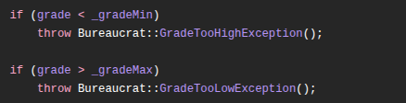
That throw is the important part.

2. What is throw?
Take this line:
It means approximately:
"An exceptional error happened. Stop normal execution right now and look for code that knows how to handle this error."
It does not behave like a normal function call.
It does not continue to the next line.
For example:
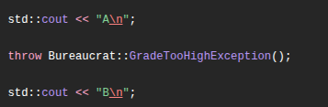

B will never print.
Execution reaches:
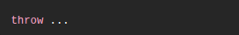
and normal execution stops there.

3. What exactly are you throwing?
This part:
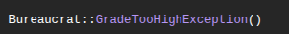
creates an exception object.
You defined the class here:
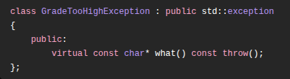
So GradeTooHighException is simply a class.
Just like:

creates a Bureaucrat object,
this:


creates a temporary GradeTooHighException object.
Then:
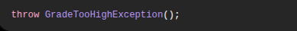
throws that object.

4. Why inherit from std::exception?
You wrote:
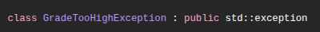
That means:
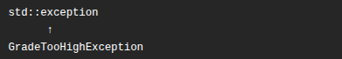
Similarly:
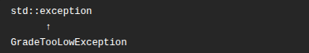
This is useful because now both of your custom errors can be caught using:
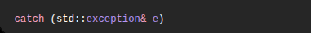
Because a GradeTooHighException is a std::exception.
This is normal polymorphism.
Very similar to:


if Dog inherits from Animal.

5. What is what()?
Your exception contains:
And you define it as:
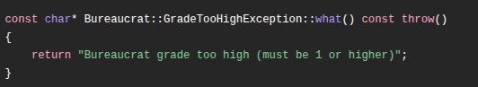
So if this exception is caught:
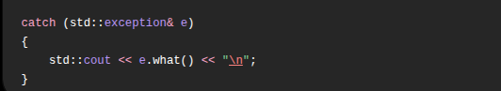
e.what() returns:
Bureaucrat grade too high (must be 1 or higher)
That is simply the human-readable description of the error.

6. Now let's follow your constructor carefully
You have:
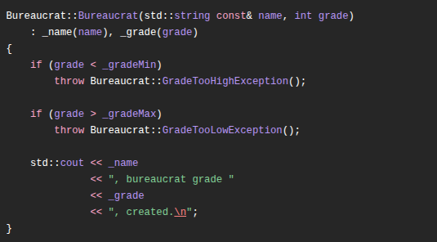
Suppose we execute:
Flow:
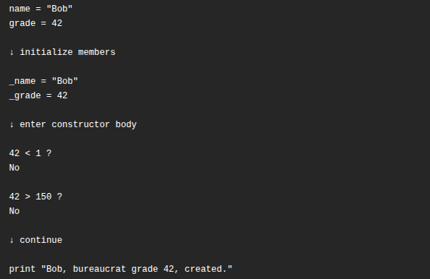
Object construction succeeds.
Now:
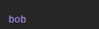
really exists.

7. What happens with grade 0?
Now look at:


Step by step:
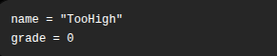
Initializer list runs:
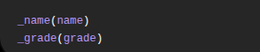
so temporarily:
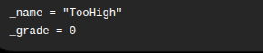
Then constructor body starts:
Since:
is true, this executes:
At that exact moment, construction fails.
The constructor does not reach:
Most importantly:
tooHigh is never considered a fully constructed Bureaucrat object.

8. Why doesn't the invalid object remain?
This is one of the most important constructor/exception concepts.
You wrote:
You might think:
But _name and _grade were already initialized. Doesn't tooHigh exist?
No.
For an object to successfully exist, its constructor must finish successfully.
Conceptually:
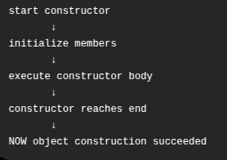
If an exception happens before the constructor finishes:
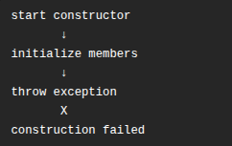
So the caller never receives a valid Bureaucrat.

9. Does Bureaucrat::~Bureaucrat() run when the constructor throws?
This is subtle.
For this:

your Bureaucrat constructor started but never completed.
Therefore:

does not run for tooHigh.
Why?
Because there is no fully constructed Bureaucrat to destroy.
However, members that were successfully constructed are cleaned up automatically.
For example:

gets cleaned up even though the full Bureaucrat was never successfully created.

10. Now we need try
You have:
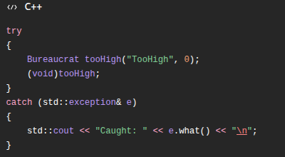

Think of try as saying:
"Execute this code, but something inside it may throw an exception."
For example:
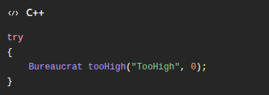
C++ begins normally.
Then constructor throws.
When that happens, C++ stops executing the try block.
It then starts looking at the associated catch blocks.

11. What does catch mean?
Your code:
means:
"If an exception compatible with std::exception reaches me, catch it and call it e."
Since:

inherits from:
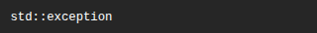
it matches.

So:

receives the thrown object.
Then:

calls your overridden what().
Therefore:
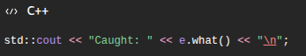
prints something like:
The try block contains the normal code that might cause an exception to be thrown somewhere underneath, but the try itself does not need to know the exact line or exact internal check that will throw.
For example:
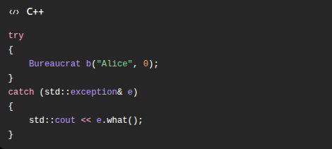
Inside the try, you are not writing the error condition itself. You are just running code that may eventually throw.

Here:

calls the constructor. Deep inside that constructor:
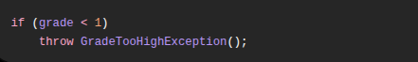
So conceptually:
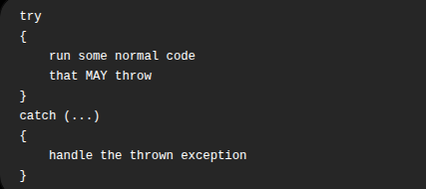
And yes, the try can be quite non-specific. It can contain many operations:
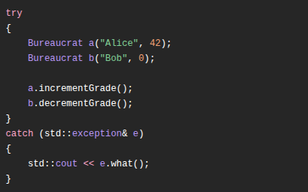
Any statement inside that try, or any function called by those statements, may throw.
So I would phrase it like this:

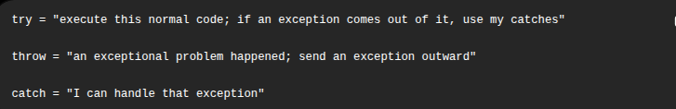
One correction to your wording: try is not really an “example of what the exception could be.” It is the region of normal code from which you want to catch exceptions.

2.2 Catch by reference, not by value

The thrown object
Bureaucrat.cpp does this:
An object of type GradeTooHighException now exists somewhere. Inside it: a vptr, pointing to GradeTooHighException's vtable, whose what() slot holds the address of your function.
That object is a std::exception too — but with your part built on top.
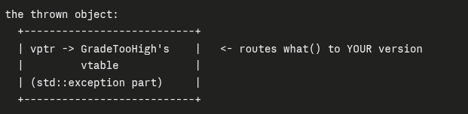
Case A — catch by reference
No copy is made. e is just another name for the thrown object — exactly like Animal& a = d;.
The vptr is untouched. It still points to GradeTooHigh's vtable. So e.what() walks the vptr and lands on your function:

Case B — catch by value
A copy is made. And the copy is declared type std::exception — which is smaller than your class. So the copy constructor takes only the std::exception-sized portion and leaves the rest behind.
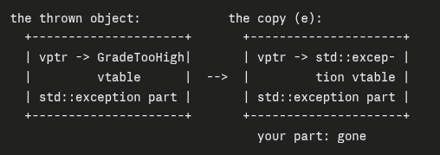
Two things died:
Thing 1 — your derived data got chopped off.
Any members your derived class added are not copied. The copy is std::exception-sized; there's no room for them.
In your specific code, this loses nothing — GradeTooHighException has no data members at all. It's an empty class. So thing 1 is real in general, but harmless here.
Thing 2 — the vptr changed.
This is the one that actually bites you.
The copy is a genuine std::exception object. When it's constructed, std::exception's constructor sets the copy's vptr to std::exception's vtable. Your object's vptr wasn't copied over — the new object got its own, appropriate for what it now is.
So the copy has lost its identity, not just its data. It no longer knows it was ever a GradeTooHighException, and e.what() finds the base version.

