Part 1: What virtual does

The problem it solves
Two classes. One is a specialized version of the other:
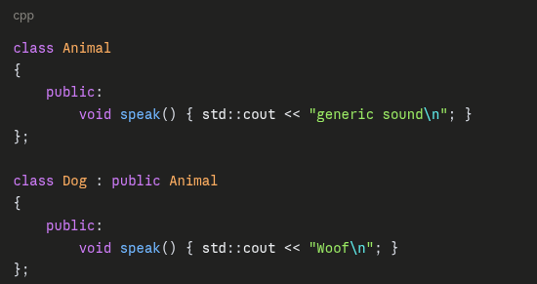
Both have speak(). Now watch this:
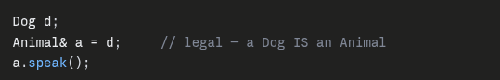
What prints?
Without virtual: generic sound
The object is a Dog. It knows how to bark. But the compiler looked at the label — a is declared Animal& — and hard-wired the call to Animal::speak(). The real type was ignored.
Now add one word:
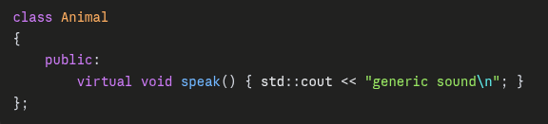
Same main, no other change. Now it prints: Woof
That's it. That's what virtual does.

Why — the actual machinery
Without virtual, the compiler decides at compile time which function to call. It reads the declared type Animal& and writes the address of Animal::speak() into the machine code. Done. Fixed forever. This is static binding.
With virtual, the compiler can't decide anymore — it has to ask the object at runtime. So it builds two things:
The vtable — one table per class, holding function addresses:
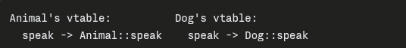
The vptr — a hidden pointer the compiler secretly adds inside every object, pointing to that object's own vtable.
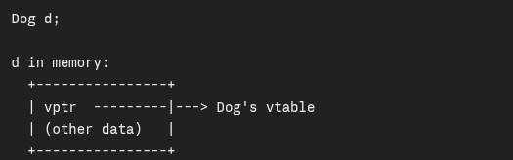
The vptr is set when the object is constructed. A Dog always gets Dog's vtable. Always.
So a.speak() becomes:
- Follow a → find the object:
a reference isn't a copy, and it isn't a separate object.
Animal& a = d; creates no new object
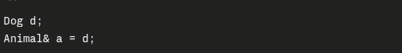
There is one object in memory: d. a is just another name for it. Nothing is copied, nothing is constructed.

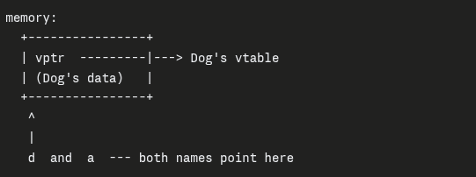
So "follow a" is really "a already is that address." Under the hood the compiler implements a reference as an address — essentially a pointer you can't reseat and don't dereference manually. a.speak() compiles to the same machine code as dogPtr->speak().

Why the vptr is still Dog's
This is the key point. The vptr was written when d was constructed. Dog's constructor set it to Dog's vtable, and it stays that way for the object's whole life.
Binding a to it changes nothing in memory. Not one byte. The line Animal& a = d; produces no runtime code at all — it's purely a compile-time relabeling.
So a.speak():
- a holds the address of d
- Read the vptr sitting at that address → Dog's vtable (because Dog's constructor put it there)
- speak slot → Dog::speak
- Call
The label Animal& controls only what you're allowed to write. Through a, you can only call functions Animal declares. But which implementation runs is decided by the vptr in the object.
That's the split worth memorizing:
The declared type decides what you may call. The vptr decides what actually runs.

Contrast: what a copy would do

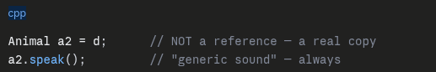
Here a genuine new Animal object is built. Only the Animal-sized portion of d gets copied; the Dog part is chopped off. And the new object's constructor sets its own vptr to Animal's vtable. Virtual dispatch now correctly finds Animal::speak — because this really is an Animal now.
That chopping is slicing.

Which is exactly our catch block

- Read the hidden vptr inside it → Dog's vtable
- Look up the speak slot → Dog::speak
- Call it
The declared type Animal& never enters the decision. The object carries its own answer. This is dynamic binding.

The single sentence
virtual = "don't decide from the label, ask the object."

Part 2: Now our code
Replace Animal/Dog with std::exception/GradeTooHighException. It's the identical shape.
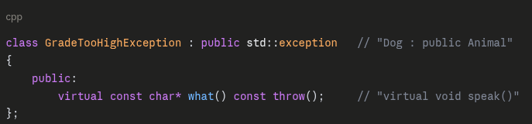
And in main.cpp:
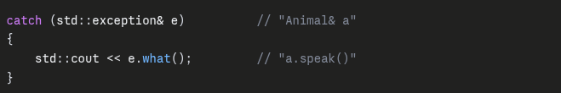
The object thrown is a GradeTooHighException. The reference e calls it a std::exception. Because what() is virtual, the vptr routes to your version, and you get your message instead of the generic one.
Same mechanism. Different names.

