whats the difference between AForm *makeForm(std::string const &formName, std::string const &target) const; and AForm &makeForm(std::string const &formName, std::string const &target) const; ????

The difference is whether "no such form" is expressible.
Pointer version. Returns an address. Can be NULL. So the failure case has a natural representation:
AForm *f = intern.makeForm("28C form", "Bender");
if (f == NULL)
// handle it
The caller receives ownership of a heap object and must delete it.
Reference version. A reference must always bind to something — there is no null reference in C++. So when the form name doesn't exist, you have no way to say so. Your options would be:
- throw an exception instead of returning
- return a reference to some dummy static form, which is worse than useless
And you'd still be handing back a heap object, so the caller does delete &form; — taking the address of a reference to delete it. That works but reads badly and hides the ownership transfer. A reference normally signals "I'm lending you this, I still own it." Here the opposite is true.
Why the subject specifies the pointer. It says makeForm "returns a pointer to a AForm object," and the example is:
AForm *rrf;
rrf = someRandomIntern.makeForm("robotomy request", "Bender");
Pointer it is, not optional.
The general rule worth carrying: return a pointer when the result may be absent or when you're transferring ownership of something heap-allocated. Return a reference when the object definitely exists and you're not giving it away — which is why your getters return
std::string const &
but
makeForm doesn't.

Stack | Heap
Automatic memory | Dynamically allocated memory
Managed automatically | You manage it yourself
Very fast | Usually slower
Variables disappear when scope ends | Memory stays until you release it
Usually smaller | Usually much larger
Example: int x = 5; | Example: int* x = new int(5);

In CPP05 ex03, the genuinely new ideas are concentrated in the Intern class. The previous exercises already introduced inheritance, abstract AForm, virtual functions, polymorphism, exceptions, and execution through executeAction(). In ex03, the new layer is: the Intern dynamically creates the correct concrete form from a string name.
The main new concepts are:
- Factory-style object creation
You now have:
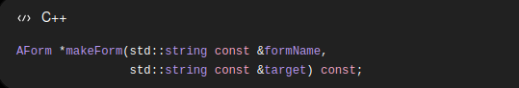

The caller says something like:

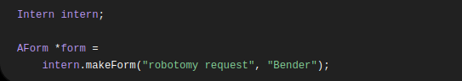

The caller does not directly write:

Instead, the Intern decides which class to instantiate.

Conceptually:
