No — and this is the single most important misunderstanding to clear up, because it's about what these pieces actually are.
what() is not a catcher. It's a getter.
Look at it stripped of context:
const char* Form::GradeTooLowException::what() const throw()
{
return "Grade too low";
}
That is an ordinary member function that returns a pointer to a string literal. It has no special powers. It does not run by itself. It does not observe throws. It sits there, inert, exactly like getGrade() sits there, until somebody explicitly calls it.
The only thing that ever calls it in your program is this line:
std::cout << ... << " because " << e.what() << ".\n";
^^^^^^^^
Delete the catch block and nothing anywhere calls what(). The function still compiles, still links, still exists in the binary — and never executes. The string "Grade too low" never leaves the object.
The two separate things throw does
throw Form::GradeTooLowException(); performs two distinct actions:
- Constructs an object of type Form::GradeTooLowException. This object carries the ability to produce a message (it has a what()), but constructing it prints nothing.
- Hands that object to the runtime and says: find me a handler.
Step 2 is the search. The runtime walks the call stack from the throw point outward, looking for a catch clause whose type matches. catch is the only construct it looks for. Function definitions — including what() definitions — are invisible to this search. They're not handlers.
Trace your program with the catch removed
Take section 8 of your main, which is the interesting one:
std::cout << "\n--- 8. signForm() failure message ---\n";
{
Bureaucrat intern("Intern", 150);
Form request("Request", 10, 5);
intern.signForm(request); // <-- no try/catch here in main
std::cout << request;
}
Stack at the moment of the throw, innermost first:
Form::beSigned ← throw happens here. Any catch? No.
Bureaucrat::signForm ← (catch removed) Any catch? No.
main ← section 8 has no try Any catch? No.
--- ran out of stack ---
The search reaches the end of the stack without finding a handler. When that happens the standard says std::terminate() is called, whose default behaviour is abort(). Your program dies. In the terminal you get something like:
terminate called after throwing an instance of 'Form::GradeTooLowException'
Aborted (core dumped)
Notice the runtime prints the type name there — that's a compiler courtesy, not your what() running. Sections 9 and "end of main" never print. And because no handler was found, the implementation isn't even required to unwind: intern and request typically get no destructor call, so your "destroyed." lines vanish too.
Compare with a section that does have a catch
Section 6 is different:
try {
form.beSigned(lowRank);
}
catch (std::exception& e) {
std::cout << "Caught: " << e.what() << "\n";
}
Same search, but now the walk is beSigned → main, and main has a catch (std::exception&). Form::GradeTooLowException derives from std::exception, so it matches. Control transfers into that block, e binds to the thrown object, and now somebody calls e.what() — which is the first and only moment "Grade too low" gets produced.
So the answer to your question
Removing the try/catch from signForm doesn't make the message appear elsewhere. It makes the message disappear entirely, and in your current main it crashes the program at section 8. The catch isn't optional plumbing around a mechanism that works anyway — the catch is the mechanism that turns a thrown object into visible output.
One reframing that usually makes this click: an exception is not an error message. It's an object in flight, plus a demand that someone handle it. If nobody handles it, the program is terminated on the grounds that an error was signalled and ignored.

Terminal A (will run your program's output):
1. Open a new terminal window.
2. Run: tty
3. It prints something like /dev/pts/2 — remember this exact path.
4. Run: cat
5. Leave this window alone from now on — don't click into it or type anything else.

Terminal B (your original one, where you'll run gdb):
6. cd into ex01/ if you're not already there.
7. c++ -Wall -Wextra -Werror -std=c++98 -g -O0 -I include -o bureaucrat_dbg src/main.cpp src/Bureaucrat.cpp src/Form.cpp
8. gdb ./bureaucrat_dbg
9. tty /dev/pts/2 (the exact path from step 3)
10. layout src
11. break main.cpp:78
12. run → program's output appears in Terminal A; Terminal B stays clean, stopped at line 78
13. catch throw
14. catch catch
15. continue → stops at the throw
16. bt → note the 4 frames
17. continue → stops at the catch
18. bt → note it's now 3 frames — which one disappeared?
19. up → moves to frame #1, source pane follows

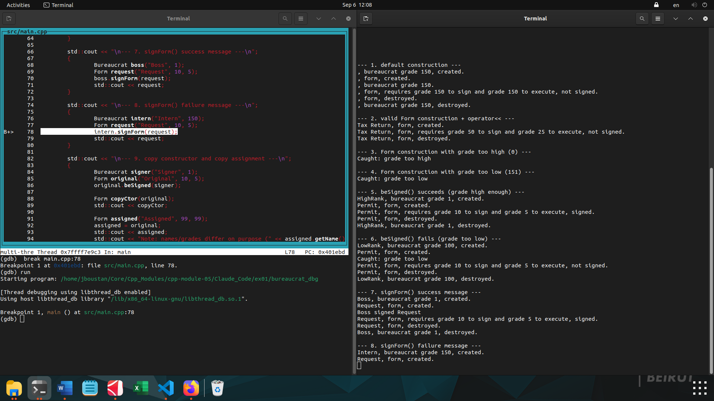

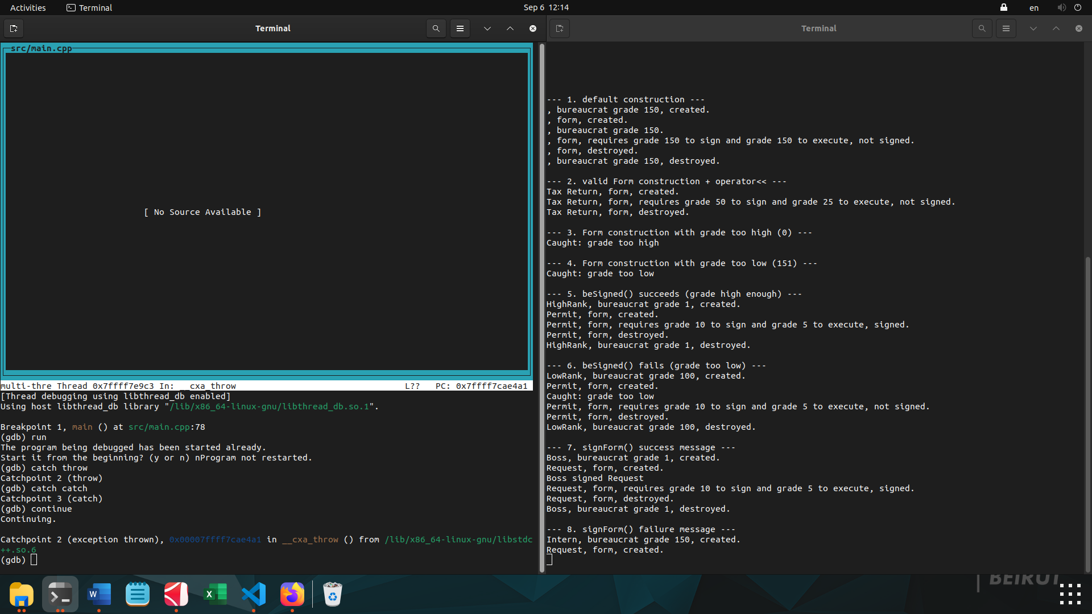
catch throw, catch catch, continue → stopped in __cxa_throw. This is the real result, and it's exactly what you want: Catchpoint 2 (exception thrown) fired the moment your program actually threw. The left pane shows [No Source Available] and In: __cxa_throw — that's not an error, it's because you're currently standing inside a function from libstdc++ itself (the C++ runtime's internal "start throwing an exception" routine), not inside your own code, so gdb has no source file to show for it. That's expected — __cxa_throw is always the very first frame right after a throw, before the stack starts unwinding back into your code.

This one line is gdb telling you three things at once:

- Catchpoint 2 (exception thrown) — the catchpoint you armed with catch throw just fired. Something in your program executed a throw statement.
- 0x00007ffff7cae4a1 — the memory address execution is currently stopped at.
- in __cxa_throw () from /lib/x86_64-linux-gnu/libstdc++.so.6 — that address is inside __cxa_throw, a function belonging to libstdc++ (the C++ standard library's runtime), not your code. __cxa_throw is the actual internal machinery the compiler calls whenever your source code says throw SomethingException(); — it's the function that packages up the exception object and starts the search up the call stack for a matching catch.

So: your program is now frozen at the exact instant a throw began executing — before any stack unwinding, before any search for a handler has happened yet. That's why the source pane showed "No Source Available" right after this — you're one level below your own code, inside the library's throw mechanism itself, not inside Form::beSigned yet (even though Form::beSigned is what called it).

bt is short for backtrace. It prints the full chain of function calls that got you to where you're currently stopped — frame #0 (where you are right now) up through whoever called that function, and whoever called them, all the way to main.

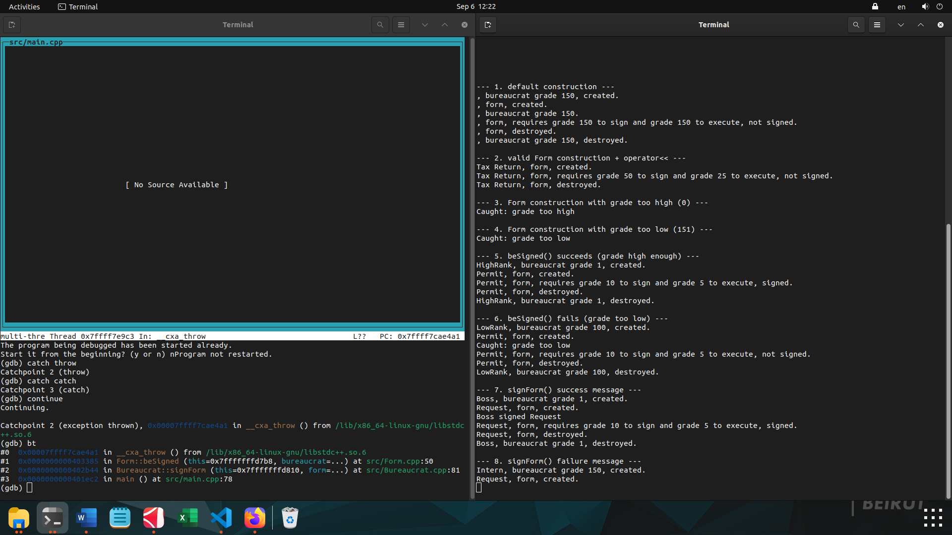
This is the exact call chain that led to the throw, frame by frame, read bottom-up:

- #3 main () at src/main.cpp:78 — the outermost frame. This is your intern.signForm(request); line.
- #2 Bureaucrat::signForm (this=..., form=...) at src/Bureaucrat.cpp:81 — main called into signForm, and it's currently paused at line 81 — that's form.beSigned(*this); inside your try block.
- #1 Form::beSigned (this=..., bureaucrat=...) at src/Form.cpp:50 — signForm called into beSigned, which is at line 50 — the throw Form::GradeTooLowException(); line.
- #0 __cxa_throw () from libstdc++.so.6 — beSigned's throw statement compiled down to a call into the C++ runtime's actual throw mechanism, which is where you're frozen right now.

So this one bt output is proof of the exact chain: main → signForm → beSigned → throw. Four frames currently on the stack.

Remember this number — 4 frames — because the next thing to do is continue again to reach the catch, then run bt a second time. Compare the frame count and which functions are still listed. That comparison is the whole point of this exercise: it shows you which frame got removed (unwound) once a handler was found.

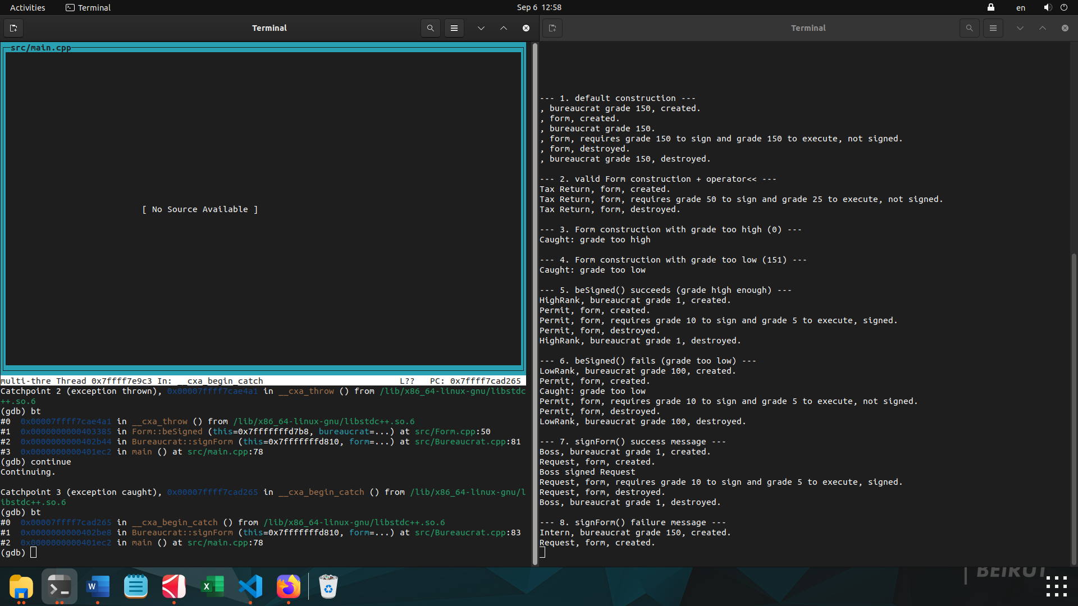

At the throw (4 frames):
#0 __cxa_throw
#1 Form::beSigned src/Form.cpp:50
#2 Bureaucrat::signForm src/Bureaucrat.cpp:81
#3 main src/main.cpp:78

At the catch (3 frames):
#0 __cxa_begin_catch
#1 Bureaucrat::signForm src/Bureaucrat.cpp:83
#2 main src/main.cpp:78

What to notice:

1. Form::beSigned's frame is completely gone. It was frame #1 before, now it doesn't exist at all. Between the two bts, the runtime searched upward for a matching catch, didn't find one in beSigned, popped that frame off the stack (this is "unwinding"), and moved up to the next one.

2. Bureaucrat::signForm is still there, but the line number changed: 81 → 83. Line 81 was form.beSigned(*this); (inside the try). Line 83 is the closing } of that try block — meaning execution is now entering the matching catch (std::exception& e) right below it.

3. The search stopped here. It never needed to touch main's frame at all — main is still sitting there unchanged at line 78, never disturbed.
This is the direct, visual answer to your original question: signForm's try/catch is the reason the unwinding stopped one frame above the throw, instead of continuing to climb past signForm into main (which has no handler) and crashing the whole program. You watched the exact frame that has no handler (beSigned) get discarded, and the exact frame that does (signForm) catch it.

Think of the stack as "which functions are currently mid-call, waiting for something they called to finish":

- main called signForm() and is waiting for it to return.
- signForm() called beSigned() and was waiting for it to return.
- beSigned() threw.

Unwinding only removes the frames between the throw and wherever the catch is found — because those are the ones that failed to handle it and get discarded. beSigned() is exactly that: it's between the throw and the catch, so it gets popped.

main isn't between anything — it's the caller of signForm(), and the catch was found inside signForm(), not above it. main was never part of the search at all. It's just sitting there the whole time, unaffected, still waiting for signForm() to eventually return — which it will, normally, right after the catch block finishes.
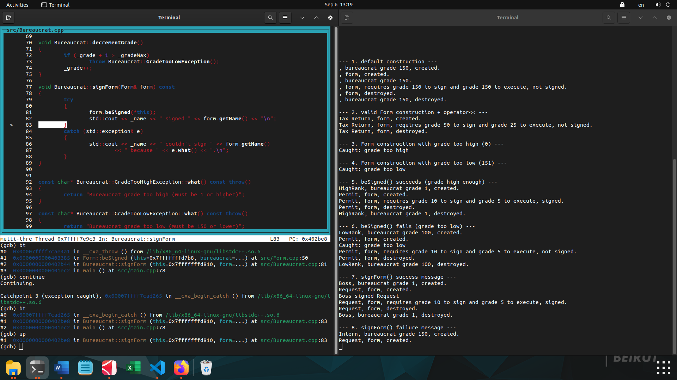
up moved your view one level up the call stack — from frame #0 (deep inside the library's __cxa_begin_catch) to frame #1, which is your code.

The source pane now proves it directly: it's showing Bureaucrat.cpp, with the > marker sitting on line 83 — the closing } of the try block, right before your catch (std::exception& e) on line 84. The status bar confirms it too: In: Bureaucrat::signForm L83.

So this is the literal, physical spot in your source file where the whole search from earlier ended up. Not main.cpp:78 (frame #2, still just waiting), not Form.cpp:50 (gone — already discarded) — right here, at the boundary between your try and your catch, inside signForm.

Next natural thing to try: down twice to go back to frame #0/verify, or just continue and watch the right-hand terminal print Intern couldn't sign Request because grade too low. — that's this same catch block, line 86-87, actually executing right after this.

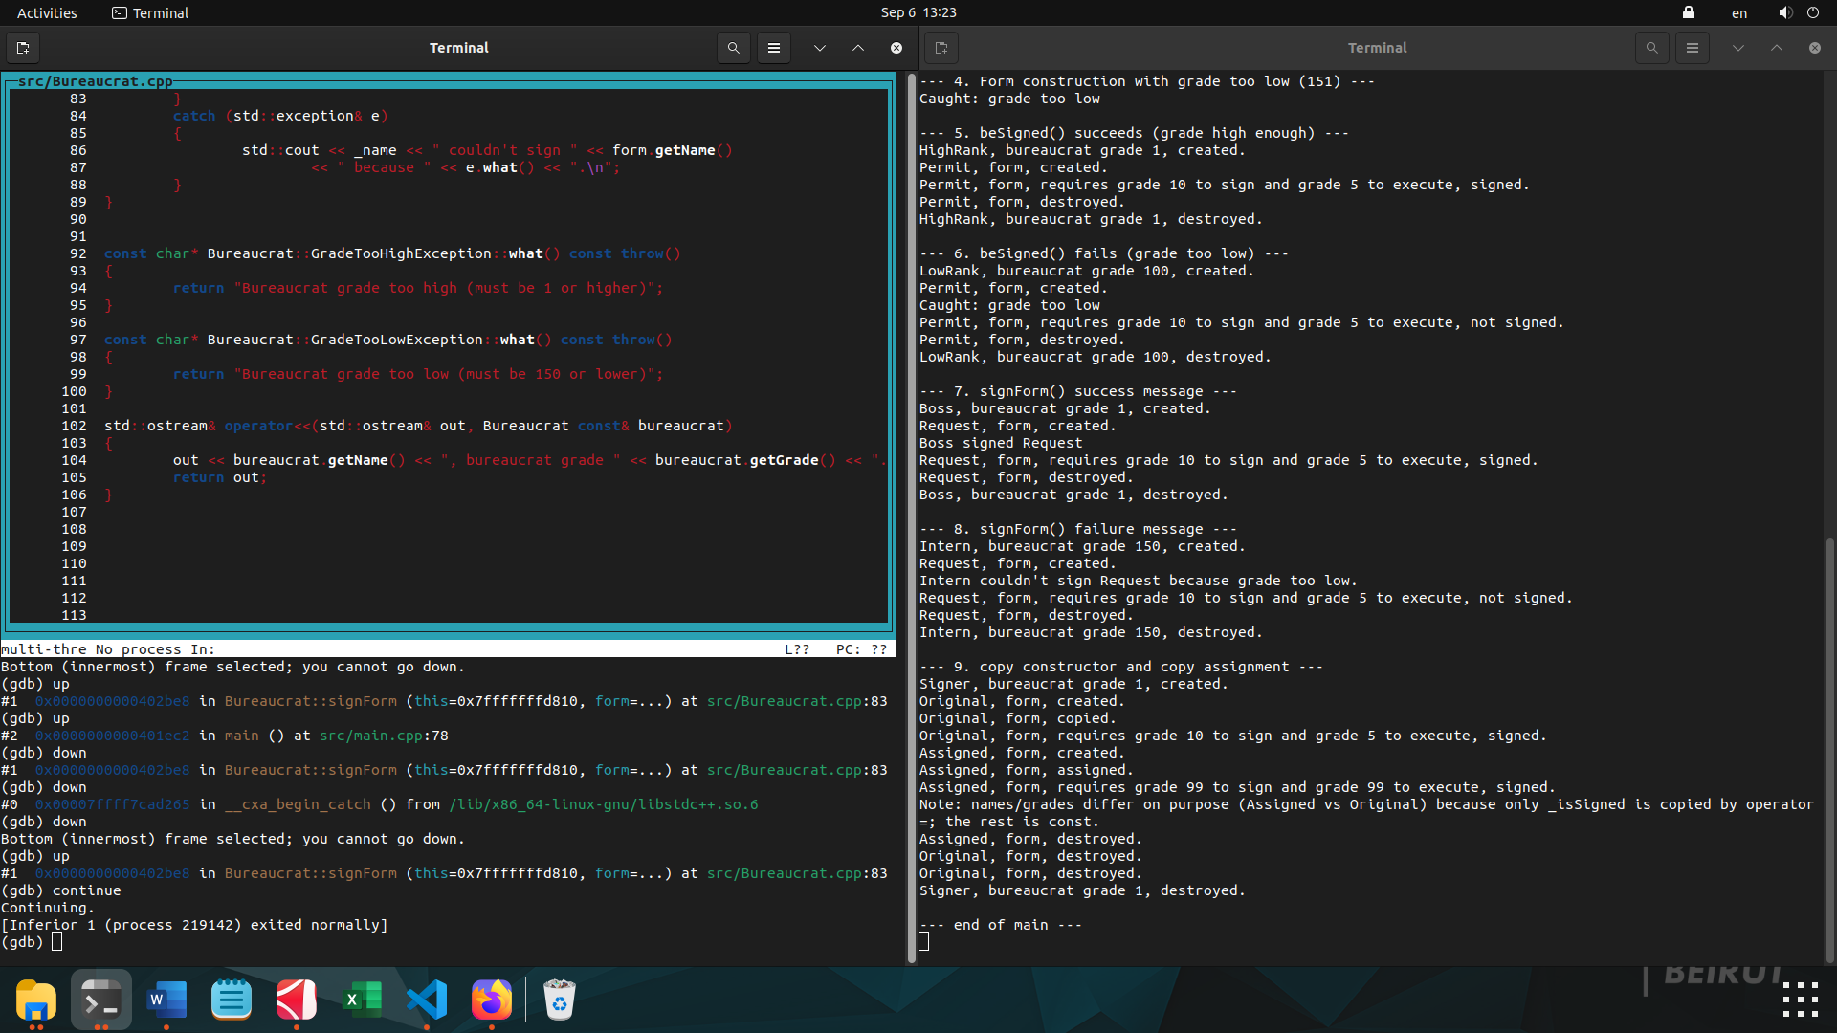

Second Case:

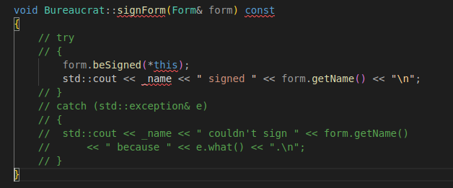

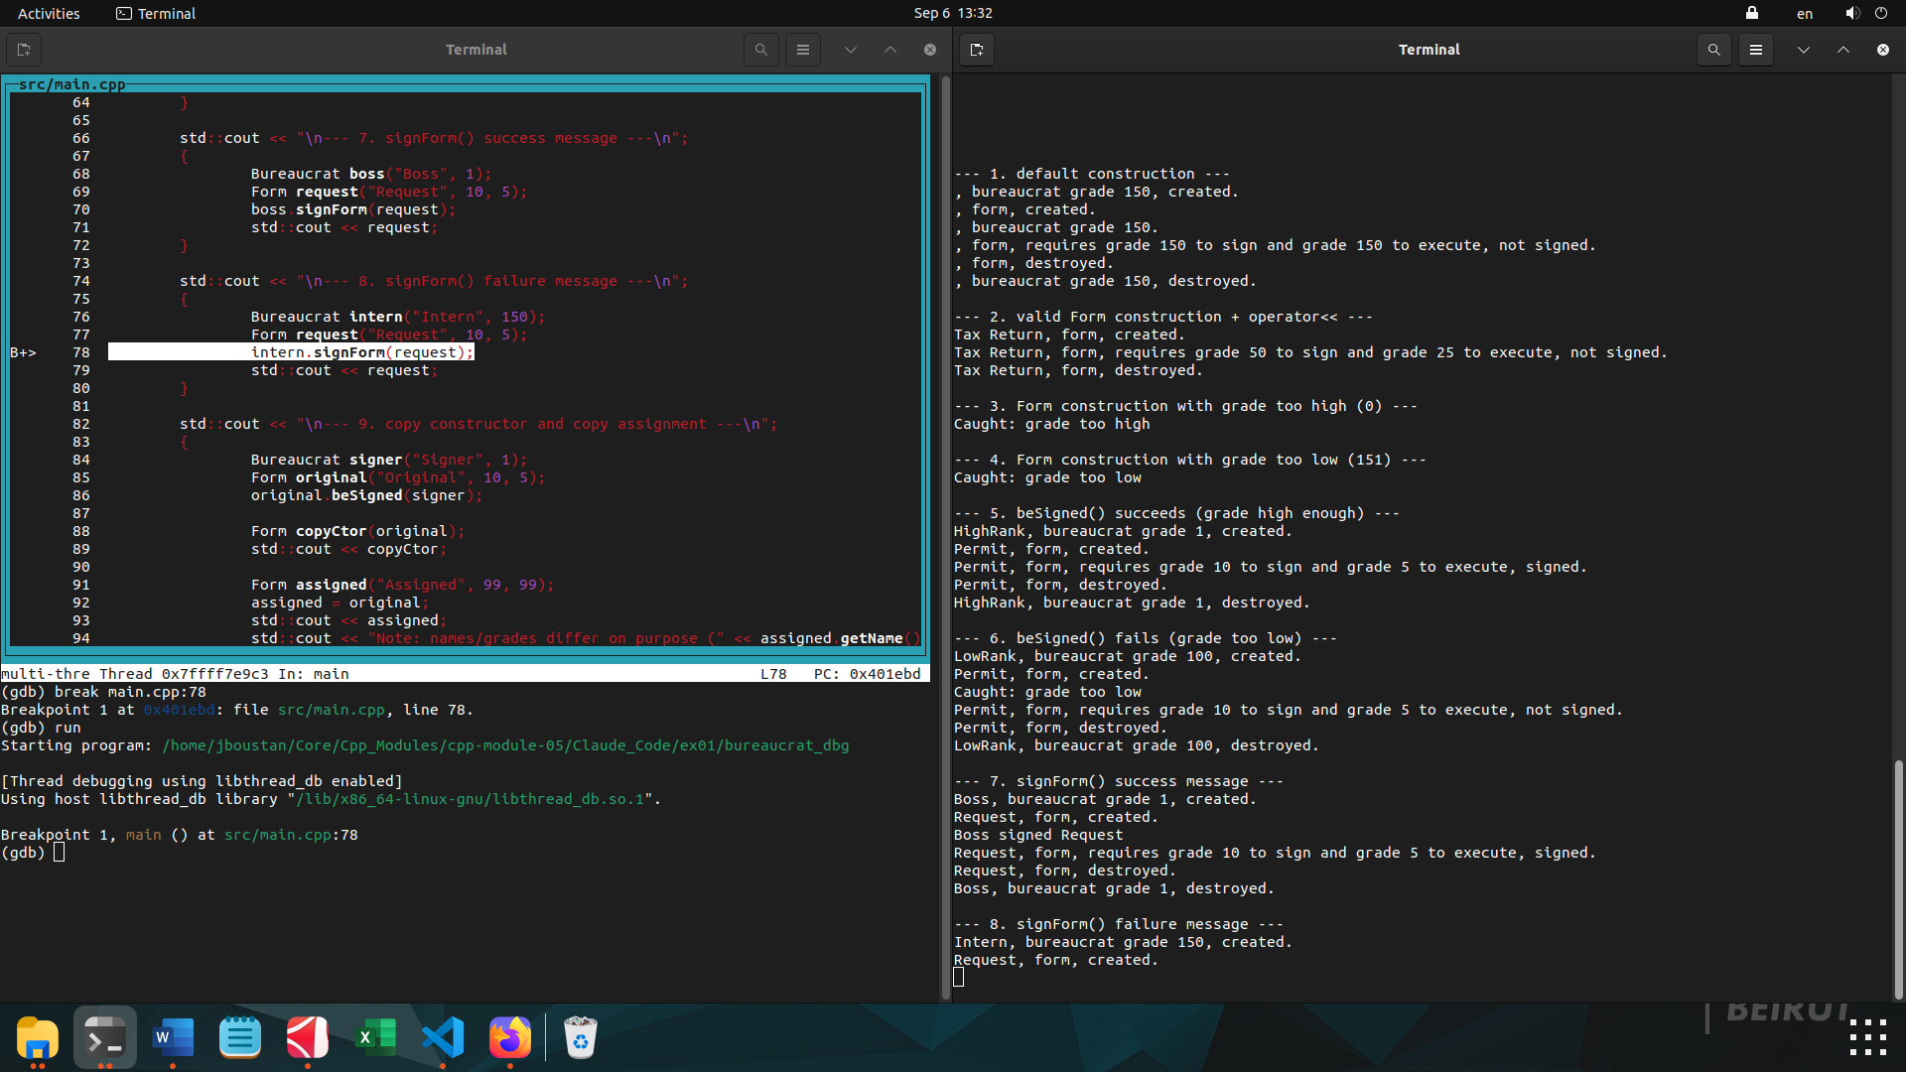

1. cd into ex01/ if you're not already there.
2. c++ -Wall -Wextra -Werror -std=c++98 -g -O0 -I include -o bureaucrat_dbg src/main.cpp src/Bureaucrat.cpp src/Form.cpp
3. gdb ./bureaucrat_dbg
4. tty /dev/pts/2 (your Terminal A path)
5. layout src
6. break main.cpp:78
7. run → output in Terminal A, Terminal B stops at line 78
8. catch throw
9. catch catch
10. continue → stops at the throw (same as last time)
11. bt → still the same 4 frames as before — nothing different yet, since the runtime hasn't started searching for a handler at this exact instant
12. continue → this time watch closely. Predict: does Catchpoint 3 (exception caught) ever print? Or something else entirely?
13. bt → look at what function names appear now. Are any of them library functions you haven't seen yet (hint: something with "terminate" or "abort" in the name)?

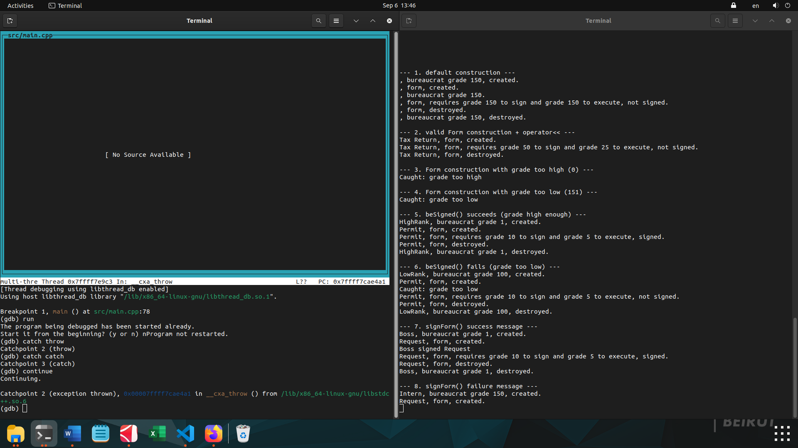
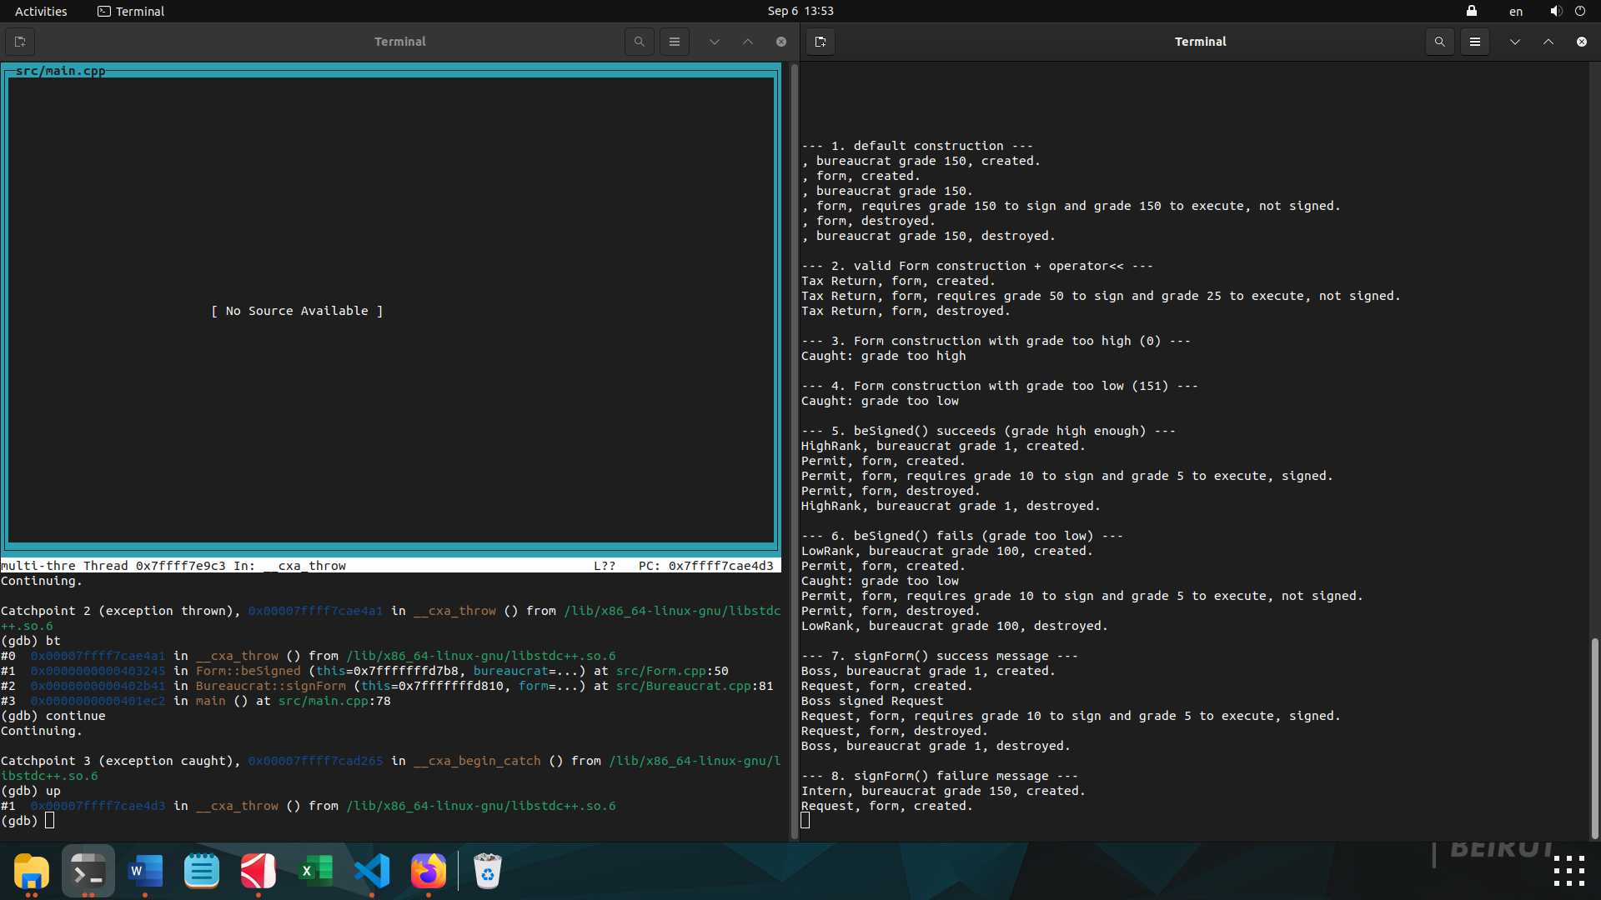
this result is actually really informative, but it's subtle. Let's decode exactly what you're looking at.

You saw Catchpoint 3 (exception caught) fire — which looks like a real catch happened, same as last time. But look at what up showed:

(gdb) up
#1 0x00007ffff7cae4d3 in __cxa_throw () from /lib/x86_64-linux-gnu/libstdc++.so.6

Compare that to what up showed you last time, when the real catch in your code handled it:
#1 0x0000000000402be8 in Bureaucrat::signForm (this=..., form=...) at src/Bureaucrat.cpp:83

Last time, one level above the catch was your code — signForm, line 83. This time, one level above the catch is __cxa_throw itself — still library internals, not your code at all.

That's the tell: this __cxa_begin_catch call isn't a real handler in your program. What's actually happening: since you removed the try/catch, nothing in signForm or main can catch this anymore. The runtime searches, finds no handler, and gives up — but right before it kills the program, its own internal "no one caught this" routine (the thing that prints terminate called after throwing an instance of ...) needs to peek at the exception object to get its type name and what() message. To do that, it briefly uses __cxa_begin_catch itself, internally — which is exactly what your catch catch catchpoint is designed to notice, even though it's not your catch.

So: nothing was actually handled. You're watching the failure path's own bookkeeping, one step before it kills the process.

Do this next: continue again (don't bother with down first — it doesn't affect execution, only which frame is displayed). Watch Terminal B for the words terminate called and SIGABRT.

when your program is about to die because nothing caught the exception, it prints a message like:
terminate called after throwing an instance of 'Form::GradeTooLowException'
what(): grade too low

To print that, the runtime's failure-handling code needs to know two things about the exception object still sitting there: its type name (Form::GradeTooLowException) and its what() message (grade too low). Getting at those requires briefly reaching into the exception object — which internally uses the same __cxa_begin_catch mechanism a real catch block uses to grab hold of the exception.

That's the "peek": it grabs the exception just long enough to read its type and message for that printout — not to recover from it, not to let your program continue. Right after, it still calls abort(). So catch catch fired, but nothing was actually "handled" — it was just read on the way to killing the program.
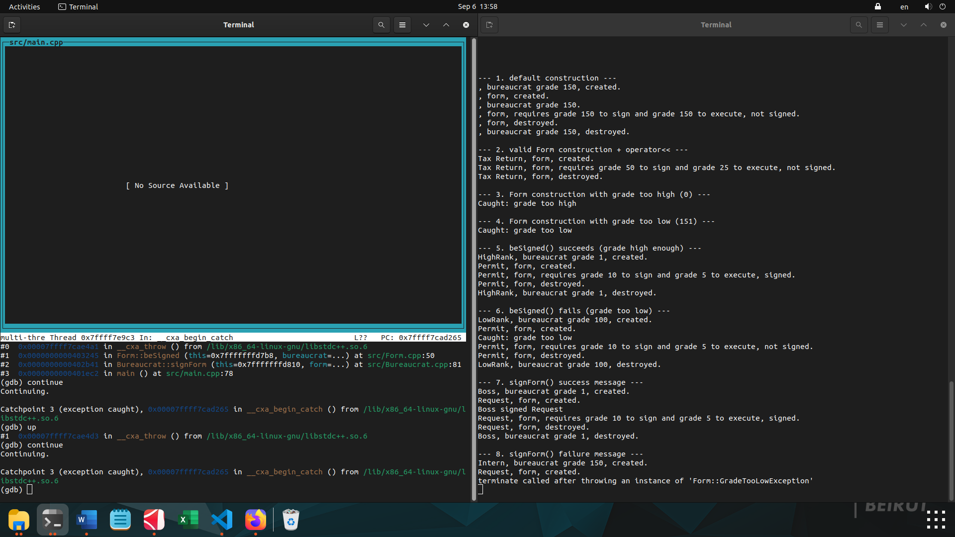
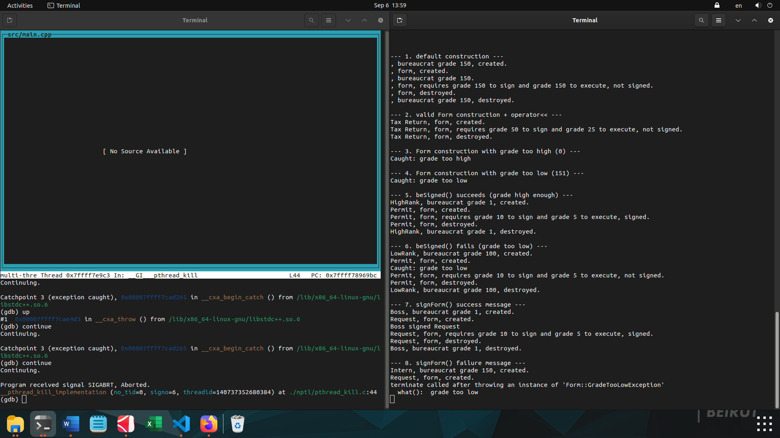

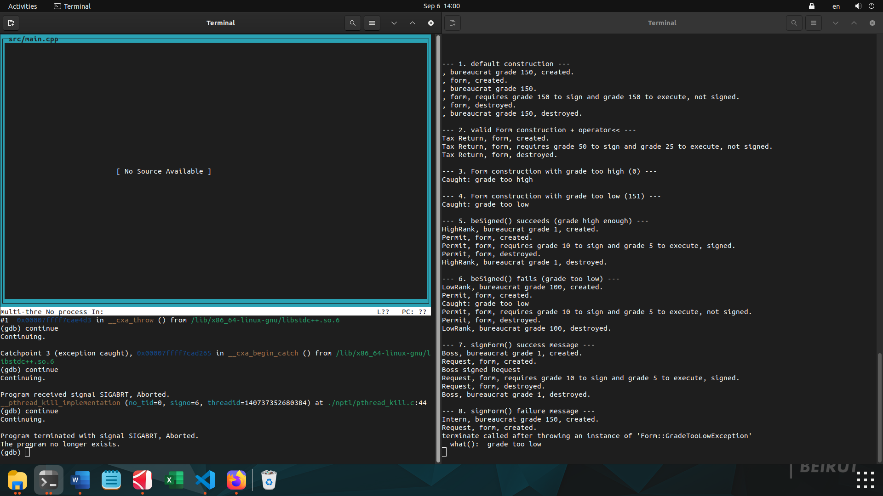
Third Case:

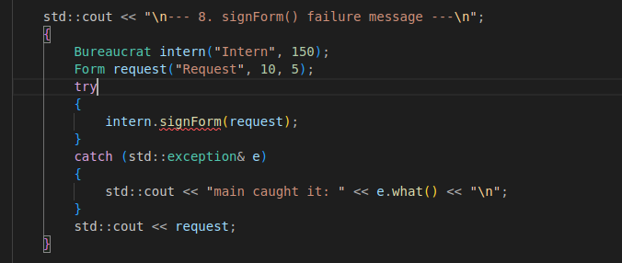

1. cd into ex01/ if you're not already there.
2. c++ -Wall -Wextra -Werror -std=c++98 -g -O0 -I include -o bureaucrat_dbg src/main.cpp src/Bureaucrat.cpp src/Form.cpp
3. gdb ./bureaucrat_dbg
4. tty /dev/pts/2 (your Terminal A path)
5. layout src
6. break main.cpp:78
7. run → output in Terminal A, Terminal B stops at line 78
8. catch throw
9. catch catch
10. continue → stops at the throw (same as last time)
11. bt → still the same 4 frames as before — nothing different yet, since the runtime hasn't started searching for a handler at this exact instant
12. continue → this time watch closely. Predict: does Catchpoint 3 (exception caught) ever print? Or something else entirely?
13. bt → look at what function names appear now. Are any of them library functions you haven't seen yet (hint: something with "terminate" or "abort" in the name)?

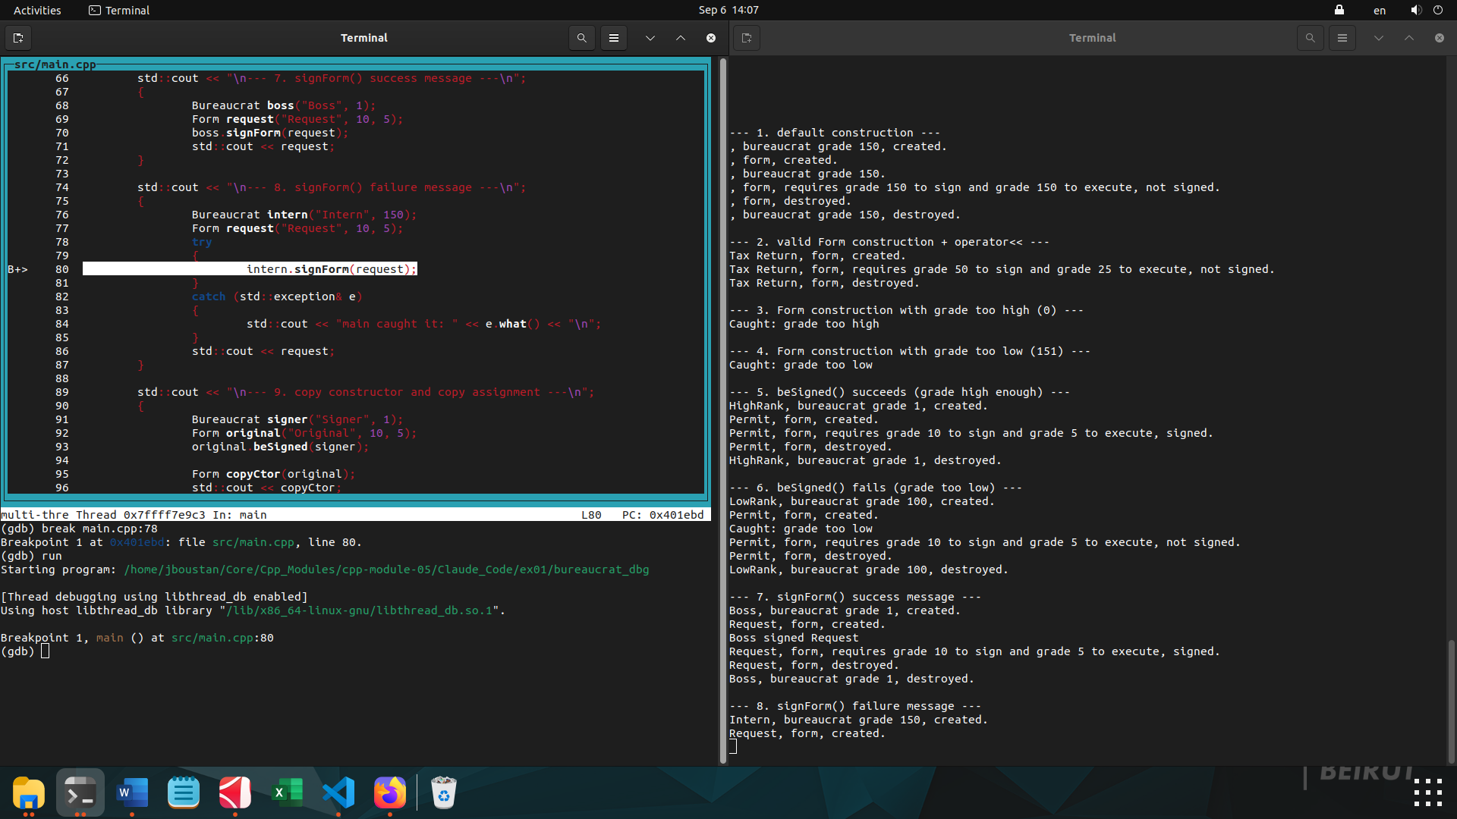
1. cd into ex01/ if you're not already there.
2. c++ -Wall -Wextra -Werror -std=c++98 -g -O0 -I include -o bureaucrat_dbg src/main.cpp src/Bureaucrat.cpp src/Form.cpp
3. In Terminal A: tty → note the path, then cat
4. In Terminal B: gdb ./bureaucrat_dbg
5. tty /dev/pts/2 (your Terminal A path)
6. layout src
7. break Bureaucrat::signForm (use the function name this time, not a line number — since we added lines to main.cpp, the old line 78 no longer points at the same statement)
8. run → stops right as signForm is entered
9. catch throw
10. catch catch
11. continue → stops at the throw
12. bt → same 4 frames as always
13. continue → stops at the catch
14. bt → look at frame #1 this time
15. up → check whose code you land in

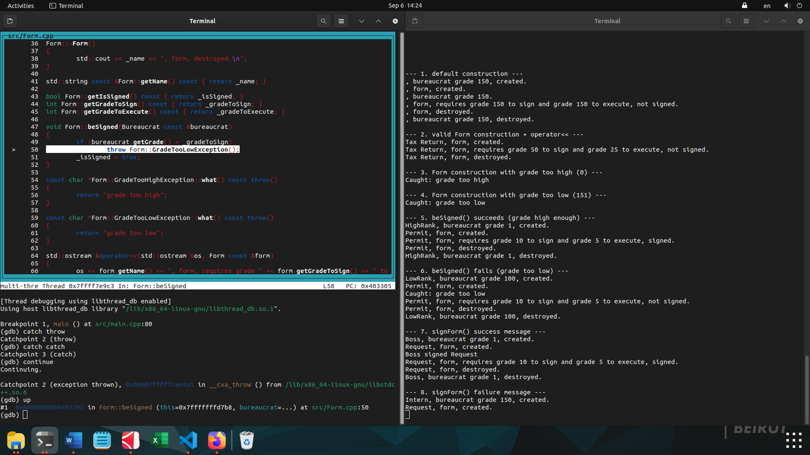

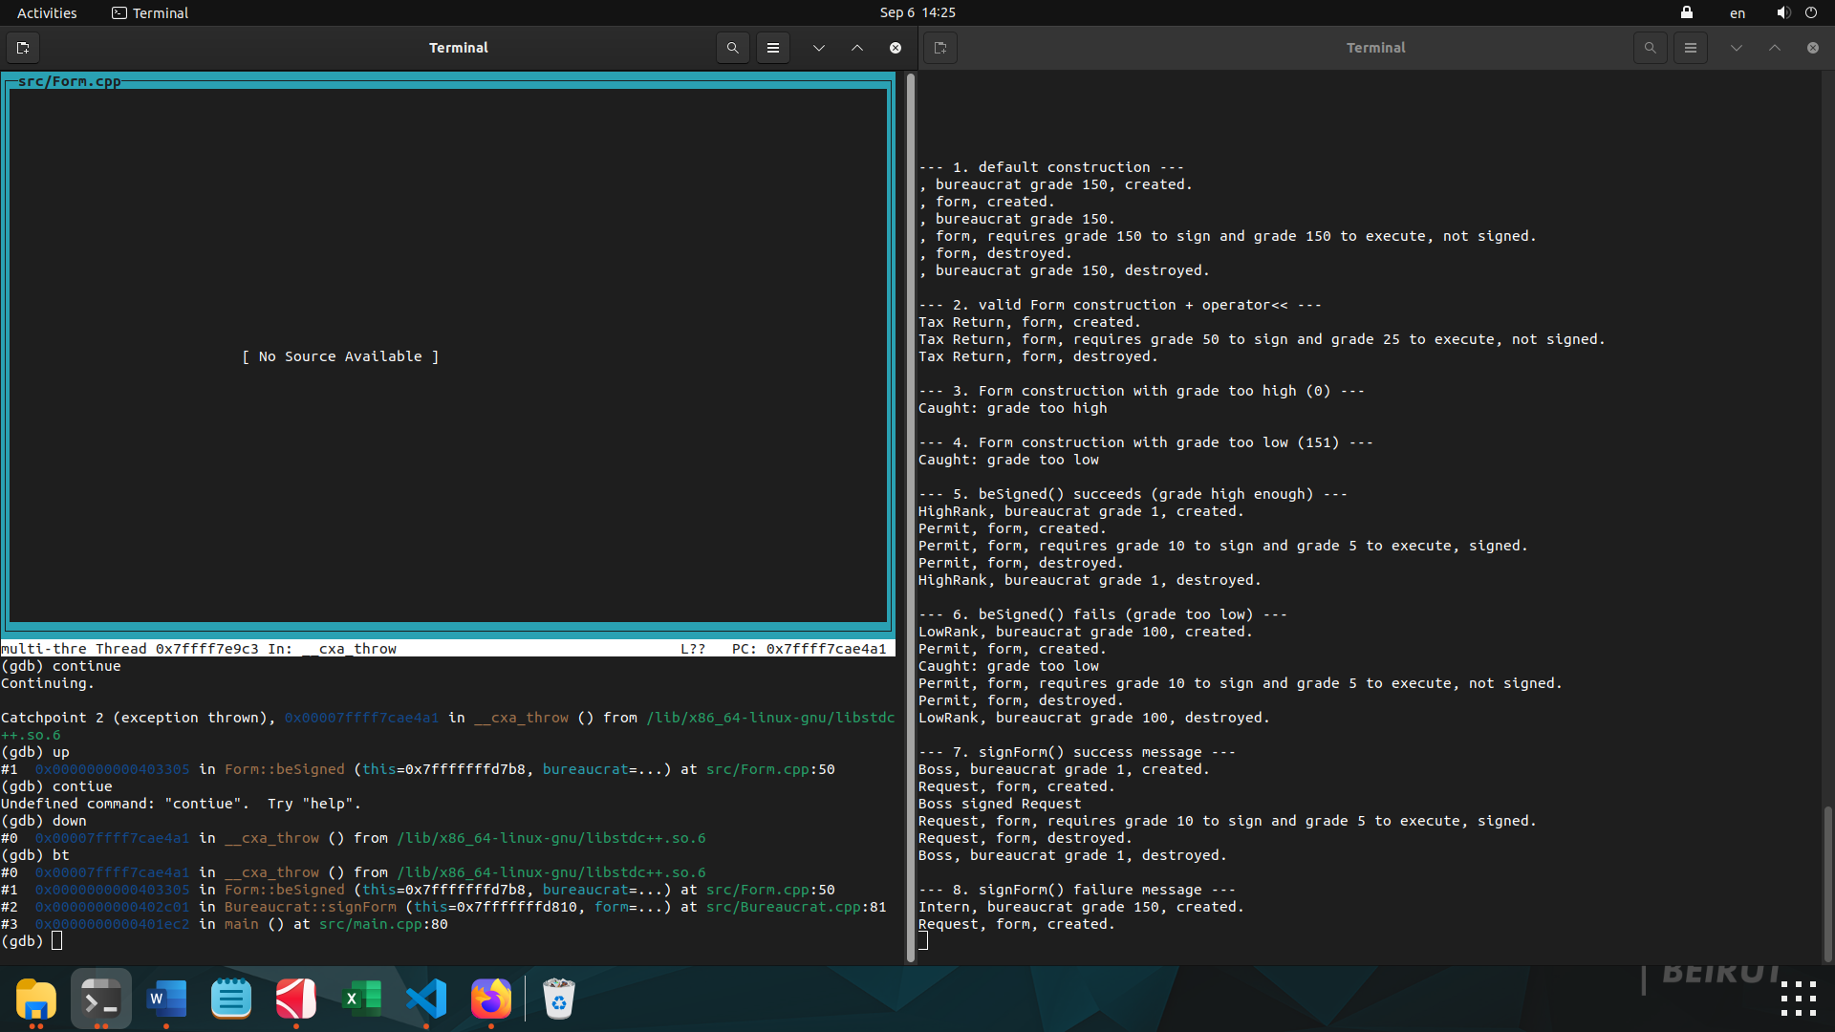

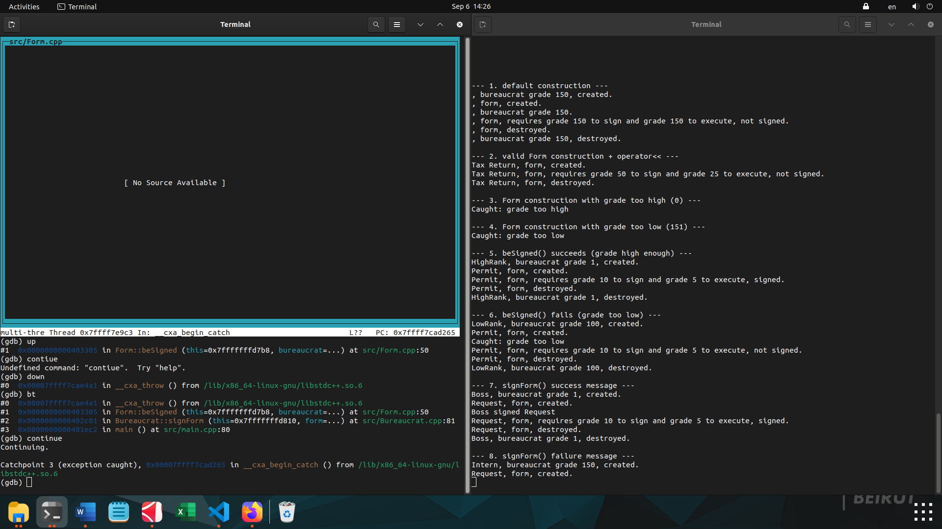
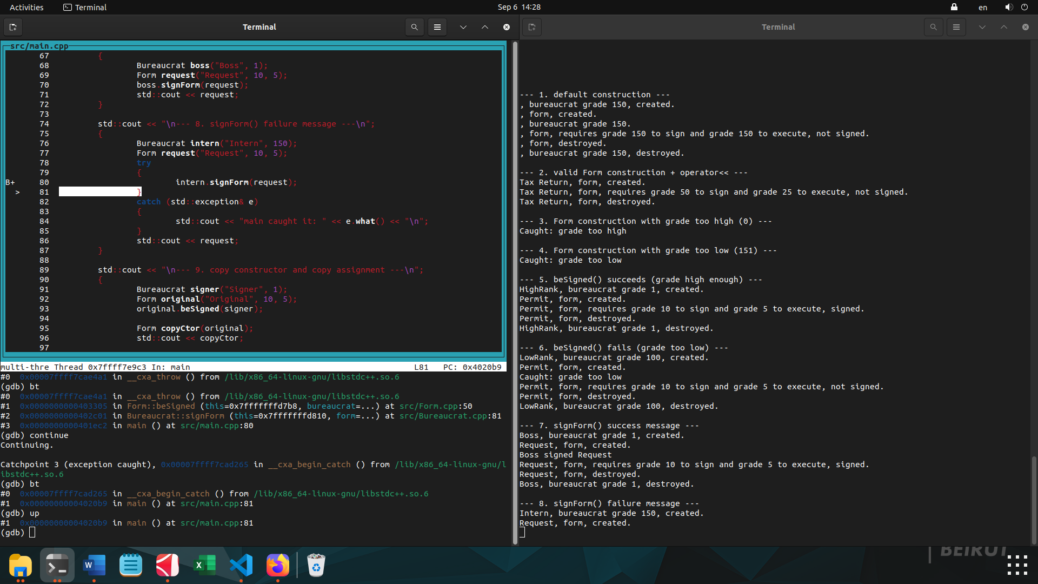

The experiment worked exactly as it should:

- signForm()'s try/catch — still commented out, not helping at all.
- Yet the program didn't crash this time — because main() now has its own try/catch around intern.signForm(request);, and the search for a handler just kept climbing past signForm (which has none) and found main's instead.

That's the core rule of throw/catch, demonstrated concretely: a catch can be anywhere up the call chain — it doesn't have to be in the immediate calling function. The runtime doesn't care who catches it, only that someone, somewhere above the throw, has a matching catch. Last experiment (no catch anywhere) → crash. This experiment (catch moved to main, one level further up) → caught, program continues, no crash.

The only difference between "your real, submitted code" and this experiment is where the try/catch sits — inside signForm() vs inside main(). Both are valid C++, both prevent the crash. The reason the real subject wants it inside signForm() specifically (not main()) goes back to the very first thing we discussed: main() calls signForm() on many different bureaucrats/forms, and doing the catching inside signForm() means that message-printing logic exists once, not duplicated at every call site.

