Question 5: The trained network average 90% accuracy for PenTets and 86% accuracy for CarTest.

PenTest

Max: 0.906232132647

Average: 0.900171526587

Standard Deviation: 0.0056409969054

CarTest

Max: 0.885471204188

Average: 0.862041884817

Standard Deviation: 0.0180343504185

Question 6: Increasing the size of the hidden layer gives diminishing marginal returns that are evident at even five perceptrons.

The average accuracy is 70% for CarTest and 0% for PenTest with 0 perceptrons, but by five perceptrons this number rapidly rises

to about 85% for CarTest and 90% for PenTest. The average accuracy does not increase much from here for PenTest. For CarTest,

the accuracy decreases after 5 perceptrons, most likely due to noise from having a large amount of layers. More iterations would fix

this problem.

|  |  |  |  |  |  |  |  |  |  |
| --- | --- | --- | --- | --- | --- | --- | --- | --- | --- |
| Pen Test |  |  |  |  |  |  |  |  |  |
| Max | 0 | 0.849342 | 0.89251 | 0.941395 | 0.909663 | 0.907376 | 0.907376 | 0.909377 | 0.904231 |
| Average | 0 | 0.840137 | 0.884277 | 0.90972 | 0.903373 | 0.902401 | 0.899714 | 0.898628 | 0.898342 |
| StdDev | 0 | 0.008036 | 0.006615 | 0.015904 | 0.009369 | 0.007408 | 0.006637 | 0.008271 | 0.006128 |
| Perceptrons | 0 | 5 | 10 | 15 | 20 | 25 | 30 | 35 | 40 |
|  |  |  |  |  |  |  |  |  |  |
| Car Test |  |  |  |  |  |  |  |  |  |
| Max | 0.697644 | 0.867801 | 0.867147 | 0.856021 | 0.862565 | 0.853403 | 0.852094 | 0.853403 | 0.846204 |
| Average | 0.697644 | 0.857461 | 0.851702 | 0.85144 | 0.83966 | 0.842408 | 0.843455 | 0.844895 | 0.837827 |
| StdDev | 0 | 0.009728 | 0.010152 | 0.003702 | 0.011838 | 0.006537 | 0.005482 | 0.006801 | 0.008745 |
| Perceptrons | 0 | 5 | 10 | 15 | 20 | 25 | 30 | 35 | 40 |

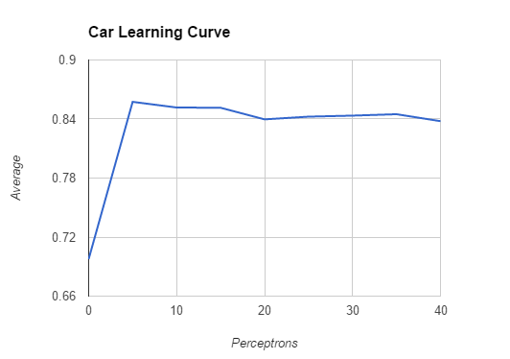

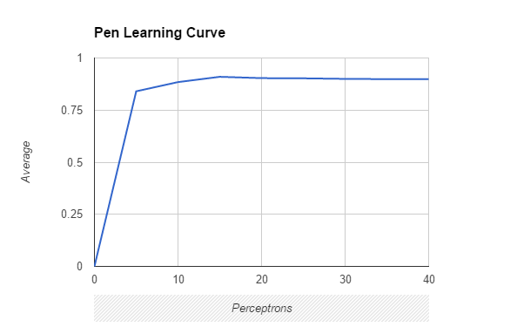

|  |  |  |  |  |  |  |  |  |  |  |  |  |  |  |  |
| --- | --- | --- | --- | --- | --- | --- | --- | --- | --- | --- | --- | --- | --- | --- | --- |
| XorTest | No Hidden Layer: 0.5 accuracy |  |  |  |  |  |  |  |  |  |  |  |  |  |  |
| Max | 0.75 | 0.75 | 0.75 | 0.75 | 1 | 0.75 | 0.75 | 1 | 1 | 0.75 | 1 | 0.75 | 1 | 1 | 1 |
| Average | 0.55 | 0.55 | 0.6 | 0.6 | 0.7 | 0.6 | 0.65 | 0.65 | 0.75 | 0.6 | 0.85 | 0.65 | 0.85 | 0.95 | 0.9 |
| StdDev | 0.1 | 0.1 | 0.1224744871 | 0.1224744871 | 0.1870828693 | 0.1224744871 | 0.1224744871 | 0.2 | 0.158113883 | 0.1224744871 | 0.2 | 0.1224744871 | 0.2 | 0.1 | 0.1224744871 |
| Perceptrons | 1 | 2 | 3 | 4 | 5 | 6 | 7 | 8 | 9 | 10 | 11 | 12 | 13 | 14 | 15 |
|  |  |  |  |  |  |  |  |  |  |  |  |  |  |  |  |
| Max | 1 | 1 | 1 | 1 | 1 | 1 | 1 | 1 | 1 | 1 | 1 | 1 | 1 | 1 | 1 |
| Average | 0.85 | 0.8 | 0.95 | 1 | 0.95 | 0.95 | 1 | 0.95 | 1 | 0.9 | 0.95 | 1 | 1 | 1 | 1 |
| StdDev | 0.2 | 0.1870828693 | 0.1 | 0 | 0.1 | 0.1 | 0 | 0.1 | 0 | 0.1224744871 | 0.1 | 0 | 0 | 0 | 0 |
| Perceptrons | 16 | 17 | 18 | 19 | 20 | 21 | 22 | 23 | 24 | 25 | 26 | 27 | 28 | 29 | 30 |

Question 7: I trained the neural network using 1,000 iterations. The Xor Test had 50% accuracy with no hidden layer.

Training the neural network with more perceptrons yielded a mostly increasing average accuracy. Getting a neural network

with no error was achieved steadily using at least 27 perceptrons. Here, the average remained 100% accuracy and the

standard deviation was 0, meaning each of the five tests yielded 100% accuracy. With 10,000 iterations the no hidden layer

accuracy was also 50%. With 1 perceptron, the average accuracy was 65%, with 2 it was 90%, and with 3 it was 100% accurate.

With each subsequent increase in perceptrons the average accuracy remained 100% and the standard deviation remained 0.

As expected, more iterations allow the neural network to train with more accuracy using less perceptrons.