Assignment 5
Due date: 6 December 2023
TA: 鄒冠勳 E814

- (30%) Consider a mixture of two Gaussian distributions

compute the marginal distributions of each dimension.
- (30%) Consider the following example. Compute the conditional distributions and .
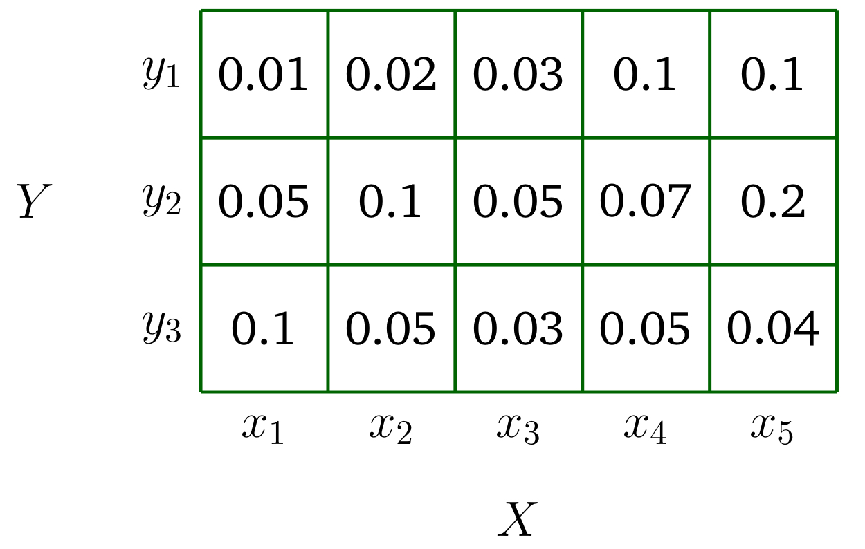

- (40%) Exercise in the slides.
