Assignment 2
Due date: 23 October 2024
TA: 薛凱駿, 楊承霖, 吳奇軒 (ECG 706)

- (30%) Write C functions read_matrix, print_matrix and search that read triples (i.e., (row, col, value)) into a new sparse matrix, print_out the matrix and search for a value in a sparse matrix. Refer to the following sample driving main() function:
#define MAX_TERMS 101
int main {
term mat[MAX_TERMS];
read_matrix(mat); // read the input into the matrix
print_matrix(mat); // print out the matrix
search(mat, 2); // return 1 if found and 0 otherwise
search(mat, -2); // return 1 if found and 0 otherwise
return 0;
}
Sample Input:
2 3 4
0 0 1
0 1 3
1 1 -1
1 2 2
Sample Output:
1 3 0
0 -1 2
1
-1

- (30%) Rewrite fast_transpose so that it uses ONLY ONE array rather than the two arrays required to hold row_terms and starting_pos.
Note: You can only submit the C function (or pseudo-code).
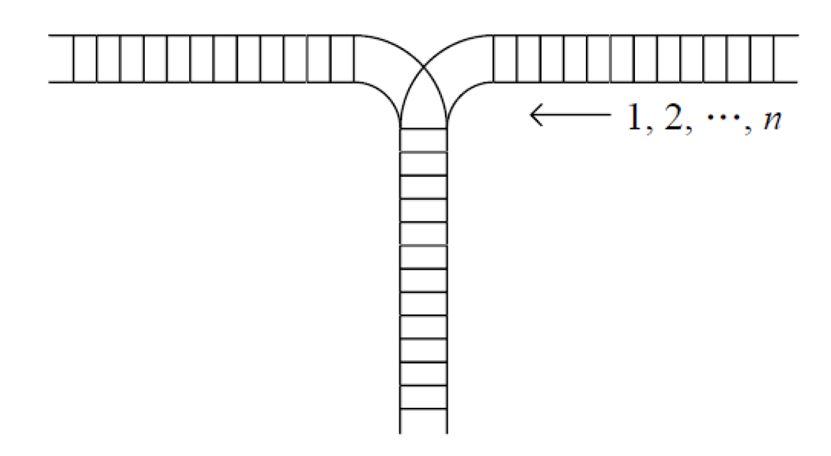
- (40%) Consider the railroad switching network (Figure below). Railroad cars numbered 0, 1, …, are the right. Each car is brought into the stack and removed at any time. For instance, if , we could move in 0, move in 1, move in 2, and then take the cars out, producing the new order 2, 1, 0. For , find out the IMPOSSIBLE permutations of the cars. Submit your answers as well as either your explanations or the C code.
(Hint: Implement the stack and consider all sequences of n pushes and n pops.)

