Assignment 2
Due date: 23 March 2021

- Solve the system with variables 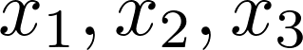:
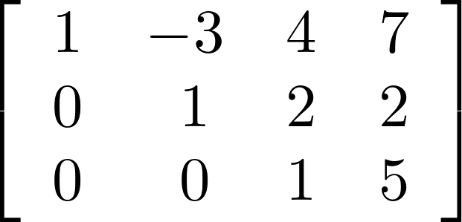
- Solve the system with variables 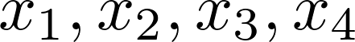:
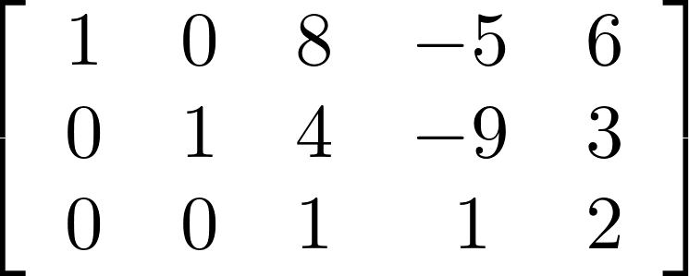
- Solve the system with variables :
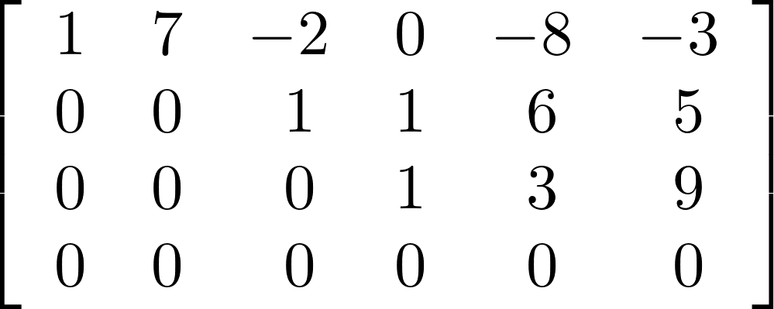
- Solve the system by Gaussian elimination.
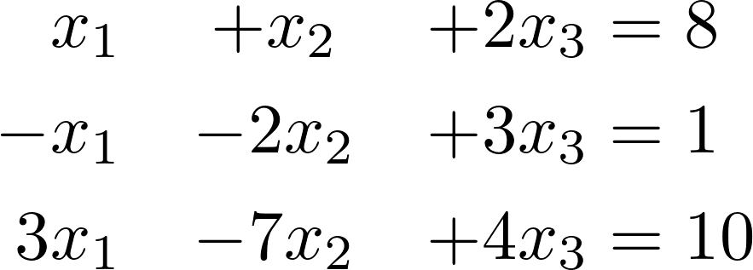
- Solve the system by Gaussian elimination.
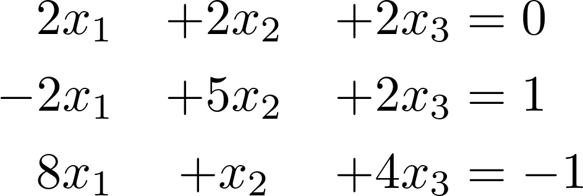
- Solve the system by Gaussian elimination.
