Assignment 3
Due date: 8 April 2021
TA: 林宏懌 E817 (13:10~14:00)

- If 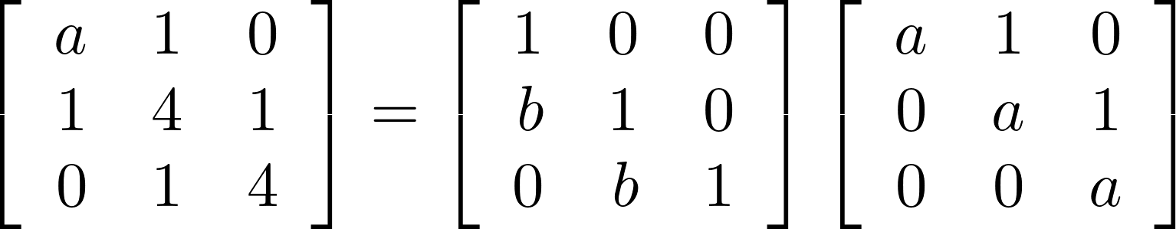 and 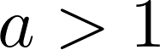, find 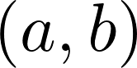.

- Compute 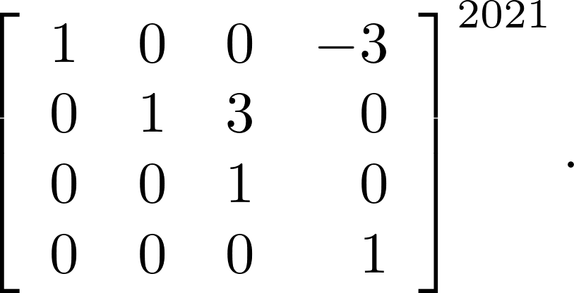
- Suppose that 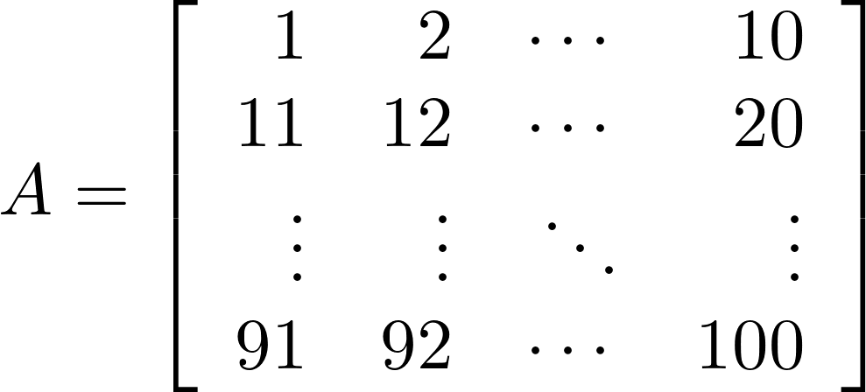. Find 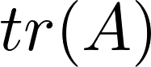.
- Compute 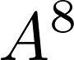 where 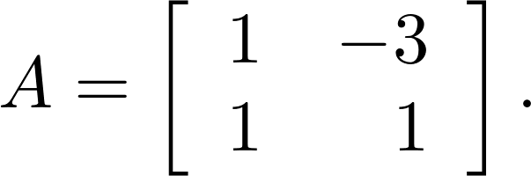
- Compute 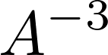 where 

