Assignment 7
Due date: 21 May 2021
TA: 林宏懌 E817 (13:10~14:00)

- Use the adjoint method to find the inverse of A, where
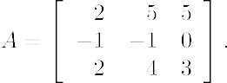

- Use the adjoint method to find the inverse of A, where
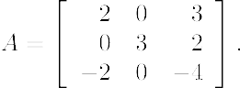
- Solve the following system using Cramer’s rule.
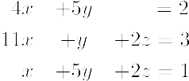
- Solve the following system using Cramer’s rule.
