Assignment 10
Due date: 11 June 2021
TA: 林宏懌 E817 (Online; iClass due to 23:59)

- Determine whether the following polynomials span .
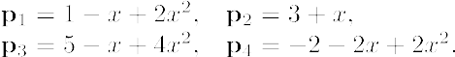

- Let be multiplication by matrix A. Determine whether the vector is in the span of

- Determine whether the following vectors are linearly independent or linearly dependent in
- Determine whether the following vectors are linearly independent or linearly dependent in
- Use the Wronskian to show that are linearly independent vectors in

