Assignment 3
Due date: 18 December 2024
TA: 薛凱駿, 楊承霖, 吳奇軒 (ECG 706)

- (20%) Write out the inorder, preorder, postorder, and level-order travels for the binary trees (a) and (b).
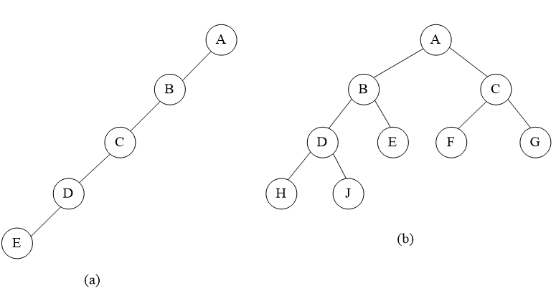

(b)
(a)

- (20%) Transforming the forest into a binary tree using the rule:

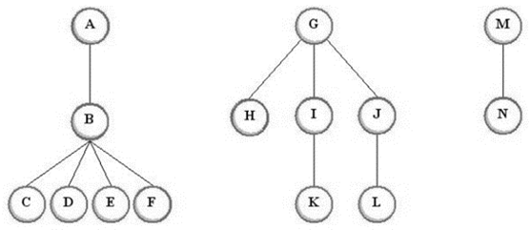

- (20%) Compute the generating function for the number of ways of computing multi-plications of square matrices of the same shape.
Note: You should only give the closed form of the function (e.g., ).
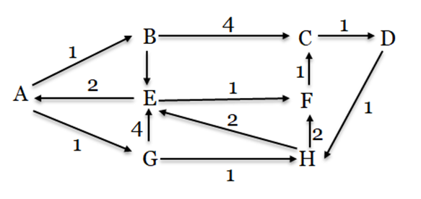
- (20%) A weighted directed graph is given as follows. Filling in the given table using Dijkstra’s algorithm to find shortest path from to all nodes. If more than 1 vertices have the same minimum distance, choose the vertex with alphabet priority.
3
3
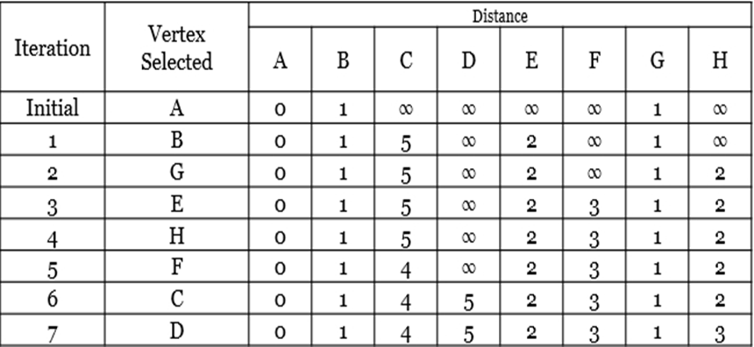

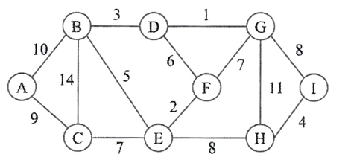
- (20%) Answer the questions with respect to the following graph.
(a) Show the result by the Kruskal's algorithm.
(b) Starting from node , show the result by the Prim's algorithm.
(c) Starting from node , give the sequence by depth-first-search. If you have multiple choi ces, just follow the alphabetical order.
(d) Starting from node , give the sequence by bread-first-search. If you have multiple choices, just follow the alphabetical order.

