Quiz 1
Due date: 27 March 2024
TA: 盧禹丞 E814

- (25%) Solve the system with variables 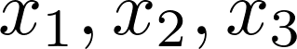:
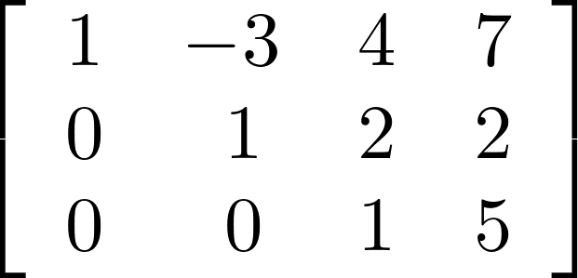.
- (25%) Solve the system with variables 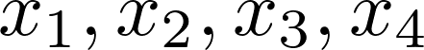:
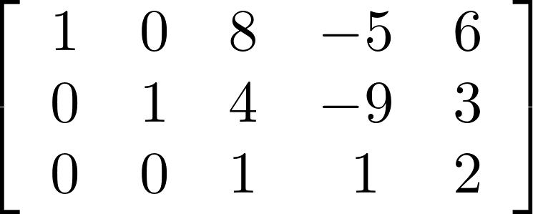.
- (25%) Compute 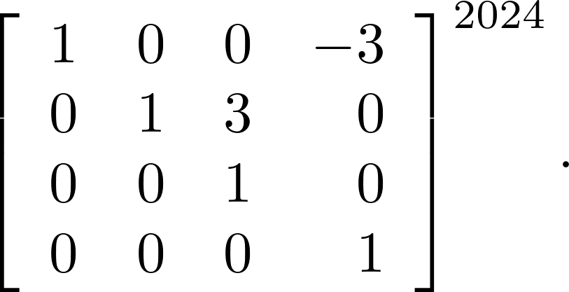
- (25%) Find 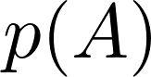 for 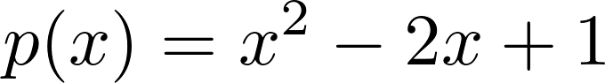 and 