Quiz 2
Due date: 15 May 2024
TA: 盧禹丞 E814

- (25%) Suppose that , , and are vectors such that inner product , and . Moreover, the norms , , . Please compute the value of .

- (25%) Find the adjoint of the matrix 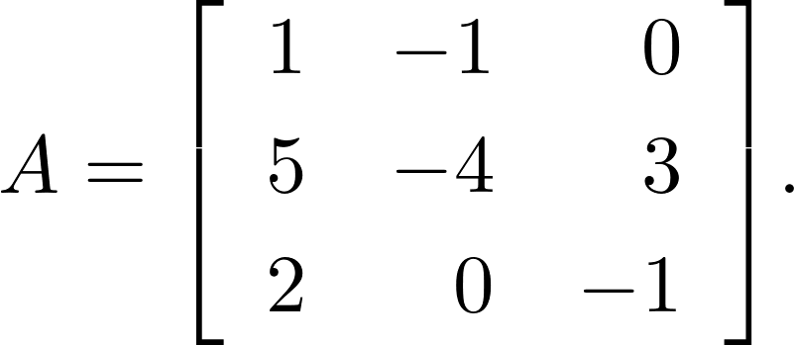
- (25%) Find the , where
- (25%) Show that for any . (Hint: Using Cauchy–Schwarz inequality)

