TUPC/PUPC線上題庫
2024/01/18
TUPC/PUPC 歷屆試題
2016
https://csie.asia.edu.tw/uploads/archive_file_multiple/file/621db5f6063ca2e3cd15de1a/ncTu_2016.pdf
2017
https://csie.asia.edu.tw/uploads/archive_file_multiple/file/621db5f6063ca2e3cd15de19/ncTu_2017.pdf
2018
https://csie.asia.edu.tw/uploads/archive_file_multiple/file/621db5f6063ca2e3cd15de18/ncTu_2018.pdf
2019
https://csie.asia.edu.tw/uploads/archive_file_multiple/file/621db5f6063ca2e3cd15de1d/ncTu_2019.pdf
2020
https://csie.asia.edu.tw/uploads/archive_file_multiple/file/621db5f6063ca2e3cd15de1c/ncTu_2020.pdf
2021
https://csie.asia.edu.tw/uploads/archive_file_multiple/file/621db5f6063ca2e3cd15de1b/ncPu_2021.pdf
2022
https://csie.asia.edu.tw/uploads/archive_file_multiple/file/62c4ed99063ca258a4fb4d91/PUPC2022%E7%AB%B6%E8%B3%BD%E9%A1%8C%E7%9B%AE.pdf

2023 (詳解 by 謝育平老師)
https://www.youtube.com/watch?v=yR2qCzy17kA

ICPC/NCPC線上題庫


請至ITSA 教育部智慧創新跨域人才培育聯盟計畫聯合登入平臺 (https://portal.itsa.org.tw/index) 註冊帳號並登入，成功登入後會看到以下入口畫面

選擇程式自學平台 → 線上題庫，便可看到各樣題庫



針對ICPC 題庫，可點選 "各競賽試題" 進入，即可看見 "ICPC 臺灣區 題目專區"，勾選 "同意加入題庫成員"

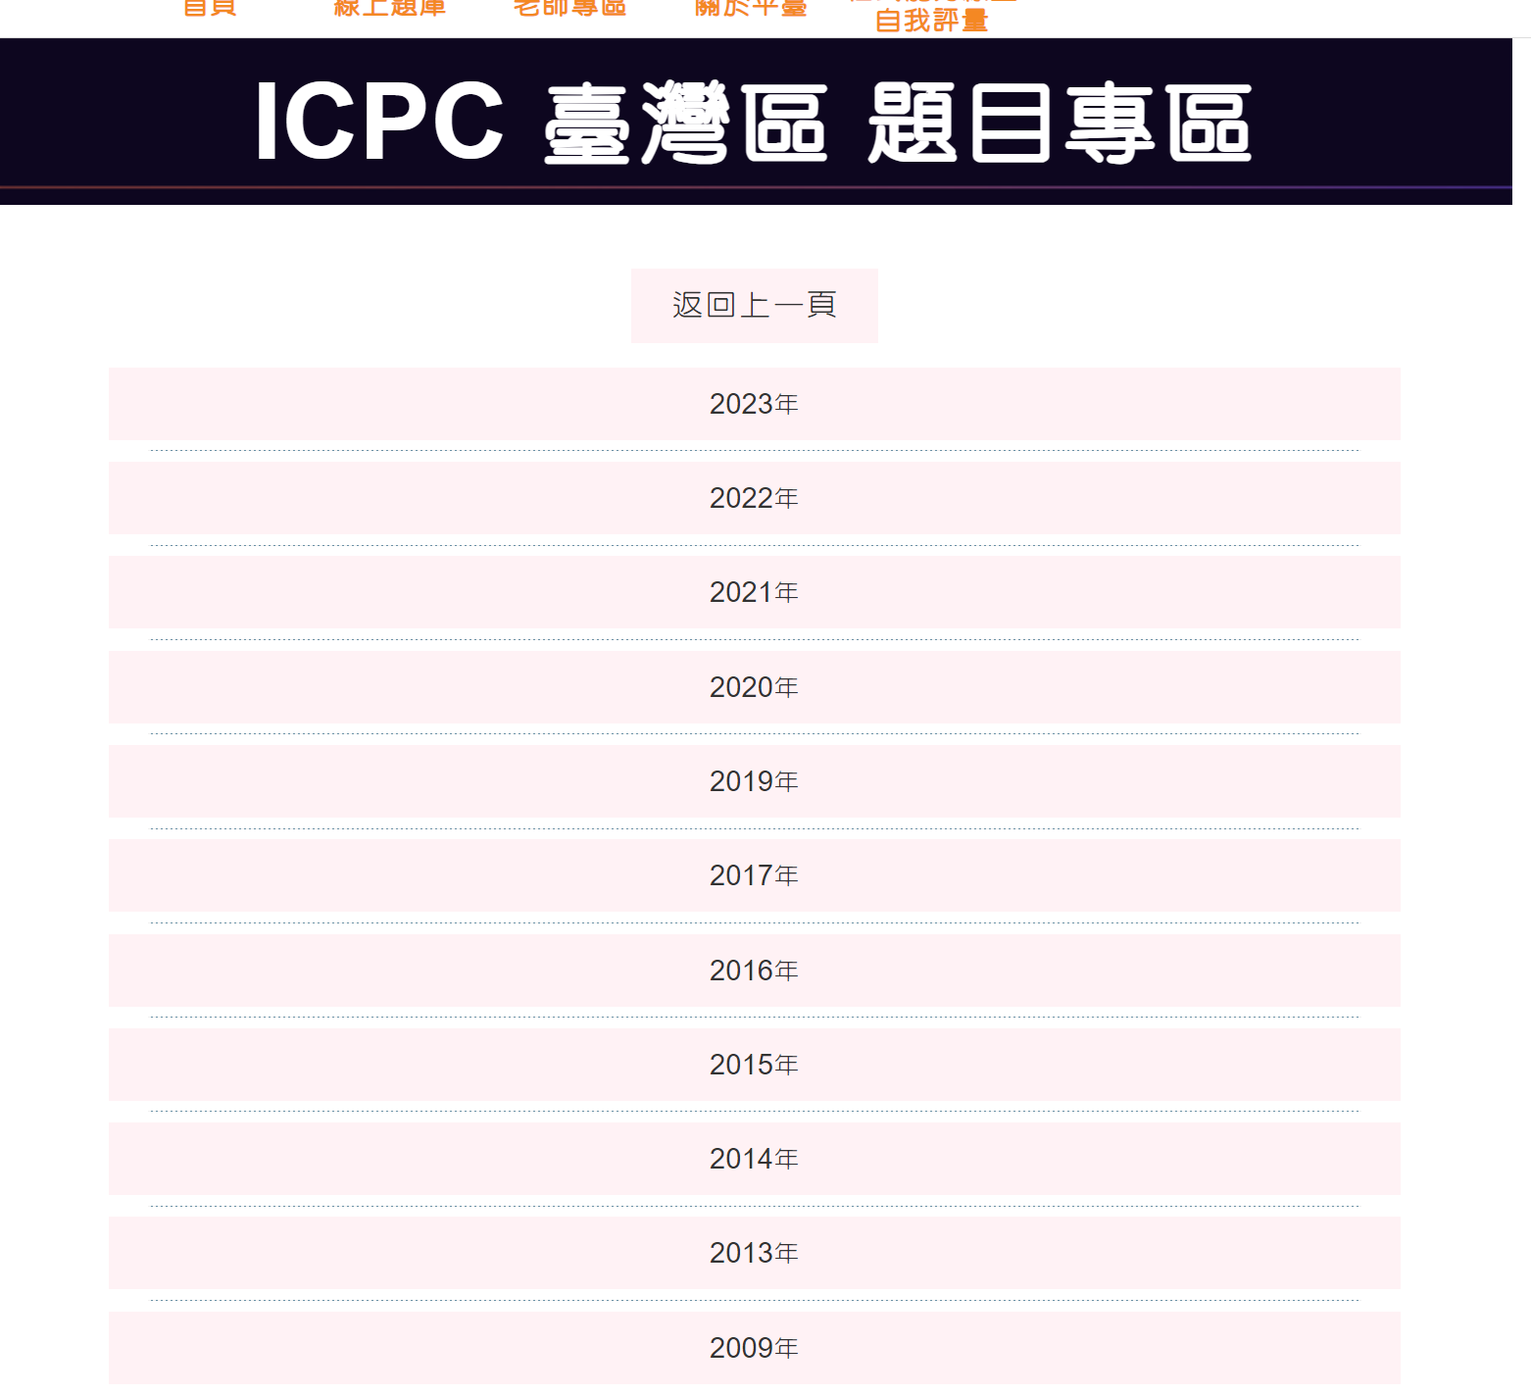

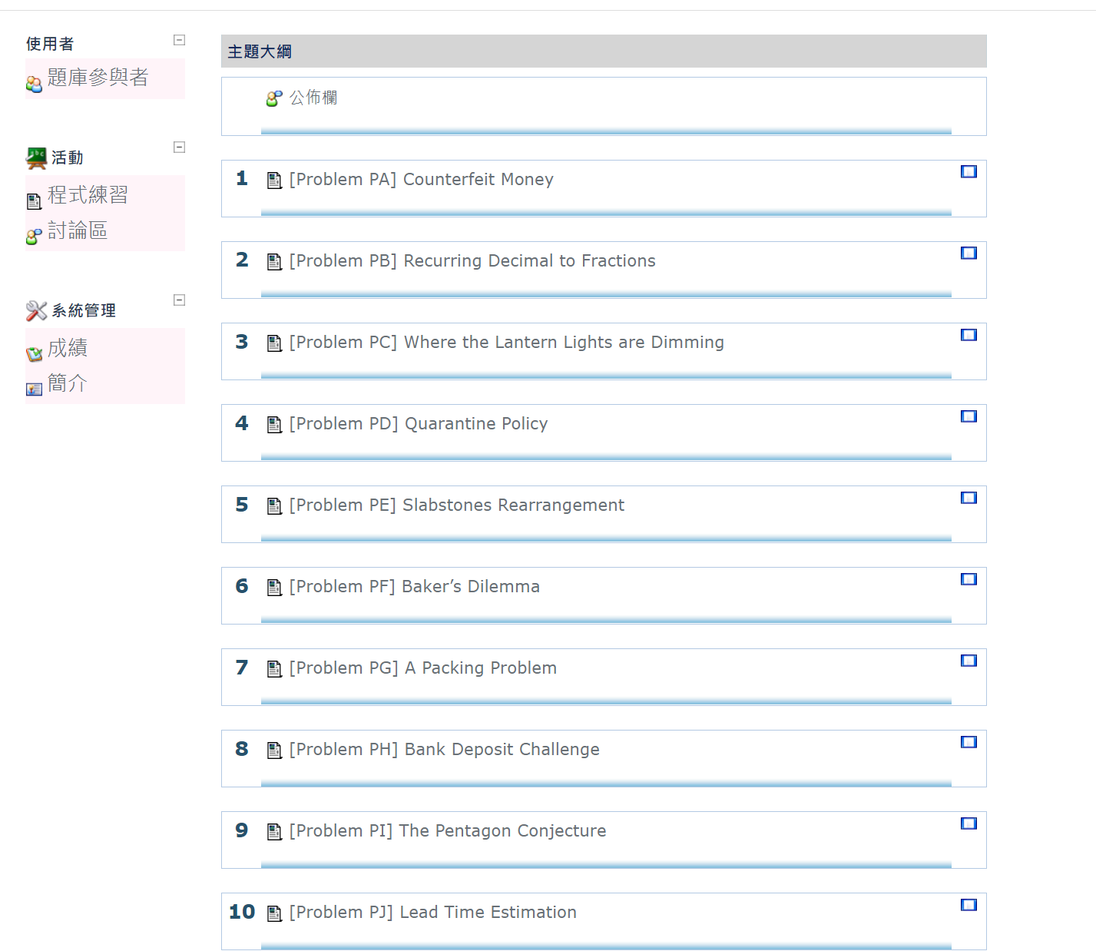

其他題庫與資源

CSES Problem Set (https://cses.fi/problemset/; 感謝張碩齊同學提供)
Problem Set (https://cses.fi/problemset/)
AP325－從 APCS 實作題檢測三級到五級 (https://jmj.cmgsh.tp.edu.tw/files/AP325_v1.3.pdf; by 吳邦一教授)
競賽導論及常用函式 (https://hackmd.io/@MingdaoCP/ryG67cnQK?print-pdf#/)
UVa Online Judge (請見次頁說明; 感謝陳淯鑫同學協助)

UVa Online Judge使用說明

1. UVa Online Judge網址: https://onlinejudge.org/
2. 介面如下:已有帳號者則直接登入，未有帳號則點選“Register” 進行註冊。
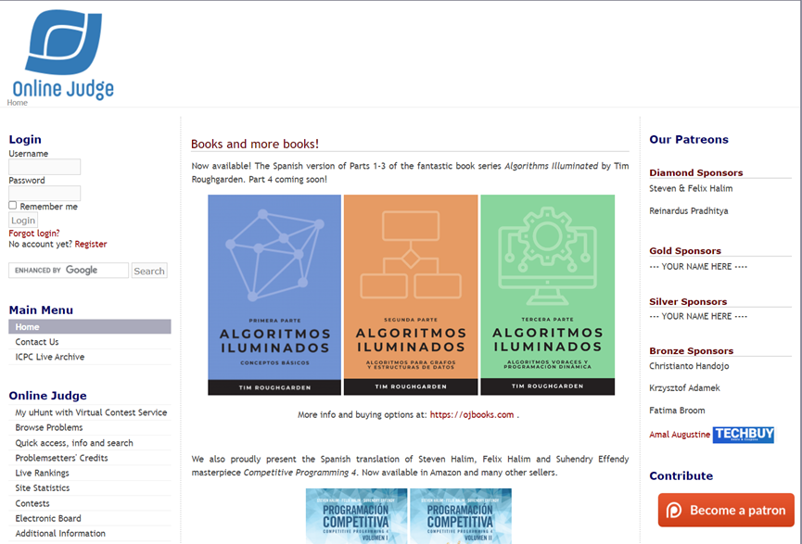

- 接下來填寫相關資訊，Result email勾選:如有排名更動會email通知，若不勾選則不會有排名通知。Virtual Judge可勾選或不勾選。

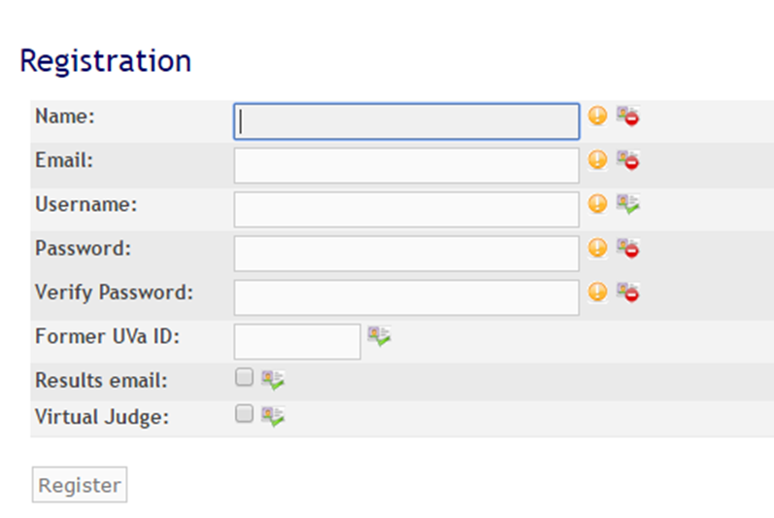

- 接著點選Browse problem即可瀏覽題目，並選擇題目閱覽及點選submit作答。

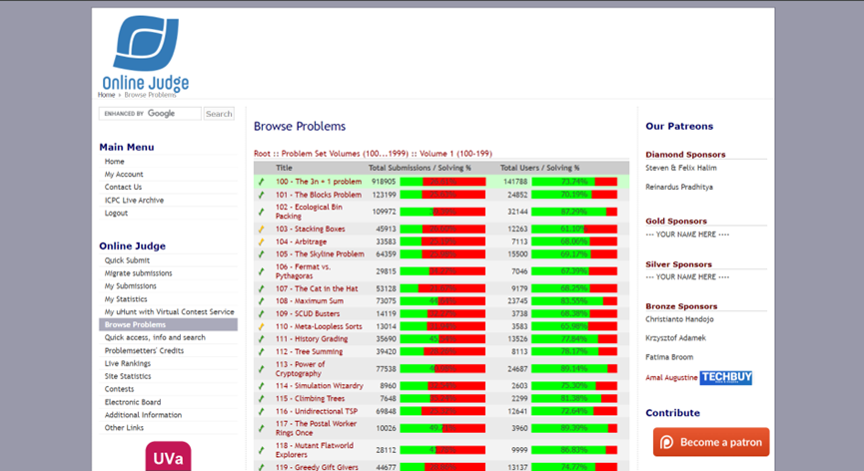

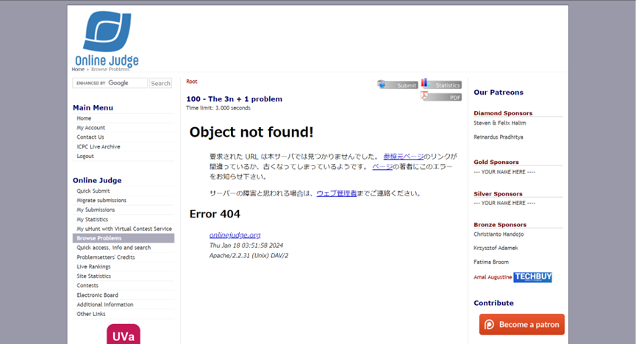

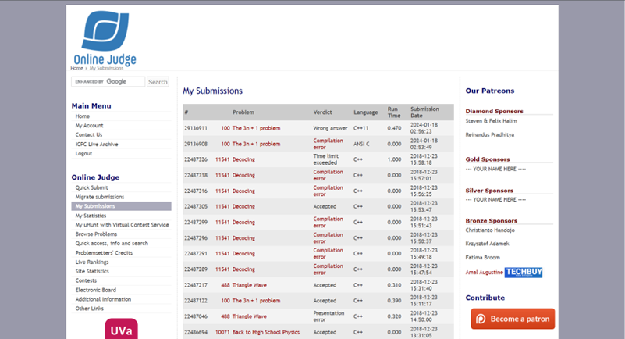

- 部分題目有中文翻譯可參考: http://web.kshs.kh.edu.tw/academy/luckycat/index.htm

- 以下提供部分題目類型分類及難度:

New Comer

★ 100 The 3n+1 problem
★ 10189 Minesweeper
★ 10137 The Trip
★ 706 LCD Display
★ 10267 Graphical Editor
★★ 10033 Interpreter
★ 10196 Check The Check
★ 10142 Australian Voting

Data Structure

★ 10038 Jolly Jumpers
★★ 10315 Poker Hands
★★ 10050 Hartals
★★ 843 Crypt Kicker
★ 10205 Stack 'em Up
★★ 10044 Erdos Numbers
★ 10258 Contest Scoreboard
★★★ 10149 Yahtzee
String

★ 10082 WERTYU
★★ 10010 Where's Waldorf?
★ 10252 Common Permutation
★★ 850 Crypt Kicker II
★ 10188 Automated Judge Script
★★ 10132 File Fragmentation
★★★ 10150 Doublets
★★ 848 Fmt

Sorting

★ 10041 Vito's Family
★★ 120 Stacks of Flapjacks
★★★ 10037 Bridge
★ 10191 Longest Nap
★★ 10026 Shoemaker's Problem
★★ 10138 CDVII
★★ 10152 ShellSort
★ 10194 Football (aka Soccer)

Arithmetic and Algerba

★ 10035 Primary Arithmetic
★ 10018 Reverse and Add
★ 701 The Archeologists' Dilemma
★★ 10127 Ones
★★★ 847 A Multiplication Game
★ 10105 Polynomial Coefficients
★ 10077 The Stern-Brocot Number System
★★★★ 10202 Pairsumonious Numbers

Combinations

★ 10183 How Many Fibs?
★★ 10213 How Many Pieces of Land ?
★★ 10198 Counting
★★ 10157 Expressions
★★ 10247 Complete Tree Labeling
★★ 10254 The Priest Mathematician
★★ 10049 Self-describing Sequence
★★ 846 Steps

Number Theory

★ 10110 Light, More Light
★★ 10006 Carmichael Numbers
★ 10104 Euclid Problem
★★ 10139 Factovisors
★★ 10168 Summation of Four Primes
★ 10042 Smith Numbers
★ 10090 Marbles
★★ 10089 Repackaging

其他 (僅列出分類、題號與題目)
-----------------------------------
Flood Fill
-----------------------------------

352 - The Seasonal War
469 - Wetlands of Florida
572 - Oil Deposits
657 - The die is cast
705 - Slash Mazes
776 - Monkeys in a Regular Forest
782 - Contour Painting
784 - Maze Exploration
785 - Grid Colouring
830 - Shark
852 - Deciding victory in Go
10279 - Mine Sweeper
10336 - Rank the Languages
10592 - Freedom Fighter
10946 - You want what filled?

-----------------------------------
Max Flow / Max Bipartite Matching:
-----------------------------------

259 - Software Allocation
563 - Crimewave
663 - Sorting Slides
670 - The Dog Task
753 - a plug for unix
820 - Internet Bandwidth
10080 - Gopher II
10092 - The Problem with the Problem Setter
10122 - Mysterious Mountain
10249 - the grand dinner (Max Flow too slow for TLE)
10330 - Power Transmission

10380 - Shogi Tournament
10511 - Councilling
10746 - Crime Wave - The Sequel
10779 - Collectors Problem
10804 - Gopher Strategy

-----------------------------------
Games:
-----------------------------------

847 - Multiplication Game
10368 - Euclids Game
10404 - Bachet's Game
10578 - The Game of 31

-----------------------------------
Dynamic Programming:
-----------------------------------

108 - Maximum Sum
111 - History Grading
116 - Unidirectional TSP
147 - Dollars
164 - String Computer
231 - Testing the CATCHER
348 - Optimal Array Multiplication Sequence
357 - Let Me Count The Ways
442 - Matrix Chain Multiplication
481 - What Goes Up
497 - Strategic Defense Initiative
507 - Jill Rides Again
526 - String Distance and Edit Process
531 - Compromise
562 - Dividing Coins
674 - Coin Change
711 - Dividing Up
836 - Largest Submatrix
10003 - Cutting Sticks
10032 - Tug Of War
10051 - Tower of Cubes
10066 - The Twin Towers
10069 - Unidirectional TSP
10081 - Tight Words
10100 - Longest Match
10130 - SuperSale
10131 - Is Bigger Smarter?
10154 - Weights and Measures
10192 - Vacation
10201 - Advantures in Moving Part IV
10259 - Hippity Hopscotch
10261 - Ferry Loading
10280 - Old Wine into New Bottles
10304 - Optimal Binary Search Tree
10379 - Pit Stop Strategy
10400 - Game Show Math
10405 - Longest Common Subsequence
10465 - Homer Simpson
10482 - The Candyman Can
10529 - Dumb Bones
10549 - Russian Dolls
10558 - A Brief Gerrymander
10559 - Blocks
10593 - Kites
10599 - Robots (II)
10604 - Chemical Reaction
10617 - Again Palindrome
10635 - Prince and Princess
10645 - Menu
10664 - Luggage
10690 - Expression Again
10721 - Bar Codes
10723 - Cyborg Genes
10739 - String to Palindrome
10755 - Garbage Heap
10759 - Dice Throwing
10817 - Headmaster's Headache
10819 - Trouble of 13-Dots
10827 - Maximum Sum on a Torus
10860 - Many a Little Makes a Mickel
10874 - Segments
10898 - Combo Deal
10912 - Simple Minded Hashing
10913 - Walking on a Grid

-----------------------------------
Graphs:
-----------------------------------

117 - The Postal Worker Rings Once
125 - Numbering Paths
280 - vertex
709 - Formatting Text (the shortest path)
793 - Network Connections
10239 - The Book-shelver's Problem (the shortest path)
10265 - Toroidal Chess Queens' Problem (tree rounds ???)
10266 - Surveying (connected components)
10054 - euler problem
10178 - count the faces
10608 - Friends
10731 – Test

-----------------------------------
Connectivity:
-----------------------------------

459 - Graph Connectivity
10147 - Highways
10397 - Connect the Campus

-----------------------------------
Big Integer:
-----------------------------------

324 - Factorial Frequencies
424 - Integer Inquiry
495 - Fibonacci Freeze
623 - 500!
713 - Adding Reversed Numbers
10013 - Super long sums
10018 - Reverse and Add
10035 - Primary Arithmetic
10106 - Product
10220 - I Love Big Numbers !
10515 - Powers Et Al.

-----------------------------------
Counting:
-----------------------------------

357 - Let Me Count The Ways
369 - Combinations
10219 - Find the ways !
10338 - Mischievous Children

-----------------------------------
Josephus:
-----------------------------------

151 - Power Crisis
440 - Eeny Meeny Moo

-----------------------------------
Math:
-----------------------------------

106 - Fermat vs. Pythagoras
113 - Power of Cryptography
579 - ClockHands
834 - Continued Fractions
847 - A Multiplication Game
10071 - Back to High School Physics
10079 - Pizza Cutting
10161 - Ant on a Chessboard
10302 - Summation of Polynomials
10408 - Farey sequences

-----------------------------------
Matrix:
-----------------------------------

108 - Maximum Sum
348 - Optimal Array Multiplication Sequence
541 - Error Correction
836 - Largest Submatrix
10189 - Minesweeper

-----------------------------------
Number Conversion:
-----------------------------------

344 - Identifying Concurrent Events
446 - Kibbles `n'' Bits `n'' Bits `n'' Bits
575 - Skew Binary
10469 - To Carry or not to Carry

-----------------------------------
Number Theory:
-----------------------------------

136 - Ugly Numbers
138 - Street Numbers
160 - Factors and Factorials
256 - Quirksome Squares
294 - Divisors
350 - Pseudo-Random Numbers
382 - Perfection
406 - Prime Cuts
408 - Uniform Generator
543 - Goldbach's Conjecture
686 - Goldbach's Conjecture (II)
10200 - Prime Time

-----------------------------------
Simulation:
-----------------------------------

10346 - Peter's Smoke
10409 - Die Game

-----------------------------------
Sorting & Searching:
-----------------------------------

299 - Train Swapping
331 - Mapping the Swaps
499 - What's The Frequency, Kenneth?
10008 - What's Cryptanalysis?
10107 - What is the Median?
10295 - Hay Points
10327 - Flip Sort

-----------------------------------
String:
-----------------------------------

272 - TEX Quotes
401 - Palindromes
444 - Encoder and Decoder
458 - The Decoder
483 - Word Scramble
490 - Rotating Sentences
492 - Pig-Latin
494 - Kindergarten Counting Game
576 - Haiku Review
739 - Lost in Space
10082 - WERTYU
10222 - Decode the Mad man
10260 - Soundex
10293 - Word Length and Frequency
10340 - Peter's Smoke
10361 - Peter's Smoke
10424 - Love Calculator
10508 - Word Morphing

-----------------------------------
Tree:
-----------------------------------

536 - Tree Recovery
10223 - How many nodes ?
10410 - Tree Reconstruction

-----------------------------------
Variable Range:
-----------------------------------

10055 - Hashmat the Brave Warrior

-----------------------------------
Greedy:
-----------------------------------

10020 - Minimal Coverage
10382 - Watering Grass
10440 - Ferry Loading (II)
10563 - Least Squares
10665 – Diatribe

------------------------------------------------------------
Graph Theory:
------------------------------------------------------------

- Topological Sorting:

00200 Rare Order Find the correct ordering of an alphabet
10305 Ordering Tasks Provide some ordering of tasks

- Trees

00112 Tree Summing Navigate through a LISP encoded binary tree
00115 Climbing Trees Figure out the relationships between people
00122 Trees on the level Produce level-order traversals of binary trees
00615 Is It A Tree? Determine whether or not the graph is a tree
10308 Roads in the North Find the longest distance (diameter) of a tree.

- Eulerian Graphs

00117 The Postal Worker... Minimize a cost tour for a postman
(Simplified Chinese Postman problem)

- Cycles

00125 Numbering Paths Count number of paths in a directed graph
00626 Ecosystem Find/Print all cycles of size 3

- Polygon Intersection

00137 Polygons Find the XOR of two polygon areas

- Maximum Flow

00563 Crimewave Solve the escape problem

- Minimum Spanning Trees

10307 Killing Aliens in Bor.. Find least cost way to assimilate all

------------------------------------------------------------
Dynamic Programming:
------------------------------------------------------------

- Memotization

00101 The 3n + 1 Problem Find the size of the longest sequence
00371 Ackermann Functions Find the size of the longest sequence
00547 DDF Output the longest Decimal-Digit Factor

- Longest Asc/Desc Subsequence

00103 Stacking Boxes Find the longest desc. subsequence in n-dims.
00111 History Grading Find marks for a chronologic ordering question

- Longest Common Subsequence

00531 Compromise Find the LCS for two texts

- 1D Minimize/Maximize

00222 Budget Travel Minimize the cost of a road trip

- 2D Minimize/Maximize

00104 Arbitrage Find a successful arbitrage sequence
00108 Maximum Sum Find the sub-rectangle with largest sum
00116 Unidirectional TSP Find the minimal path through a 2D field
00585 Triangles Find the largest triangle in a trianglular field
00590 Always on the run Find the minimum cost for flying city to city
00526 String Distance & Transform... Find the string distance and path
10285 Longest Run on a Snowboard Find the longest snowboarding path in a 2D field
10306 E-coins Find minimum number of 2D coins to get certain sum

- Change Making

00147 Dollars Count # of ways to make change

------------------------------------------------------------
Modelling/Simulation:
------------------------------------------------------------

- Object State Modelling

00102 The Blocks Problem Manipulation of blocks with robot arm

- Planar World Modelling

00114 Simulation Wizardry Simulate a idealized pinball machine
00118 Mutant Flatworld Explorers Simulate robots moving on a plane
00407 Gears on a Board Simulate gears on a plane
00411 Centipede Collisions Simulate centipedes on a plane
00824 Coast Tracker Simulate coastal robots on a plane

- Geometric Structure Modelling

00201 Squares Count the number of squares in a grid
00209 Triangular Vertices Model triangular coordinates

- Record Keeping / Bookkeeping

00119 Greedy Gift Givers Keep track of everyone's net gain/loss
00123 Searching Quickly Keep track of keywords in titles of books
00139 Telephone Tangles Keep track of telephone bill
00145 Gondwanaland Telecom Keep track of telephone bill
00405 Message Routing Keep track of where routing goes
00603 Parking Lot Keep track of cars in a parking lot
00645 File Mapping Print out a file directory

- Josephus Rings

00130 Roman Roulette Find the survivor
00133 The Dole Queue Find the order of selected people
00144 Student Grants Find the order of students getting grants
00151 Power Crisis Find the step such that a certain region survives

- Card Games

00127 "Accordian" Patience Simulate Accordian Patience (Solitaire)
00131 The Psychic Poker Player Determine the best Poker hand
00451 Poker Solitaire Evaluate some Poker hands
00462 Bridge Hand Evaluator Evaluate some Bridge hands and suggest a move
00635 Clock Solitaire Count winning Clock solitaire games

- Board Games

00141 The Spot Game Figure out who wins the Spot game
00633 A Chess Knight Figure out how many moves for a dynamic knight
00647 Chutes and Ladders Figure out who wins a game of Chutes and Ladders
10284 Chessboard in FEN Figure out number of unattacked squares

- Parsing:

00134 Loglan-A logical Language Check to see if sentences are in the grammar
00171 Car Trialling Check to see if sentence is valid instruction
00620 Cellular Structure Identify the type of organism.
00622 Grammar Evaluation Evaluate/Parse a [+,*,(,)] math expression

- Calendar/Time Modelling

00150 Double Time Convert between two calendars
00419 Matching Meetings Find suitable meeting times for department

- Sports Games

00584 Bowling Calculate a bowling game score

- Data Type Modelling

00540 Team Queue Implement a efficient TeamQueue (buddy system)

- Print/Font Formatting

00403 Postscript Implement "fonts" with formatting
00416 LED Test Determine if there is a valid LED countdown
00426 Fifth Bank of Swamp County Output the bank record sorted in 3 columns
00433 Bank (Not Quite O.C.R) Check LED version of bank number

- Text Manipulation

00373 Romulan Spelling Fix some spelling mistakes
00444 Encoder and Decoder Encode/Decode according to certain rules
00464 Sentence/Phrase Generator Generate phrases according to grammar rules
00625 Compression Compress some source code
00628 Passwords Rule replacement
00641 Do the Untwist Untwist an encrypted string

- Assembler Modelling

00448 OOPS! Convert hexcode to assembly code

------------------------------------------------------------
Arithmetic:
------------------------------------------------------------

- Fractions

00202 Repeating Decimals Figure out length of repeat period of fraction
00834 Continued Fractions Convert fraction to a continued fraction

- Pythagorean Triples

00106 Fermat vs. Pythagoras Generating/Counting Pythagorean triples

- Additive/Multiplicative Series

00107 The Cat in the Hat Calculate the number of cats in the hat
00138 Street Numbers Find special house numbers
10302 Summation of Polynomials Find the sum of the first N cubes

- Exponentiation/Logarithms

00113 Power of Cryptography Find integer roots of large numbers
00545 Heads Find 2^-n = x.xxxE-y for large n

- Polynomials

00126 The Errant Physicist Multiply polynomials of x and y
00586 Instant Complexity Calculate the complexity of a program

- Long Division/Multiplication

00128 Software CRC Calculate the CRC value for a string of text(divide)
00550 Multiplcation by Rotation Find shortest factor with rotamult-property
00465 Overflow Determine whether numbers overflow an int

- Combinatorics:

00135 No Rectangles Find a suitable block design
00146 ID Codes Find the next permutation
00153 Permalex Convert between indices and words sorted in lex. order
00580 Critical Mass Count number of binary strings with 3 consecuive 1's
00527 The partition of a cake Count the number of partitions made by cake cutting
10294 Arif in Dhaka Count the number of necklace/bracelets of size N with T colors
10303 How Many Trees? Count the number of binary trees (Catalan numbers)

- Primes/Factorization

00136 Ugly Numbers Find the 1500th ugly number factors(2,3,5)
00583 Prime Factors List the prime factorization of a number efficiently
10311 Goldbach and Euler Determine if a number is sum of 2 primes

- Probability

00542 France '98 Figure out the probability that a team will win
10288 Coupons Figure out probability that you will win

- Number Bases

00619 Numerical Speaking Convert between words and numeric index

- Partitioning

00668 Parliament Find maximum distinct partition product

------------------------------------------------------------
Direct:
------------------------------------------------------------

- Counting:

00102 Ecological Bin Packing Find minimum number of bottles to move
00154 Recycling Find station that minimizes items moving
00278 Chess Count number of non attacking pieces
00413 Up and Down Sequences Count the number of up and down runs
00613 Numbers that Count Find out if numbers are self-inventorying
00637 Booklet Printing Figure out which pages go where in a fold-over booklet
00696 How Many Knights Find max # of knights to place on n*m board
10293 Word Length and Frequency Count length and freq of words
10300 Ecological Premium Count premiums for farmers

- Sorting:

00110 Meta-Loopless Sorts Produce Pascal programs that do sorting
00120 Stacks of Flapjacks Sort a stack of flapjacks using flips
00514 Rails Sort a train using a station
00538 Balancing Bank Accounts Figure out who owes who what
00612 DNA Sorting Sort some DNA based on some trait
00632 Compression (II) Perform a Burrows Wheel Transform

- Recursion

00155 All Squares Count number of squares surrounding a point
00432 Modern Art Generate some modern triangular art

- Palindromes

00401 Palindromes Determine the type of the word

- String manipulation/comparision

00644 Immediate Decodability Determine if the code set is immediately decodable

------------------------------------------------------------
Geometry:
------------------------------------------------------------

- Z-Buffering

00105 The Skyline Problem Construct a skyline vector
00142 Mouse Clicks Determine which windows was clicked

- Convex Hulls

00109 SCUD Busters Determine regions with power after a war
00132 Bumpy Objects Find a stable position for shapes

- Circles

00121 Pipe Fitters Calculate the most pipes that can fit
00149 Forests Determine viewable trees in an infinite forest
10301 Rings and Glue Determine number of intersecting circles

- Points in Polygons

00143 Orchard Trees Determine numbers of points in triangles
00634 Polygon Determine if a point is in a polygon

- Distance

00152 Tree's a Crowd Generate a histogram of tree distances
10310 Dog and Gopher Find out if the golpher can get to hole

- Art Gallery Problem

00588 Video Surveillance Determine if a camera can see all walls

- Spheres/Globes

00535 Globetrotter Find distance between two points on earth

- Polar/Azimuth Coordinates

00404 Radar Scopes Figure out warnings for planes using radar

- Area of polygons

00428 Swamp County Roofs Calculate area of trapezoidal roof tiles

- Pure Geometry

10283 The Kissing Circles Determine areas associated with circles in circles
10286 Trouble with a Pentagon Find the length of largest square in a pentagon
10287 Gifts in a Hexagon Box Fit circles inside a regular hexagonal box

- Center of gravity

10291 Cut the Legs Cut a table so that it balances

- Line intersection

00834 Water Falls Figure out where water will land

----------------------------------------------------------------------
Searching:
----------------------------------------------------------------------

- Constraint Satisfaction

00124 Following Orders Find all consistent orderings
00129 Krypton Factor Find special "hard" sequences

- Brute Force Searching (no pruning)

00140 Bandwidth Check all 8! sequences
00418 Molecules Find the largest molecule that can be made
00565 Pizza Anyone? Satisfy all topping requests if possible
00616 Coconuts, Revisited Find the maximum number of people on island.
00629 Test Find all "non different" sets
00638 Finding Rectangles Find all rectangles in alphabetical order

- Search with pruning

00624 CD Find set of songs which fit best on tape
10309 Turn the Light Off Find min. # of pushes to turn off lights

- Anagrams

00148 Anagram Checker Find possible anagram sentences from dictionary
00630 Anagrams(II) Find possible anagrams for words
00642 Word Amalgamation Find possible anagrams for words

- Word Searches

00581 Word Search Wonder Find words in a grid
00409 Excuses, Excuses! Find key "excuses" in a sentences
00425 Enigmatic Encryption Find the password from a text
00604 The Boggle Game Find matching words in 2 Boggle boards

- Greedy Algorithms

00410 Balance Station Minimize Imbalance for a centrifuge

