Exercise 4
4.1 Consider the function in Fig. 4.1-7(a). Show that its Fourier series is as shown in equation. 4.1-23.
4.2 The function in Fig. 4.1-7(a) may be considered as the function in Fig. 4.1-4 moved 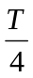 to the left. Let 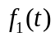 be the Fourier series of the function in Fig. 4.1-4 and 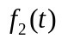 be that of the function in Fig. 4.1-7(a). Show that 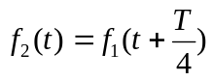.
4.3 Complete the following equations:
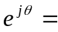
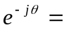
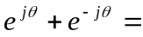
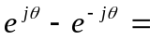
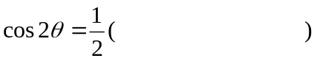
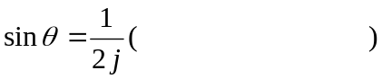
4.4 Consider Example 4.1-3. Obtain its Fourier series in exponential expression by using Equation (4.1-19) and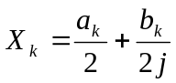. Check your answer with Equation (4.2-19).
4.5 Consider Example 4.1-4. Obtain its Fourier series in exponential expression by using Equation (4.1-20) and. Check your answer with Equation (4.2-23).
4.6 Consider Equation (4.2-15) again. Function  is a real function. Yet in Equation (4.2-15), imaginary terms exist. Besides, negative frequencies also exist. How do you explain?
4.7 Consider the term
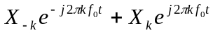
Do you understand that the above term is actually a cosine function?
  - Find the Fourier transform of the following function. Compare the result with Equation (4.3-20). Explain why.
2T
0
x(t)
t
  - Let 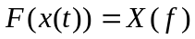. Complete the following:
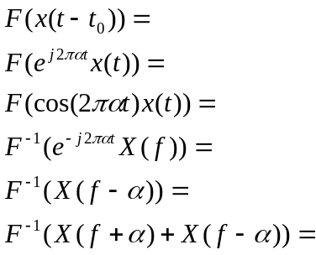
4.10 Give the definition of convolution.
4.11 Let and 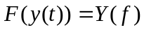. Let 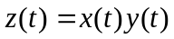. Show how we can find 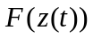 by using the concept of convolution.
  - Consider the following two functions 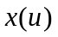 and 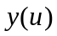.
0
x(u)
t
a₁
-a₁
0
y(u)
t
a₂
-a₂
-a₂-b
a₂+b
Explain why the convolution of andlooks like the following by showing how the convolution is found step by step. Find x₁, x₂, y₁ and y₂.
0
x(u)*y(u)
t
x₁
y₁
-x₂
-y₂
-y₁
-x₁
x₂
y₂
  - Complete the following:
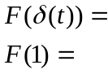
Explain how the above results can be reasoned out by using the result in Example 4.3-1.
  - Complete the following
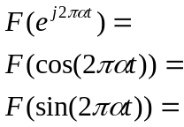
4.15 Let 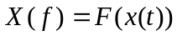 be as shown below. Let 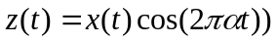. Find by using the convolution theorem of Fourier transform.
4.16 (a) Let 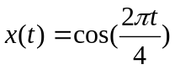. Let 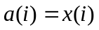 for 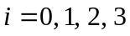 Find 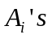 of the discrete Fourier transform for .
(b) Show that the equation of in terms of will recover for .
4.17 Do the same thing as above except now, 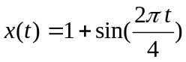
4.18 Do the same as in Exercise 4.8-16 except now, 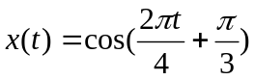.
4.19 Do the same as in Exercise 4.8-16 except now, 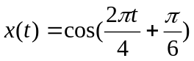.
4.20 Let 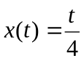 and 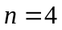. Use discrete Fourier transform to express as a series of cosine functions. Verify the result by substituting 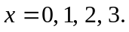
4.21 Do the same as in Exercise 4.19, except 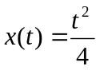.
Exercise 5
  - Use four different methods to explain why amplitude modulation would lift the frequencies of the base band to higher ones.
  - Explain the major concept of demodulation in double side band.
  - Explain why single side band works.
5.4 Let 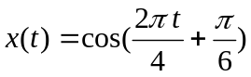. Let 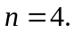 Find its discrete Fourier transform to it. Show that by applying Equation (5.3-12), we will obtain 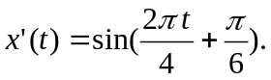
Exercise 6
  - Explain the modulation and demodulation of ASK.
  - Explain the modulation and demodulation of BPSK.
  - Explain the modulation and demodulation of FSK.
  - Explain the modulation and demodulation of QPSK.
  - Explain the modulation and demodulation of OFDM. Explain why OFDM system can be implemented by using the inverse discrete Fourier transform.
6.6 Consider 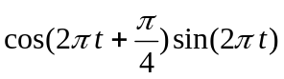. Show that this is negative for most time.

