Assignment 1
Due date: 9 March 2021

- If , then show that is a subspace of  if and only if .
- Prove that 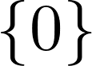 is a subspace of a vector space V.
- Show that 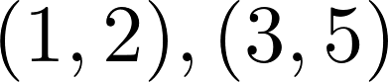 is a basis of .
- Show that
  - is a subspace of .
  - Following a., show that 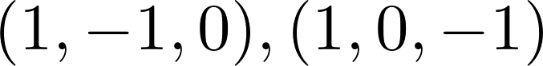 is a basis of V.

