Assignment 4
Due date: 15 April 2021
TA: 林宏懌 E817 (13:10~14:00)

- Find 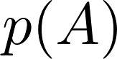 for 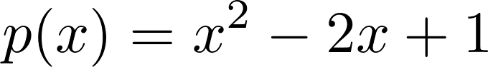 and 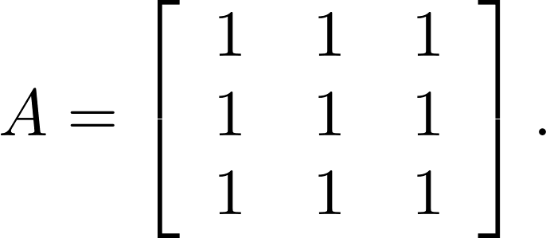
- Find the inverse of 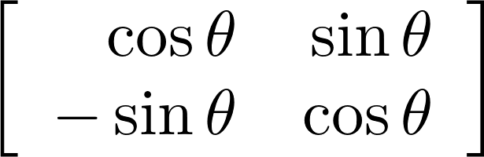.
- Show that if A, B, and A + B are invertible matrices with the same size, then
.
- Show that if A is a square matrix such that 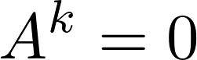 for some positive integer k, then the matrix  is invertible and
.
- Let 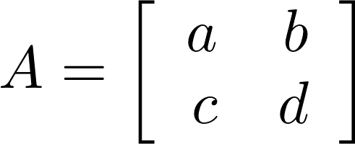. Compute .

