Assignment 5
Due date: 7 May 2021
TA: 林宏懌 E817 (13:10~14:00)

- Let 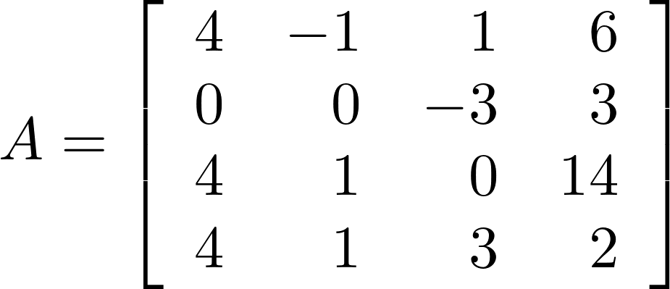. Find 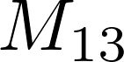, 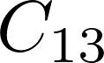, 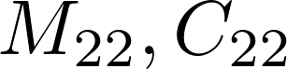.
Note: M: minor; C: cofactor.
- Let 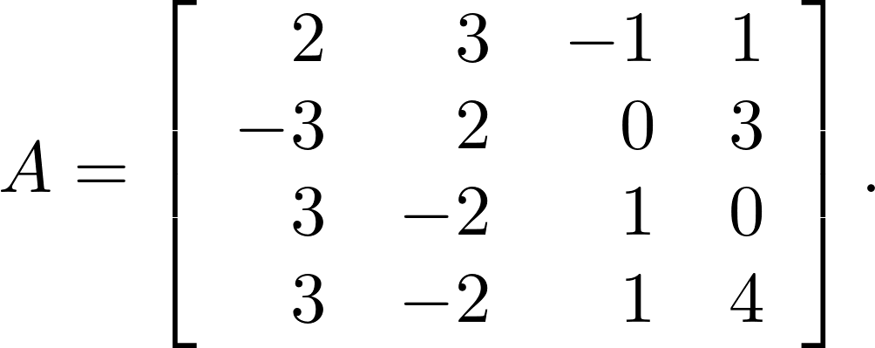 Find 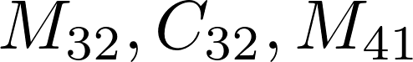 and 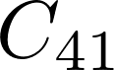.
- Evaluate 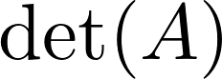, where 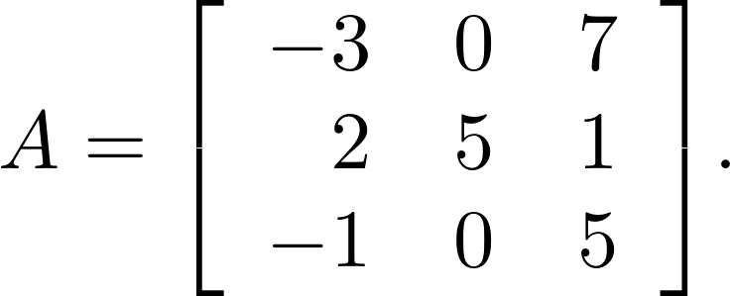
- Evaluate , where 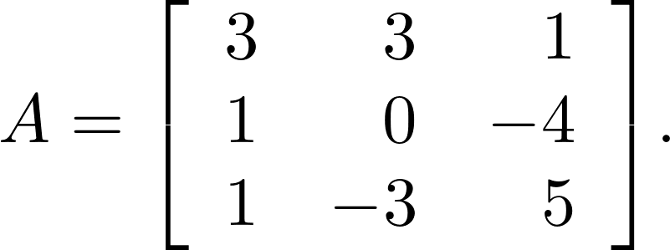
- Evaluate , where 