Assignment 6
Due date: 14 May 2021
TA: 林宏懌 E817 (13:10~14:00)

- Show that
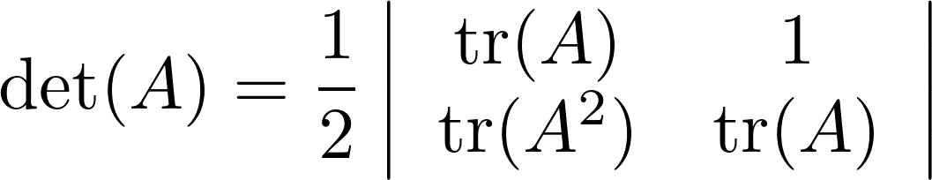
for every matrix A.

- Show that the matrices 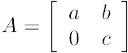 and 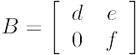 commute if and only if 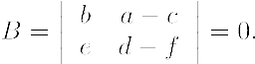
Note: Matrices A and B commute if AB = BA.

