Assignment 8
Due date: 28 May 2021
TA: 林宏懌 E817 (13:10~14:00)

- Find the values of k for which the matrix A is invertible.

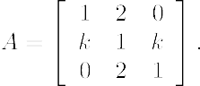

- Prove that a square matrix A is invertible if and only if is invertible.

- Prove that if A is a square matrix, then
- Show that the matrix
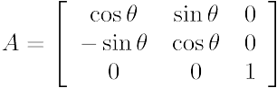
is invertible for all values of . Then, find .

