Assignment 01

1. Prove that 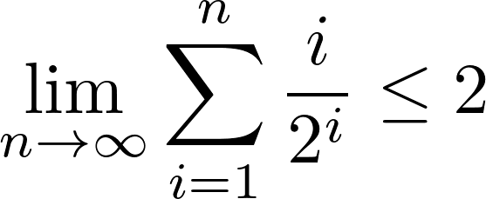.

2. Compute the value of n such that for n people who are selected uniformly at random, at least one pair of them share the same birthday with probability at least 0.9.

