Assignment 02

1. Let X~binomial distribution B(n, p). Show that 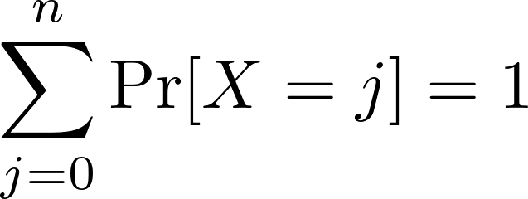.

2. Let X~geometric distribution G(p). Show that 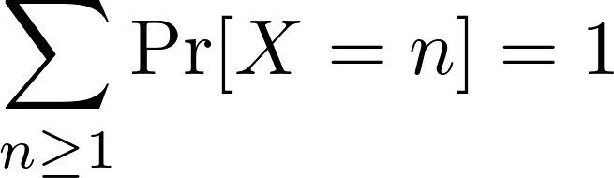.

3. Give a practical example of coupon collector’s problem and provide your analysis.

