Assignment 03

1. Given Taylor series of 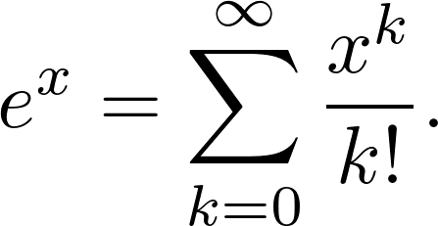 Show that 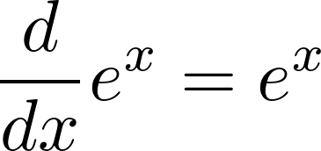.

2. Prove that for even integer 

