Assignment 05

1. We have a standard six-sided die. Let X be the number of times that a ‘6’ occurs over n throws of the die. Let p be the probability of the event 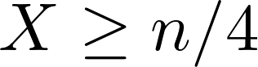. Compare the best upper bounds on p that you can obtain using Markov’s inequality, Chebyshev’s inequality, and Chernoff bounds.

2. Determine the moment generating function for the binomial random variable B(n, p).

