Assignment 06

1. Show that for 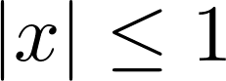, 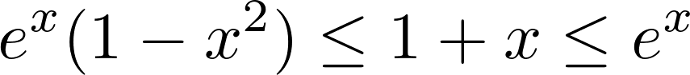.

2. Let 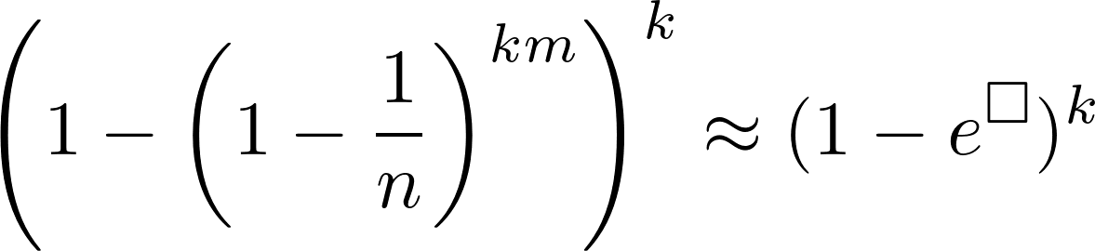. Find  = ?

