Assignment 08

1. Consider the two-state Markov chain with the following transition matrix. Find a simple expression for 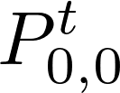. (Hint: diagonalization)

