Assignment 10

1. Consider a Markov chain with state space {0, 1} and a transition matrix

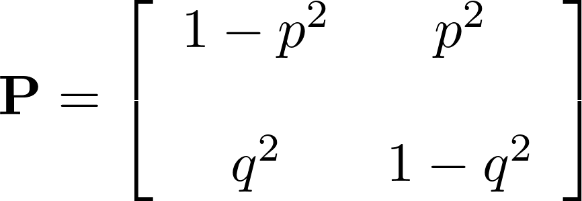

Find the stationary distribution of the Markov chain.

