Time Capsule AI - Technical Specification

# Overview

Time Capsule AI is a feature within the AI365 power suite that allows users to simulate conversations with their past or future selves. It uses historical data, current input, and AI-driven forecasting to generate realistic and insightful dialogues that help users reflect and make informed decisions.

# Step-by-Step Implementation Guide

1. 1. Create a new section in the AI365 dashboard called 'Time Capsule AI'.
2. 2. Add a UI component to choose 'Past Me' or 'Future Me' mode.
3. 3. Let users select a time frame (e.g., 1 year ago, 6 months ahead, etc.).
4. 4. Allow users to choose the context (Product, Team, Revenue, Strategy).
5. 5. Fetch relevant historical data for 'Past Me' or simulate future trends for 'Future Me'.
6. 6. Use AI prompts to generate a conversation based on chosen mode and context.
7. 7. Display the conversation in a chat interface.
8. 8. Provide a summary of insights after the chat ends.
9. 9. Allow exporting or saving the session.

# Technical Flowchart

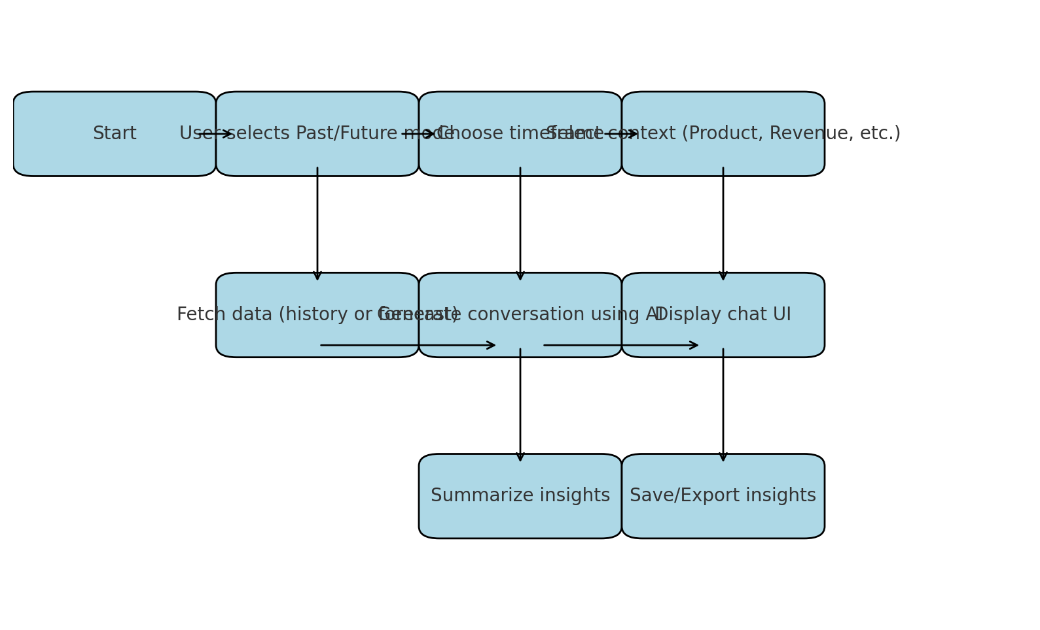

Figure: Time Capsule AI - Technical Flowchart