Links:

Gemini
Kling 3.0
Cleanup.pictures

_________________________________________

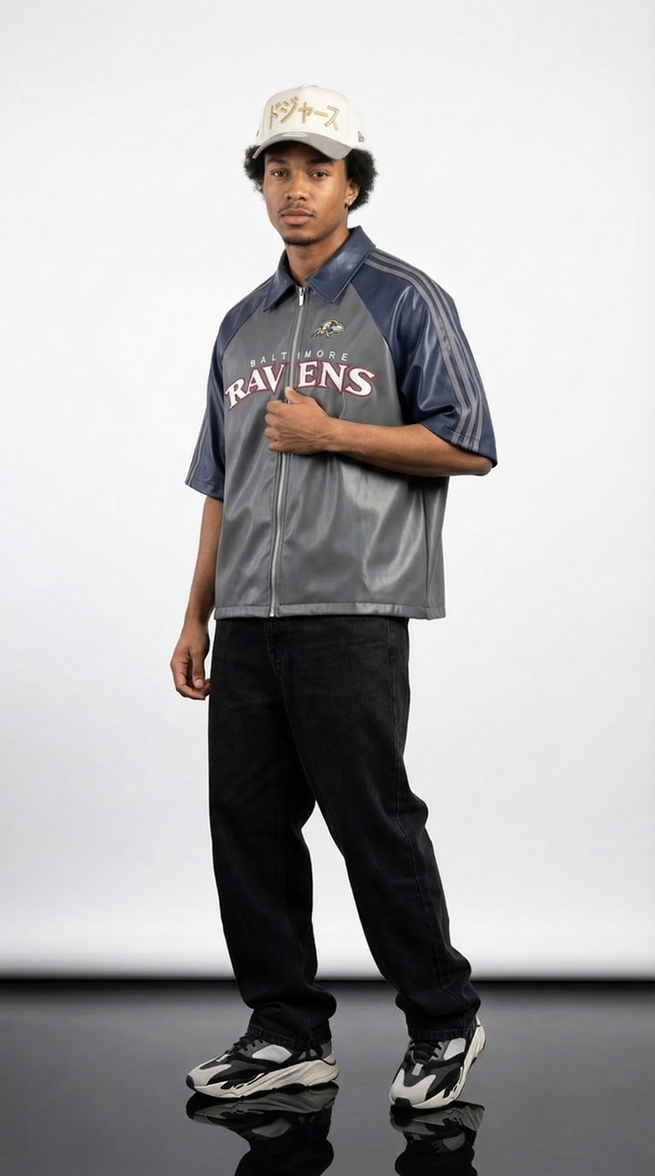

Image prompt:

A stylish light-skin Black male model is wearing a grey and navy Baltimore Ravens zip jacket with short sleeves, loose black baggy jeans, modern sneakers, and a white Japanese-style baseball cap. The outfit has a relaxed streetwear look.

The model stands in a relaxed fashion stance with his body slightly angled rather than facing directly forward. His weight rests mostly on one leg, creating a natural shift in the hips. His legs are slightly apart with one knee subtly bent, giving the pose a casual and confident feel.

One arm rests naturally by his side while the other hand lightly holds the jacket near the zipper area to showcase the logo. His shoulders are relaxed, and his head tilts slightly with a calm, confident expression.

The background is a clean white studio backdrop with a black studio floor. Professional soft studio lighting highlights the fabric and creates subtle shadows.

Portrait fashion photo captured with a high-end DSLR camera, 85mm lens, ultra-realistic, sharp details, fashion editorial quality, 8K resolution.
Aspect ratio 9:16

Video Prompt:
Scene: Minimal studio fashion shoot with a clean light gray background and glossy reflective floor. Soft professional studio lighting.
Subject: A stylish young male model wearing a grey Baltimore Ravens zip-up jersey shirt, loose black jeans, black and white chunky sneakers, and a beige baseball cap. Natural confident facial expression.
Action / Motion:
Shot 1 (0–3s):
Full body shot. The male model stands in a relaxed pose similar to the reference image, one hand lightly touching the chest of the jacket. He looks confidently at the camera like a professional fashion model.
Shot 2 (3–6s):
The model slowly turns his body slightly to the side, showing the side profile of the outfit. The jacket fabric subtly reflects the studio lights.
Shot 3 (6–9s):
He adjusts the front of the jacket zipper area with one hand and slightly nods his head, giving a stylish streetwear model attitude.
Shot 4 (9–12s):
The model takes two slow confident steps forward like a runway walk while the camera slightly pushes in to highlight the outfit details.
Style:
high-fashion streetwear modeling, confident male model attitude, smooth cinematic motion, studio fashion commercial, ultra realistic, sharp focus, detailed clothing texture, soft shadows, 4K cinematic lighting.
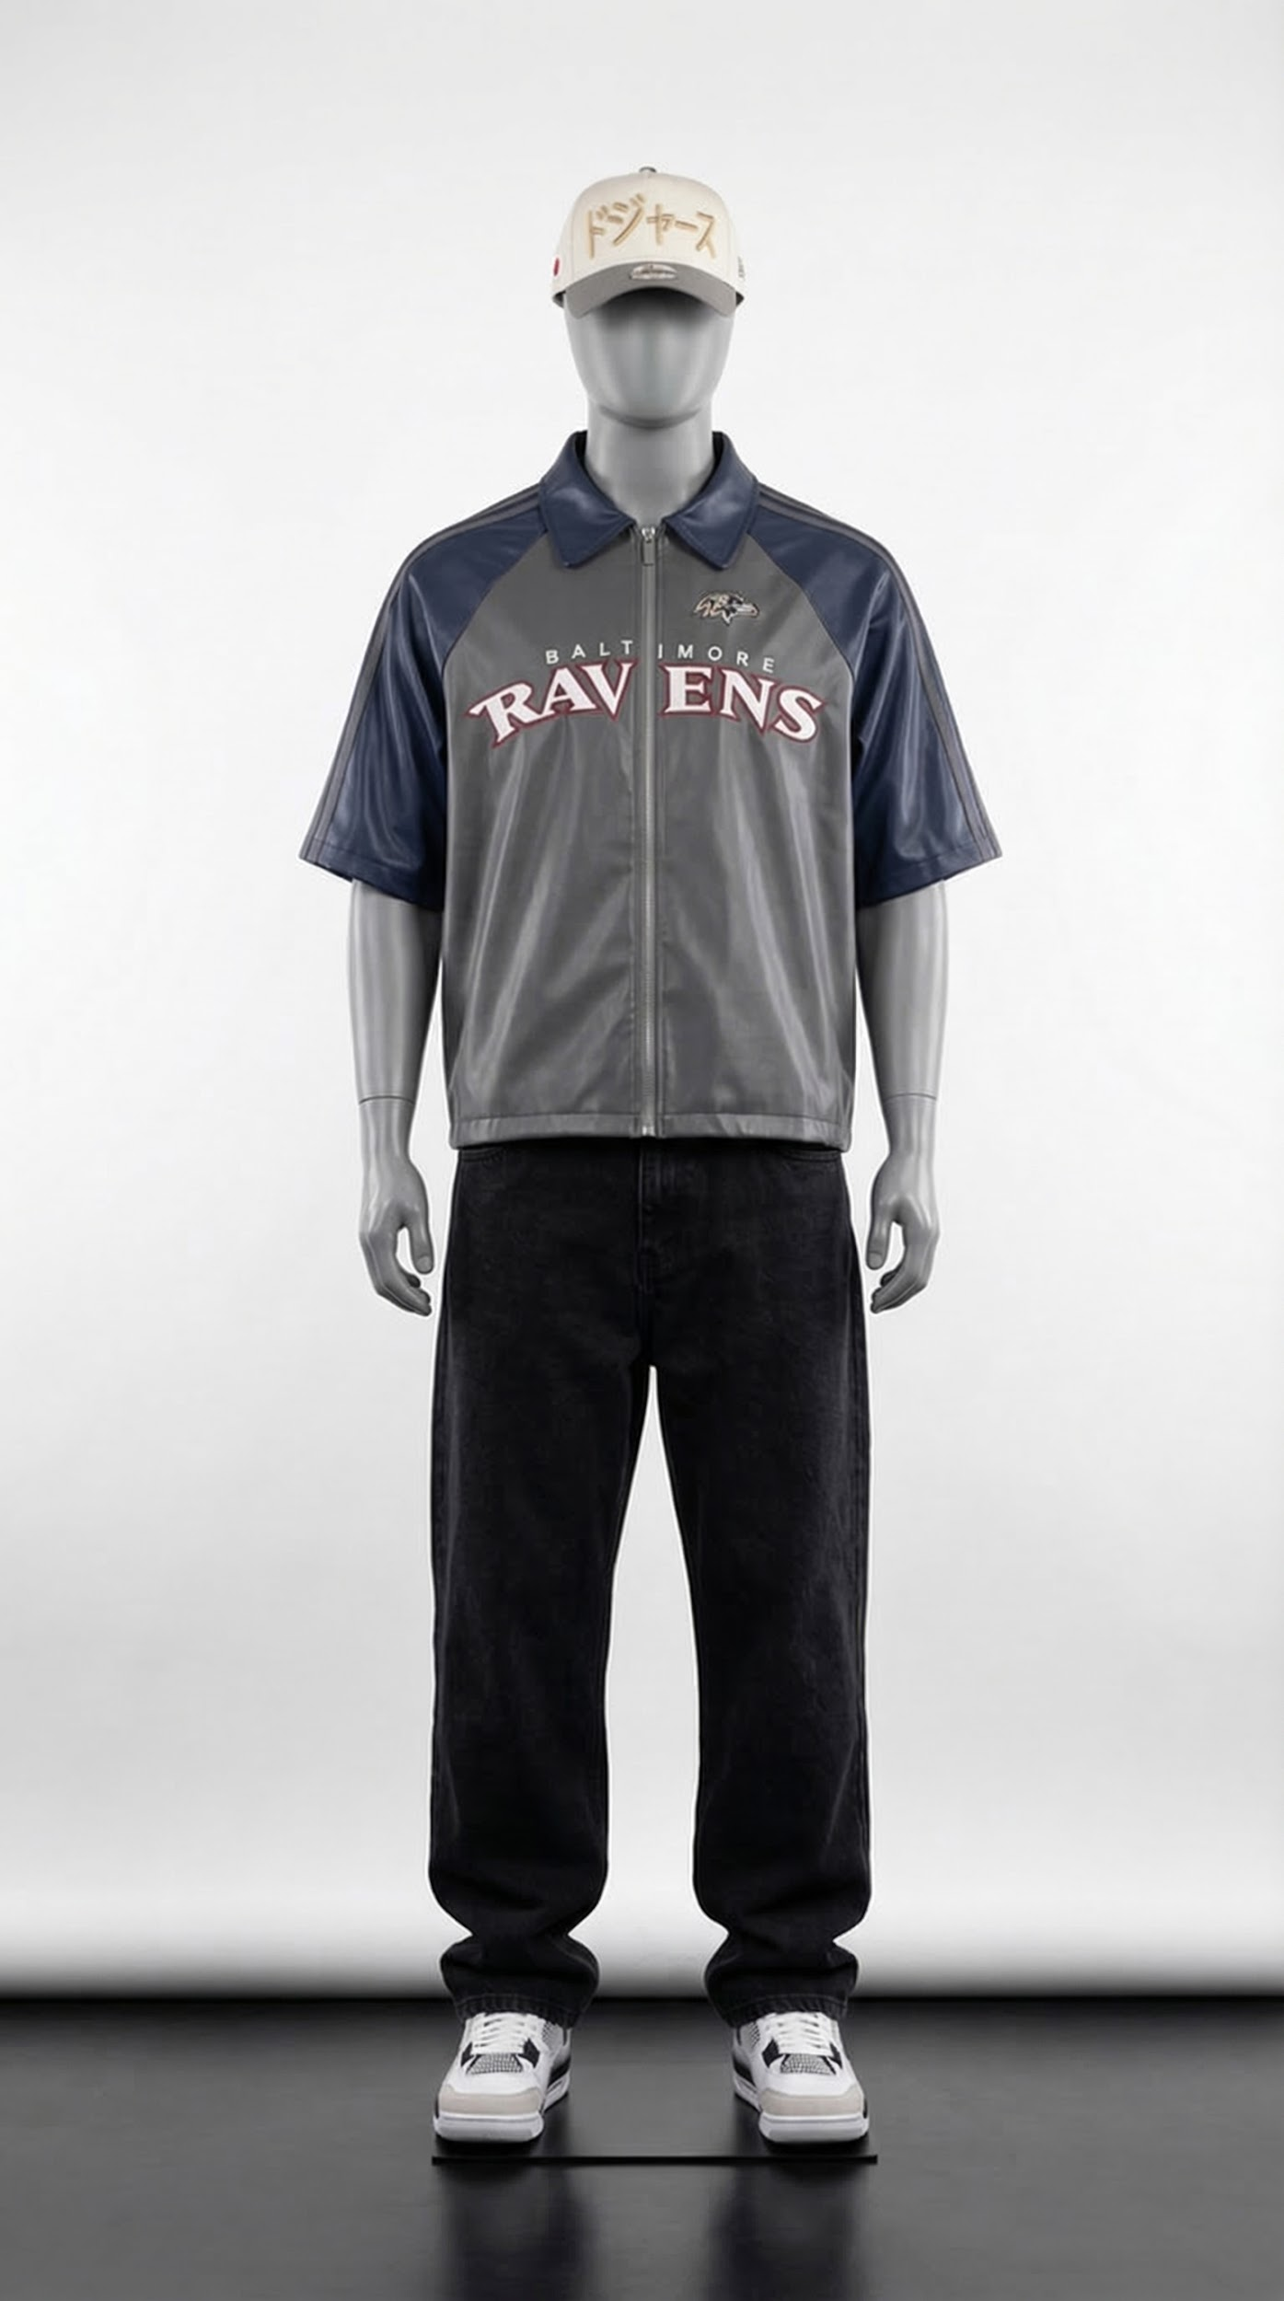

Image Prompt:

A smooth grey retail mannequin is dressed in a grey and navy Baltimore Ravens zip jacket with short sleeves, paired with loose black baggy jeans, modern sneakers, and a white Japanese-style baseball cap. The outfit has a relaxed streetwear aesthetic and is styled neatly to showcase the clothing clearly.

The mannequin stands upright facing directly toward the camera with a straight balanced posture. Both arms hang naturally by its sides so the jacket and jeans are fully visible from the front.

The legs are positioned slightly apart to create a stable stance while keeping the outfit clearly displayed. The jacket zipper is centered and smooth, and the cap sits properly on the mannequin’s head to complete the outfit.

The background is a clean white professional studio backdrop with a black studio floor. Soft, even studio lighting highlights the fabric texture of the jacket and creates subtle shadows.

High-quality product photography captured with a professional DSLR camera, 85mm lens, ultra-sharp details, realistic fabric texture, e-commerce fashion shoot style, portrait orientation, 8K resolution.
Aspect ratio 9:16

Video Prompt:

A grey retail mannequin wearing a grey and navy Baltimore Ravens zip jacket with short sleeves, loose black baggy jeans, modern sneakers, and a white Japanese-style baseball cap stands upright in a clean white studio with a black studio floor.

The mannequin remains completely stiff and motionless with its arms naturally by its sides while slowly rotating 360 degrees in a smooth circle on a hidden rotating platform. The rotation is slow and steady to showcase the outfit from all angles.

The camera remains fixed in front of the mannequin in a portrait frame, capturing a full-body view while the mannequin rotates. Soft professional studio lighting highlights the fabric textures of the jacket, jeans, and cap while creating subtle shadows on the floor.

Ultra-realistic fashion product showcase video, high-end studio quality, smooth motion, sharp details, cinematic lighting, 8K fashion product video.

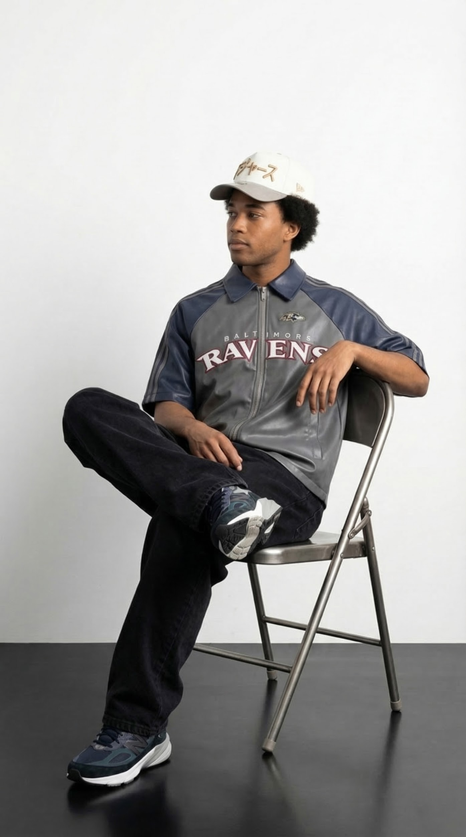

Image Prompt:

A stylish light-skin Black male model with a small Afro is seated on a simple metal folding chair in a minimalist studio. He is wearing a grey and navy Baltimore Ravens short-sleeve zip jacket, loose black baggy jeans, modern sneakers, and a white Japanese-style baseball cap, creating a relaxed streetwear aesthetic.

The model sits in a confident editorial pose similar to a high-fashion studio portrait. His body is slightly turned to the side rather than facing directly forward. One leg is crossed over the other at the knee, with the extended leg angled forward. His posture is relaxed but composed.

One arm rests casually on the backrest of the chair while the other hand rests naturally on his lap or near the jacket zipper, subtly showcasing the Baltimore Ravens logo. His shoulders are relaxed, and his head turns slightly to the side as if looking off-camera, giving a calm, confident expression.

The composition is clean and minimalist with a large amount of negative space around the subject.

The background is a clean white studio backdrop with a black studio floor. Professional soft studio lighting creates gentle shadows and highlights the texture of the clothing.

Portrait fashion editorial photograph, high-end DSLR camera, 85mm lens, ultra-realistic, sharp details, fashion magazine quality, 8K resolution.

Aspect ratio: 9:16

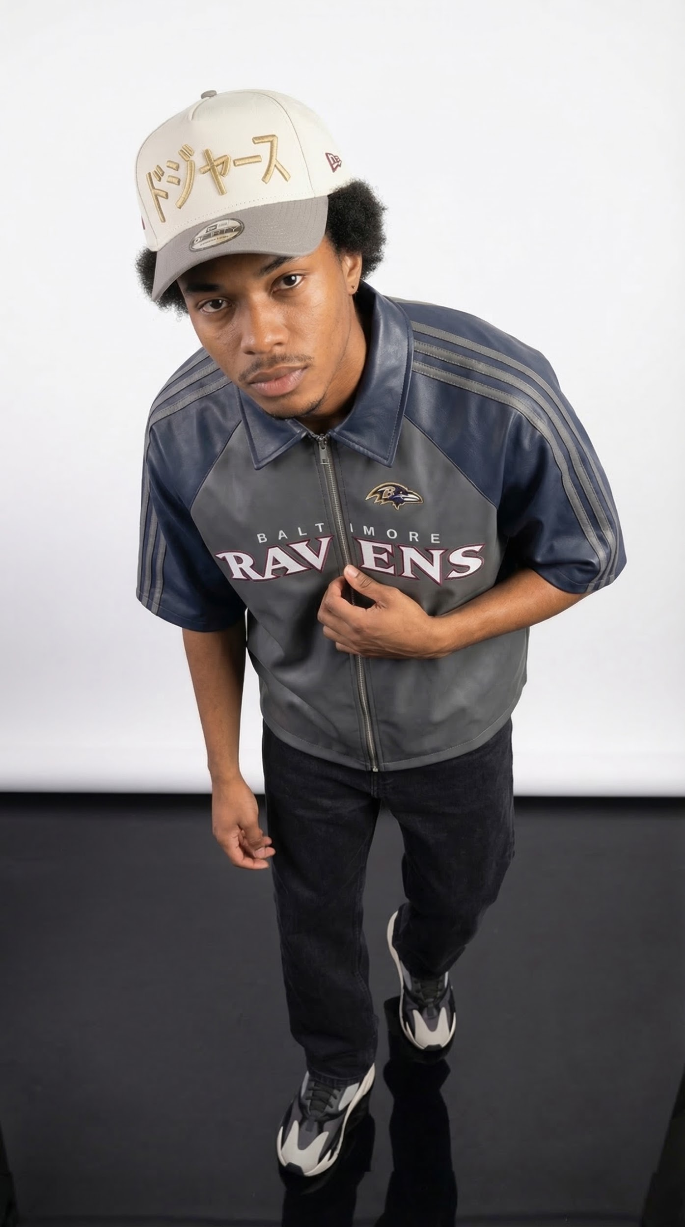

Image Prompt:

A stylish light-skin Black male model is wearing a grey and navy Baltimore Ravens zip jacket with short sleeves, loose black baggy jeans, modern sneakers, and a white Japanese-style baseball cap. The outfit has a relaxed streetwear aesthetic.

The model stands in a fashionable editorial pose viewed from a slightly top-down camera angle. His body leans slightly forward toward the camera while his head tilts upward, making direct eye contact with a confident expression.

One hand lightly holds the front of the jacket near the zipper area, subtly showcasing the Baltimore Ravens logo, while the other hand rests casually near his side. His shoulders are slightly rounded forward to create a relaxed, modern fashion posture.

His legs are positioned close together with one foot slightly forward, giving the pose a stylish, composed look similar to a high-fashion editorial stance.

The background is a clean white professional studio backdrop with a black studio floor. Soft studio lighting highlights the fabric texture of the jacket and creates gentle shadows around the model.

Portrait fashion photo captured from a slightly elevated angle using a high-end DSLR camera, 85mm lens, ultra-realistic, sharp details, fashion editorial quality, 8K resolution.
Aspect ratio 9:16

