BASIC HTML TAGS

<!DOCTYPE html>

<html>

<head>

<title>Getting Started with HTML</title>

</head>

<body>

<h1>Header 1</h1>

<p>This is an example of a paragraph.</p>

<p>This is my second paragraph.</p>

<h2>Header 2</h2>

<h3>Header 3</h3>

<h4>Header 4</h4>

<h5>Header 5</h5>

<h6>Header 6</h6>

<a href="http://www.google.com">Go to Google</a>

<a href="http://www.google.com">

<img src="https://www.google.com/images/srpr/logo11w.png" alt="Google Logo" height="200px" width="200px">

</a>

</body>

</html>

CITATIONS AND QUATATIONS

<https://gist.github.com/AndrewEddy/f60364086911ddd7a4da>

LINKS

<https://gist.github.com/AndrewEddy/1cdf66e595895eb1214f>

HTML5 offers new elements for better document structure:

|  |  |
| --- | --- |
| **Tag** | **Description** |
| <article> | Defines an article in the document |
| <aside> | Defines content aside from the page content |
| <bdi> | Defines a part of text that might be formatted in a different direction from other text |
| <details> | Defines additional details that the user can view or hide |
| <dialog> | Defines a dialog box or window |
| <figcaption> | Defines a caption for a <figure> element |
| <figure> | Defines self-contained content, like illustrations, diagrams, photos, code listings, etc. |
| <footer> | Defines a footer for the document or a section |
| <header> | Defines a header for the document or a section |
| <main> | Defines the main content of a document |
| <mark> | Defines marked or highlighted text |
| <menuitem> | Defines a command/menu item that the user can invoke from a popup menu |
| <meter> | Defines a scalar measurement within a known range (a gauge) |
| <nav> | Defines navigation links in the document |
| <progress> | Defines the progress of a task |
| <rp> | Defines what to show in browsers that do not support ruby annotations |
| <rt> | Defines an explanation/pronunciation of characters (for East Asian typography) |
| <ruby> | Defines a ruby annotation (for East Asian typography) |
| <section> | Defines a section in the document |
| <summary> | Defines a visible heading for a <details> element |
| <time> | Defines a date/time |
| <wbr> | Defines a possible line-break |

Read more about [HTML5 Semantics](http://www.w3schools.com/html/html5_semantic_elements.asp).

#### New Form Elements

|  |  |
| --- | --- |
| **Tag** | **Description** |
| <datalist> | Defines pre-defined options for input controls |
| <keygen> | Defines a key-pair generator field (for forms) |
| <output> | Defines the result of a calculation |

Read all about old and new form elements in [HTML Form Elements](http://www.w3schools.com/html/html_form_elements.asp).

#### New Input Types

|  |  |
| --- | --- |
| **New Input Types** | **New Input Attributes** |
| * color * date * datetime * datetime-local * email * month * number * range * search * tel * time * url * week | * autocomplete * autofocus * form * formaction * formenctype * formmethod * formnovalidate * formtarget * height and width * list * min and max * multiple * pattern (regexp) * placeholder * required * step |

Learn all about old and new input types in [HTML Input Types](http://www.w3schools.com/html/html_form_input_types.asp).

Learn all about input attributes in [HTML Input Attributes](http://www.w3schools.com/html/html_form_attributes.asp).

#### HTML5 - New Attribute Syntax

HTML5 allows four different syntaxes for attributes.

This example demonstrates the different syntaxes used in an <input> tag:

|  |  |
| --- | --- |
| **Type** | **Example** |
| Empty | <input type="text" value="John" disabled> |
| Unquoted | <input type="text" value=John> |
| Double-quoted | <input type="text" value="John Doe"> |
| Single-quoted | <input type="text" value='John Doe'> |

In HTML5, all four syntaxes may be used, depending on what is needed for the attribute.

#### HTML5 Graphics

|  |  |
| --- | --- |
| **Tag** | **Description** |
| <canvas> | Defines graphic drawing using JavaScript |
| <svg> | Defines graphic drawing using SVG |

Read more about [HTML5 Canvas](http://www.w3schools.com/html/html5_canvas.asp).

Read more about [HTML5 SV](http://www.w3schools.com/html/html5_svg.asp)G.

#### New Media Elements

|  |  |
| --- | --- |
| **Tag** | **Description** |
| <audio> | Defines sound or music content |
| <embed> | Defines containers for external applications (like plug-ins) |
| <source> | Defines sources for <video> and <audio> |
| <track> | Defines tracks for <video> and <audio> |
| <video> | Defines video or movie content |

CSS box model

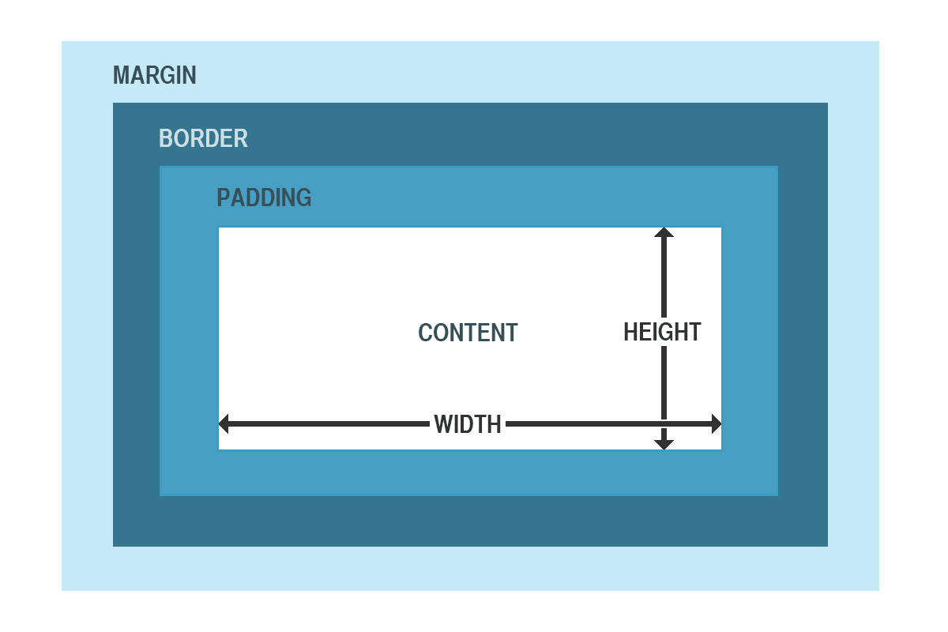

RESPONSIVE WEB PAGES

<https://www.w3schools.com/css/css_rwd_intro.asp>