# 

# 

# 

# CST-239 Activity 4

# Joseph Abraham

# 3/18/25

# Part 1: Reading and Writing Text Files

## Part 1a

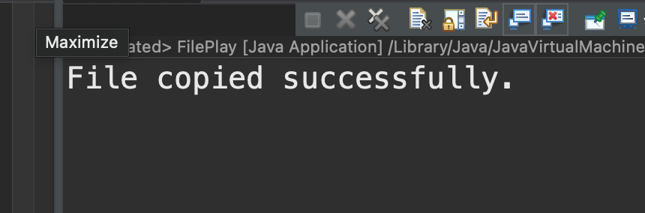

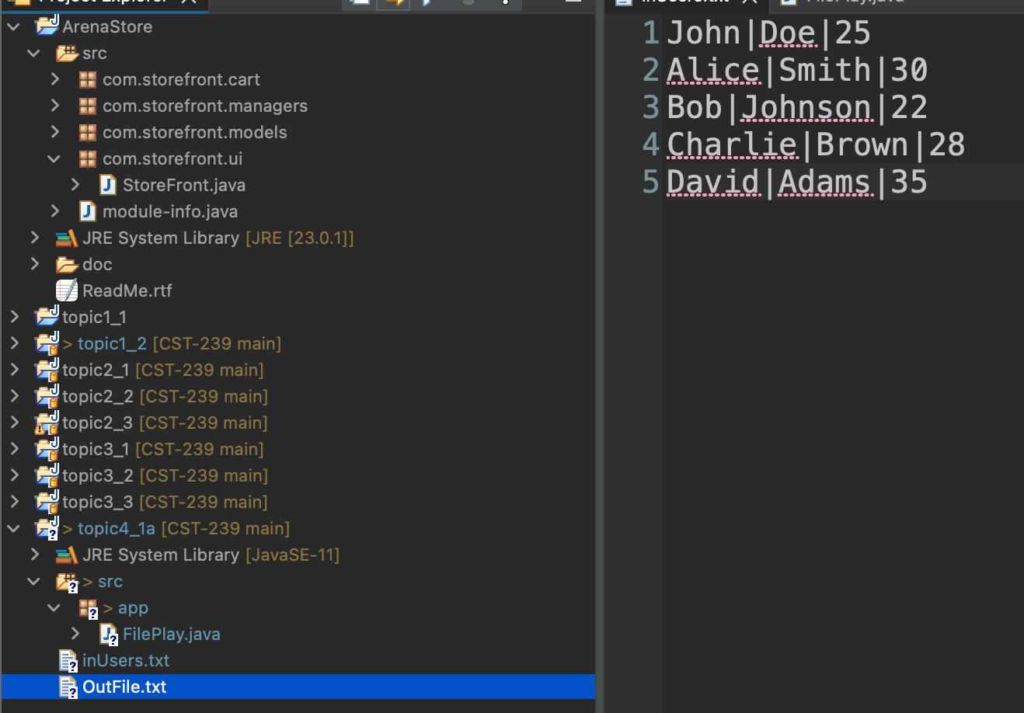

## Part 1b

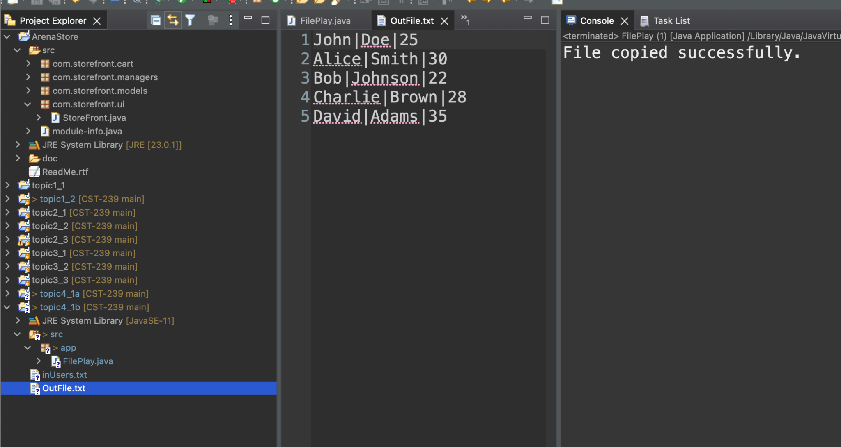

## Part 1c

## Part 1d

## Part 2: Reading and Writing JSON Files