# 

# 

# 

# **CST-239 Activity 5**

# Joseph Abraham

# 3/20/25

# Part 1: Java Generics

## Screenshot 2-i:

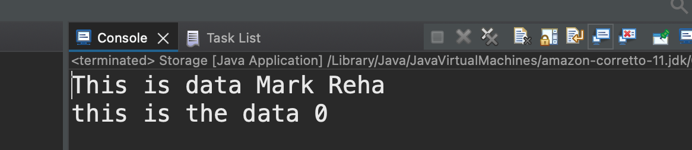

## Screenshot 3-f:

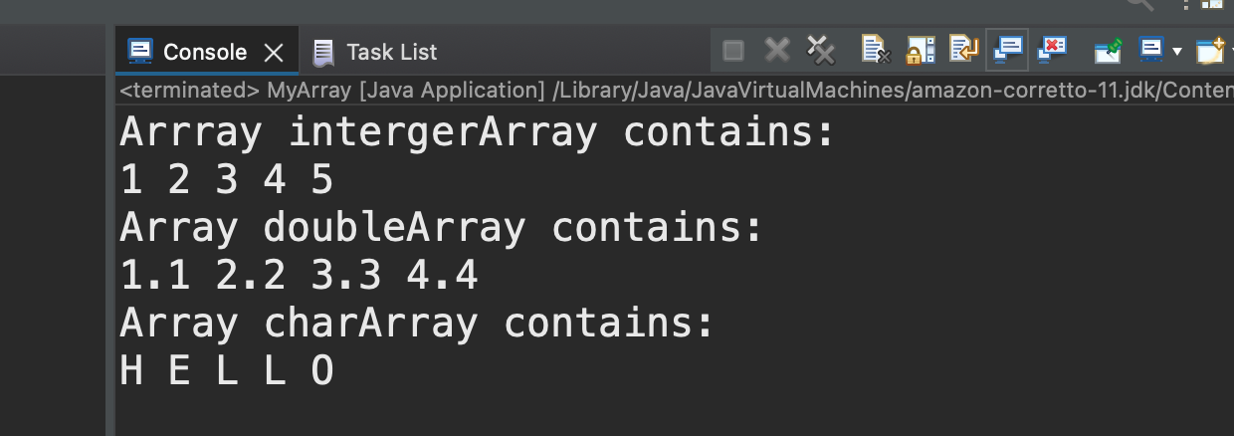

## Screenshot 3-k:

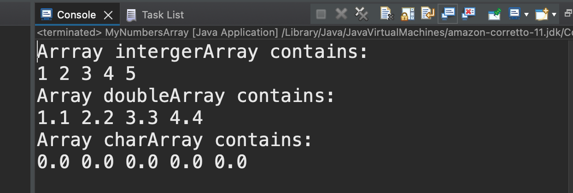

# Part 2: Java Collections Framework

## Screenshot 2-h:

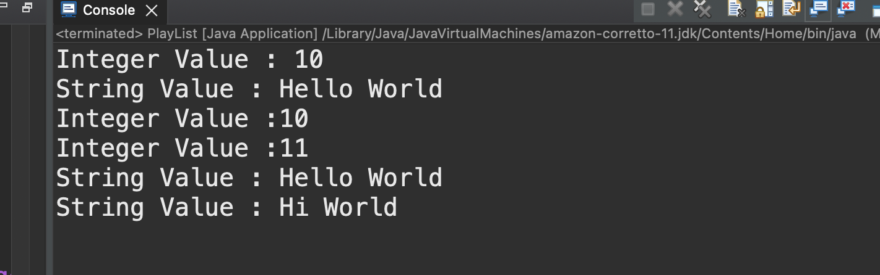

## Screenshot 3-h:

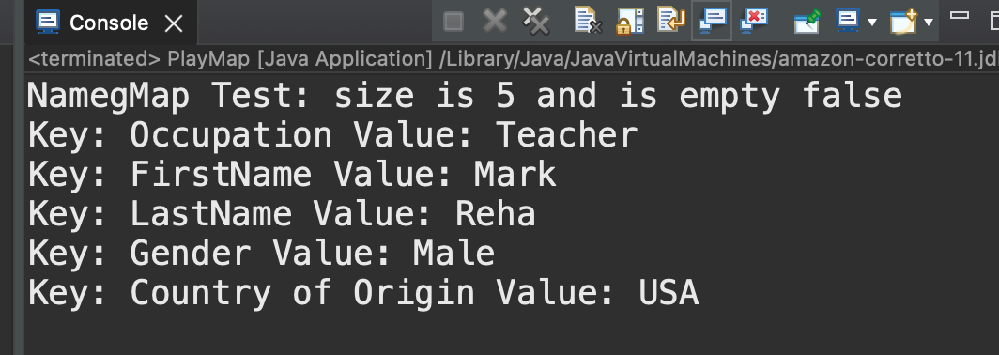

## Screenshot 4-h:

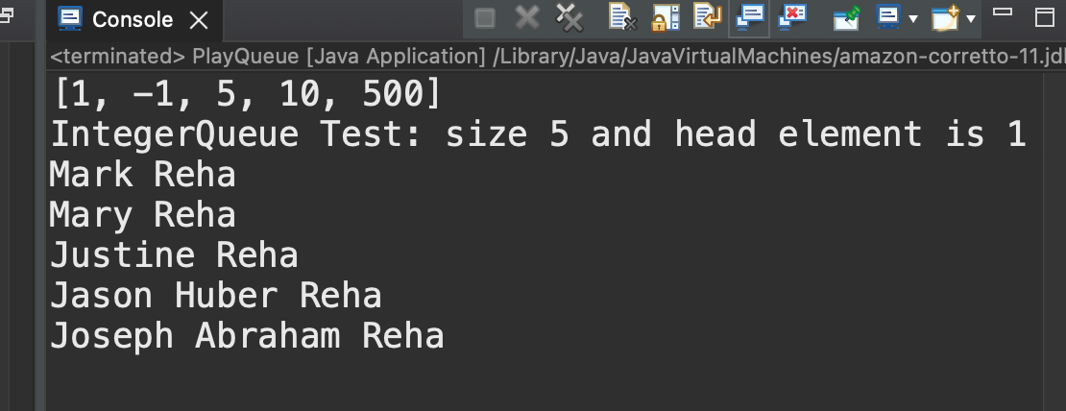

## Screenshot 5-h:

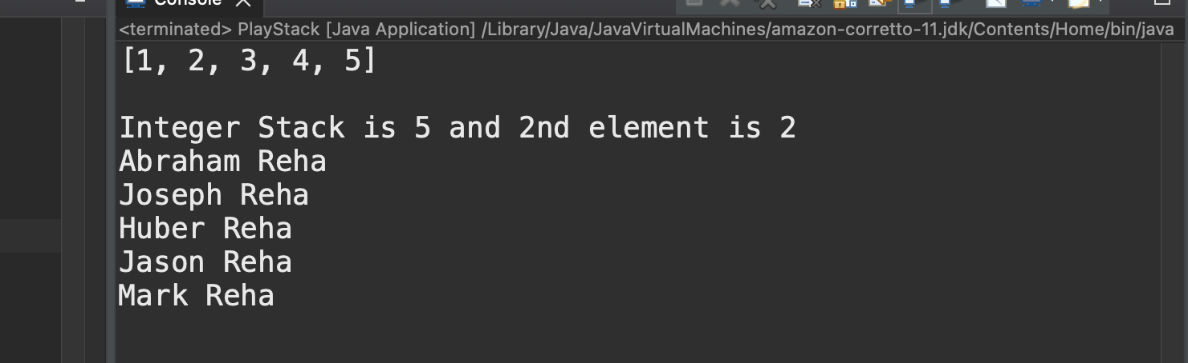

## Screenshot 6: Java Collections Tutorial Quiz

I have been unable to access http://javatpoint.com/.