Timbre Switcher

Software Design Document

Jose Valencia; Joseph D Smith

Date 11/18/14

Contents

1. Introduction

a. Purpose

b. Scope

c. Definitions and Acronyms

2. System Overview

3. System Architecture

a. Architectural Design

b. Design Rationale

4. Human Interface Design

a. Overview of User Interface

# Introduction

## Purpose

This project report describes the architecture and system design of a Timbre Switcher.

Using two different sound types, we begin by recording a sound wave using a microphone and setting that as the target sound. (ex guitar note) Next, a second sound wave is recorded (eg whistle) and that is used as a reference sound. Our goal is to output that reference sound through a speaker and have it sound as close as possible to that of the target. So regardless of the reference frequency, it will sound like the target sound. We use a process that finds the target’s resonant harmonic by performing a FFT on it. After the reference frequency is recorded, and after recording the ratio of the harmonic frequency of both sounds, we perform a reverse FFT on the reference sound that will then strongly resemble the original sound of that of the target source, but with the frequency of the reference sound.

## Scope

This software switches the timbre of one instrument for another. The software will take two DAQ input signals. One will be the target signal and the other the reference signal. The two signals should be single note instruments or sounds (ie: a saxophone rather than piano). The output will be a signal that plays the target signal’s notes with the timbre of the reference signal.

## Definitions and Acronyms

Timbre: the character or quality of a musical sound or voice as distinct from its pitch and intensity

Fourier Analysis: the study of the way general functions may be represented or approximated by sums of simpler trigonometric functions

Harmonic: an overtone accompanying a fundamental tone which varies for different sound types

Target sound: the recorded sound whose main frequency is output

Reference sound: the recorded sound whose overtones are applied to the target sound before being output

# System Overview

All sound is made up of waves of varying pressure that travel through the air. Musical instruments produce sounds that are known as notes. Each of these notes can be characterized in several ways, including amplitude, frequency, and timbre. Amplitude corresponds to the strength of the air pressure change that the note produces. This is how “loud” the sound is. The frequency corresponds to how “high” or “low” the note sounds. It depends on how fast the air pressure varies. Typical human beings can hear notes from about 20 Hz to 20,000 Hz (20 to 20,000 pressure variations per second). (*Sethares 11-13*)

The timbre of a musical instrument is derived from the overtones that that instrument produces when a note is played, as well as how those overtones evolve as the note rings through. We can determine the overtones of the sound a note produces by performing Fourier analysis on that sound. The Fourier analysis provides us with data that plots frequency versus either amplitude or decibel gain.

Fourier analysis takes in a signal that is measured as amplitude versus time and converts it into a signal that measures amplitude versus frequency. This means that each amplitude vs time signal can be thought of as a sum of many simpler sine wave signals with different amplitudes. Fourier analysis provides us with data that shows how much of each frequency of sine wave our waveform is made up of. (*Kaliz*)

For a single instrument’s note, this Fourier analyzed plot will peaks at multiple frequencies. The lowest frequency peak will be at the frequency of the note (for example, the A note used as reference for instrument tuning is 440Hz). The rest of the frequencies will roughly be integer multiples of the main original frequency. The amplitude of those peaks will likely be weaker than the main frequency, and the pattern of amplitudes for each of those frequencies is what determines the timbre of a note. (*Sethares section 2.3*)

[These facts are what we exploit to make one recorded note sound like another.](http://en.wikipedia.org/wiki/Timbre)

# System Architecture

## Architectural Design

The structure of the system contains four pieces. The first is the microphone used to record sounds. The second is the DAQ (the NI USB X series USB-6341 DAQ) that will transfer this sound into digital form and the output sound into analog form. The third is the LabVIEW program that will analyze the two input sounds, apply the timbre of the reference sound to the main frequency of the target sound and output it in digital form. The final piece is the speaker that will play the modified sound.

The LabVIEW program contains two parts that run one after the other, each with its own loop. The first part runs when the user presses run in LabVIEW. This part contains a connection to the DAQ for input. The DAQ outputs a waveform every time the loop runs. The LabVIEW program analyzes this waveform to find its frequency and its RMS amplitude. It also takes the fourier transform of the waveform to get the information in the frequency domain. It sends this fourier transform, the RMS amplitude, and the frequency to the second part of the code.

The second step in our labVIEW project begins after the target sound is recorded. When a user ends the recording of the target sound, the recording of the reference sound begins. After recording the reference sound into the DAQ using the same microphone in the first recording, we obtain its relative frequency and RMS values. We then use a custom vi that scales the harmonic frequencies (found using the FFT) using a ratio of the target and reference frequencies. (freq_reference / freq_target). This action is due to different sounds having different harmonic frequencies. But after applying the ratio, our reference harmonics are now scaled to be similar to those of the target harmonics. It is only after the ratioed target harmonic frequencies gets sent into an inverse FFT that the reference sound now appears in a waveform that strongly resembles the target sound.

This newly created reference sound wave is then sent to the DAQ and output through the speaker for audible comparison to that of the target sound. It should be observed that the reference sound, in this case our whistle, sounds like a guitar at the frequency we recorded.

## Design Rationale

This architecture contains everything necessary to run this project. We decided to use the NI USB X series DAQ instead of other DAQ devices such as an Arduino. We decided this because the NI USB DAQ has a 16 bit resolution rather than the Arduino’s 8-bit Analog Input resolution. This will result in a much higher sound quality.

This section purposefully excludes much information about the microphone or speakers. This is because practically any microphone or speakers could be used. The only requirement is that both operate at voltage levels that the DAQ can handle, and that both are powered, if that is necessary.

# Human Interface Design

## Overview of User Interface

The user first plays the target sound into the microphone right as they press “timbre record”. Then the user may simply a note of any frequency from any instrument or device into the microphone and hear the target sound’s timbre applied to the second sound’s frequency.

The Main.vi includes five graphs. “Input Note” displays the input waveform. Input FFT displays the fourier transform of the input waveform. “Controlling Note” displays the input waveform of the controlling sound. “Shifted FFT” displays the FFT of the target sound shifted by the frequency of the controlling sound. “Output Note” displays the waveform that is output to the DAQ.

So as an overview. The user will play two sounds into the interface, and the timbre of the reference sound will be applied to the main frequency of the target sound and output.

Images of Front Panel

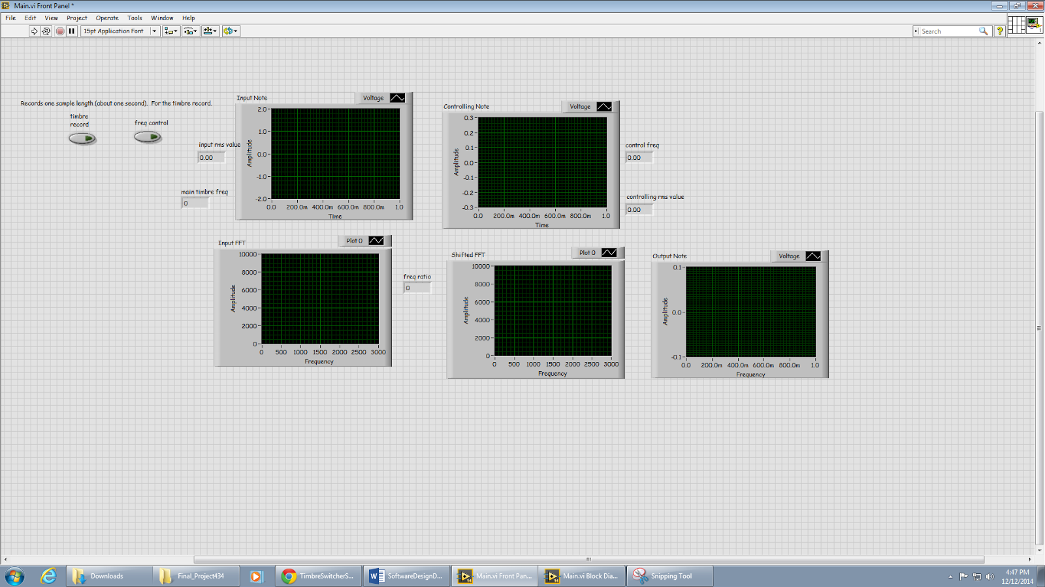

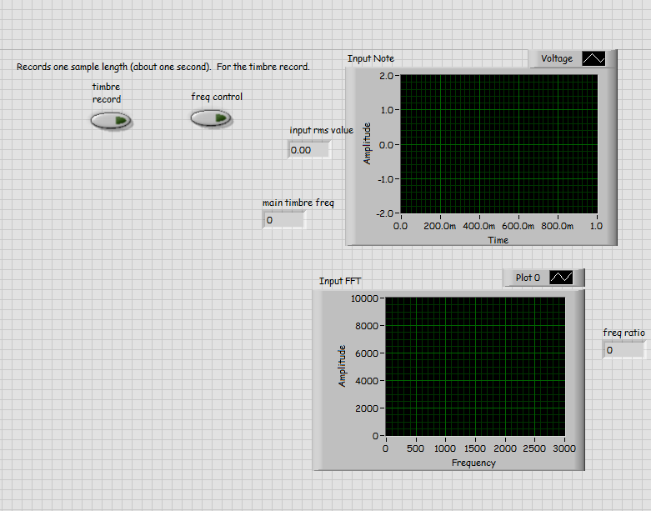

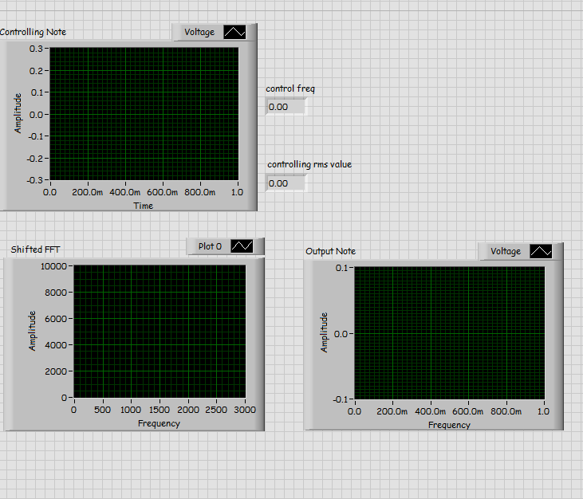

Sources

Azad, Kaliz. "An Interactive Guide To The Fourier Transform." *BetterExplained*. N.p., n.d. Web. 12 Dec. 2014.

Sethares, William A. *Tuning, Timbre, Spectrum, Scale*. London: Springer, 1998. *Google Books*. Springer Science & Business Media. Web.