Elevator Pitch:
PulseAir is a concept website for the world's first party airline — where the seat-back screen is a DJ booth, the safety video is a banger, and yes, there is a buffet on the plane. We're talking nachos at 30,000 feet. Full send. The website exists to answer one question: what if flying were actually fun? Like, embarrassingly fun. Like "I can't believe this is a real airline" fun. The kind of airline your group chat actually gets hyped about. PulseAir is built for college kids, young travelers, and families who are tired of boring flights and overpriced pretzels. Budget-friendly fares, big energy, and a whole lot of vibes — from the moment you land on the page to the moment you land at your destination.

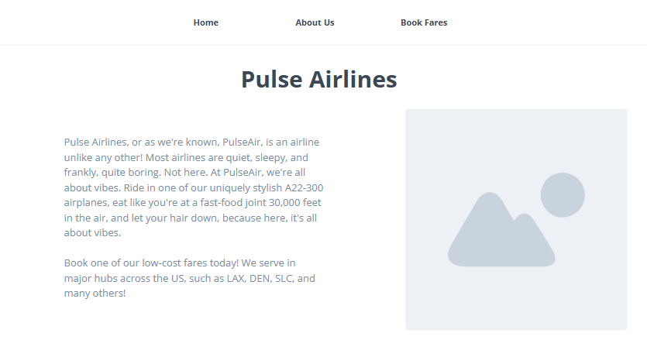
This will be my homepage of the website. In here, I will have a brief description of the airline and what the website is for. The image to the right will be an image of one of Pulse Air’s planes. I will also have the logo on the top left of the navigation bar.
Here is the Logo:


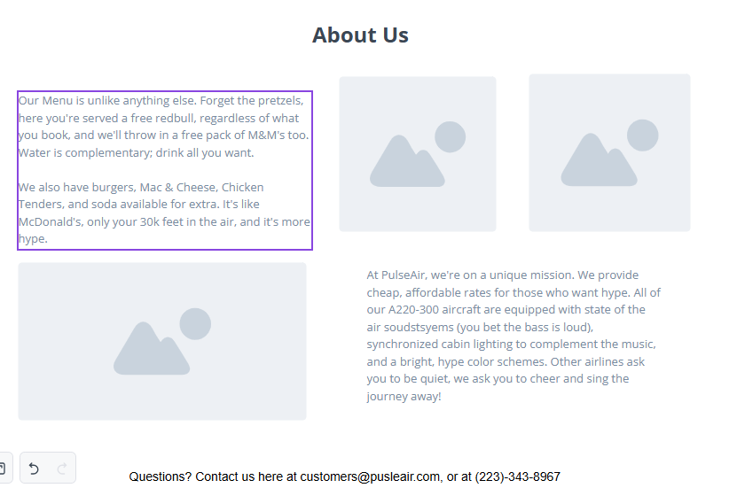

This is the “About me” page of the site. In here, a brief description of the menu, as well as the airline's purpose, will be stated. The 2 upper right images will be of food served by the airline, and the bottom image will be of one of the airline employees.
Menu Images:

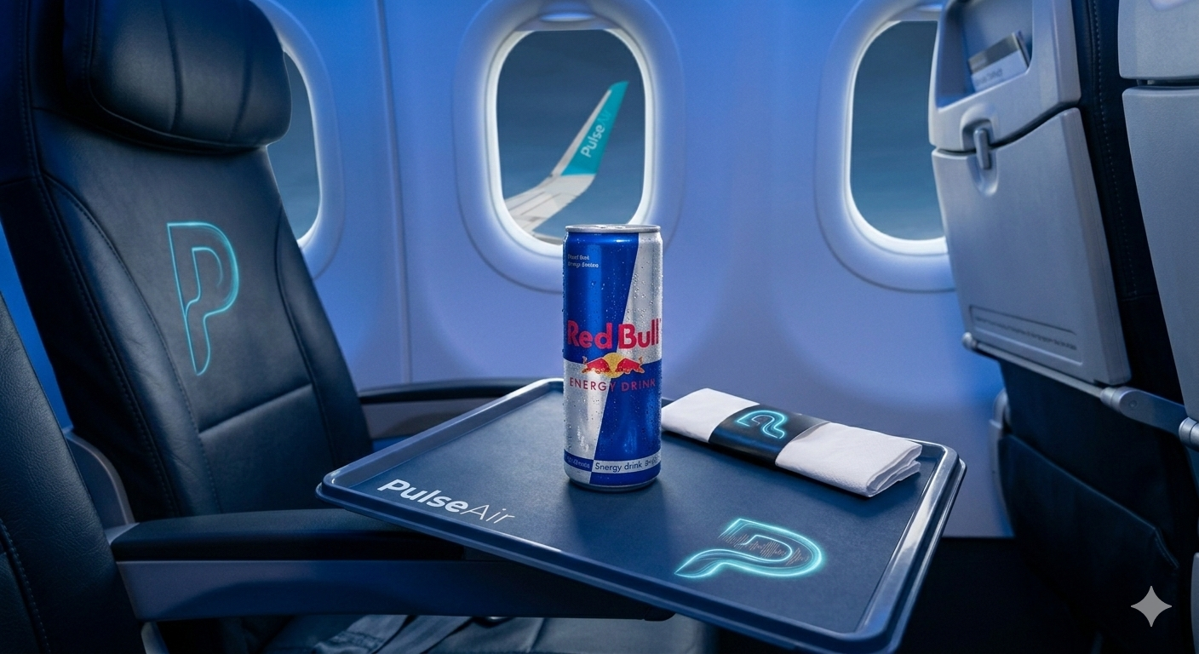

Employee Image:
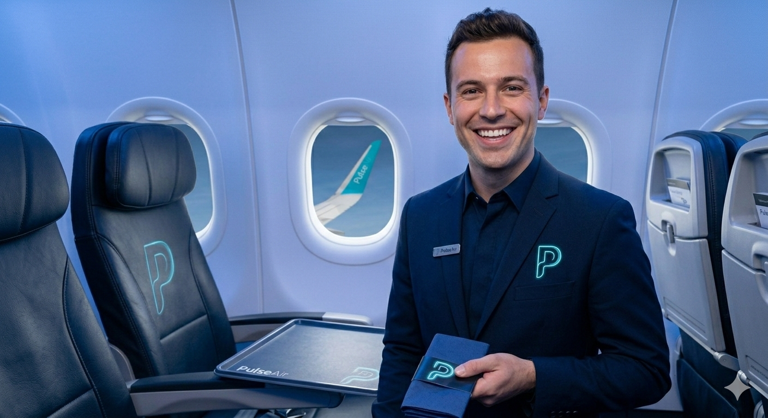

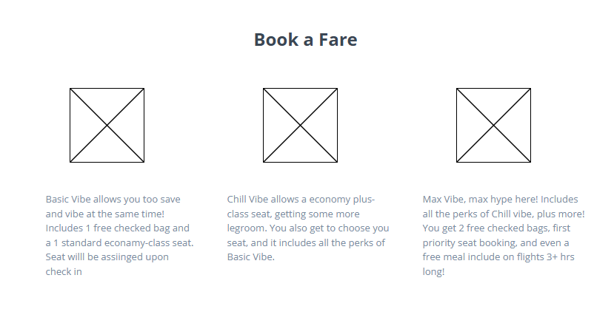

This will be our fare booking page. We will have a brief description of the 3 fares to choose from, as well as icons for them.

Here is the color scheme for the website:
#000000, Black
#1F51FF, Neon Blue
#133547, Dark Neon Blue
#A9A9A9, Dark Gray
Fonts:
-Rostex (https://www.1001fonts.com/rostex-font.html)
-Trebuchet MS
-Orbitron (https://fonts.google.com/specimen/Orbitron)
Website Purpose:
This website is meant to cleanly and simply allow users to learn more about Pulse Air, and provide a super easy interface, and to simply and easily book fares.
Target Audience:
The target audience for Pulse Air is college students, families with younger kids, and people who want flying to be fun and eventful instead of slower and quieter like other airlines.

