1. Following Nuget should be installed:

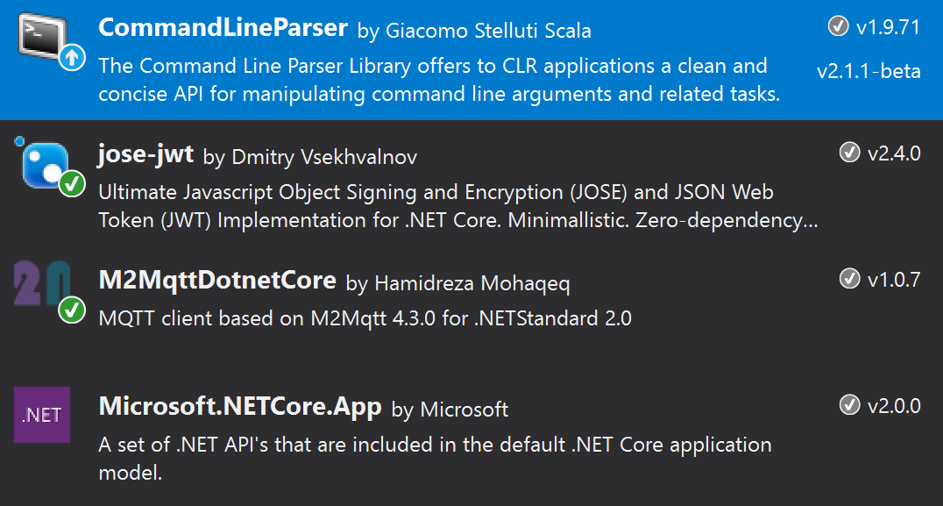

1. Create certificate and public/private keys with following instruction:

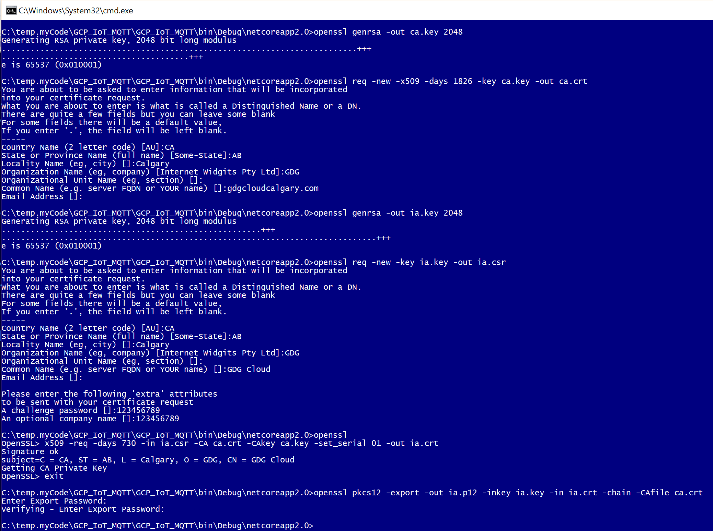

C:\>**openssl genrsa -out ca.key 2048**

Generating RSA private key, 2048 bit long modulus

..........................................................................+++

.......................................+++

e is 65537 (0x010001)

C:\ >**openssl req -new -x509 -days 1826 -key ca.key -out ca.crt**

*You are about to be asked to enter information that will be incorporated into your certificate request.  
What you are about to enter is what is called a Distinguished Name or a DN.  
There are quite a few fields but you can leave some blank   
For some fields there will be a default value,  
If you enter '.', the field will be left blank.  
-----  
Country Name (2 letter code) [AU]:CA  
State or Province Name (full name) [Some-State]:AB  
Locality Name (eg, city) []:Calgary  
Organization Name (eg, company) [Internet Widgits Pty Ltd]:GDG  
Organizational Unit Name (eg, section) []:  
Common Name (e.g. server FQDN or YOUR name) []:gdgcloudcalgary.com  
Email Address []:*

C:\ >**openssl genrsa -out ia.key 2048**

Generating RSA private key, 2048 bit long modulus  
......................................................+++  
..............................................................................+++  
e is 65537 (0x010001)

C:\ >**openssl req -new -key ia.key -out ia.csr**

You are about to be asked to enter information that will be incorporated into your certificate request.  
What you are about to enter is what is called a Distinguished Name or a DN.  
There are quite a few fields but you can leave some blank   
For some fields there will be a default value, If you enter '.', the field will be left blank.  
-----  
Country Name (2 letter code) [AU]:CA  
State or Province Name (full name) [Some-State]:AB  
Locality Name (eg, city) []:Calgary  
Organization Name (eg, company) [Internet Widgits Pty Ltd]:GDG  
Organizational Unit Name (eg, section) []:  
Common Name (e.g. server FQDN or YOUR name) []:GDG Cloud  
Email Address []:

Please enter the following 'extra' attributes  
to be sent with your certificate request  
A challenge password []:123456789  
An optional company name []:123456789

C:\ >**openssl**OpenSSL> **x509 -req -days 730 -in ia.csr -CA ca.crt -CAkey ca.key -set_serial 01 -out ia.crt**

Signature ok  
subject=C = CA, ST = AB, L = Calgary, O = GDG, CN = GDG Cloud  
Getting CA Private Key  
OpenSSL> **exit**

C:\ >**openssl pkcs12 -export -out ia.p12 -inkey ia.key -in ia.crt -chain -CAfile ca.crt**

Enter Export Password:  
Verifying - Enter Export Password:

1. Download google roots certificate from and save it on disk:

<http://pki.google.com/roots.pem>

1. Login in to gcp and create registry under IoT Core, i.e. **devreg1**
2. Create pub/sub topic as **events** or **state**

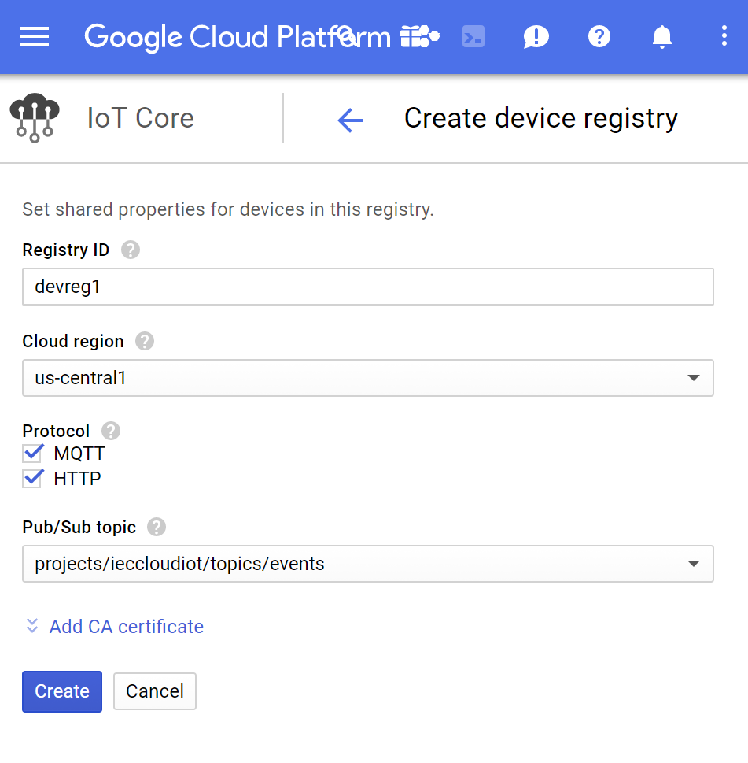

1. Add device, i.e. **dev1**

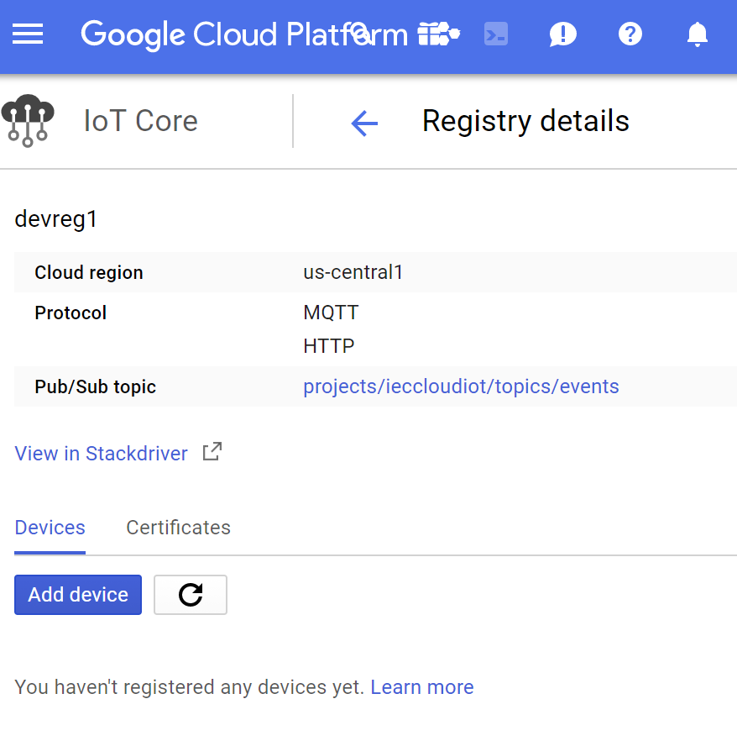

1. Add generated certificate **Ia.crt**

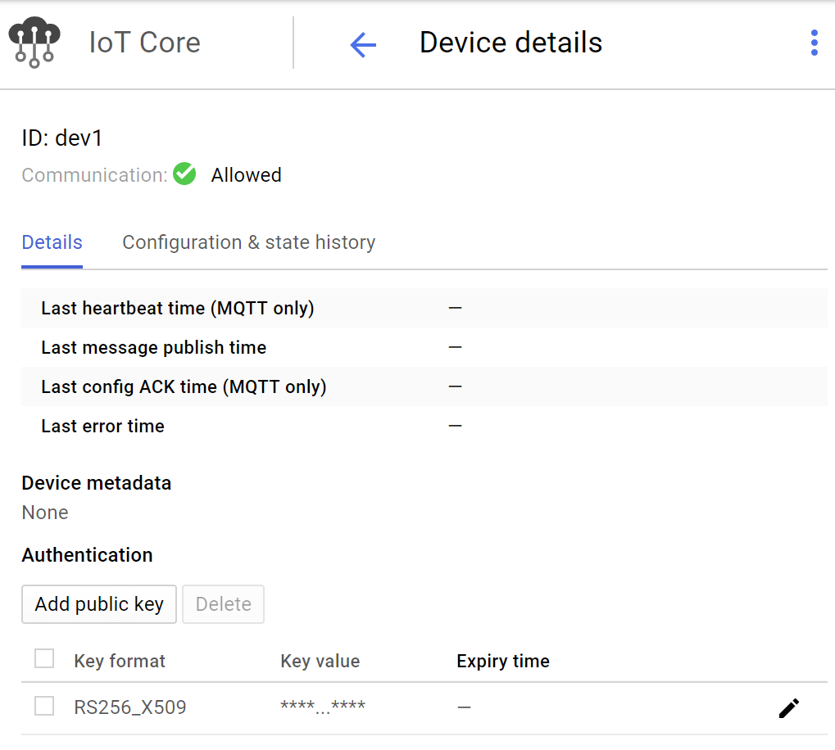

1. To verify your publish messages:

Execute following command:

gcloud beta pubsub subscriptions pull --auto-ack --max-messages=5000 projects/IECCloudIoT/subscriptions/**subdev1**

**note subdev1 is your subscription**

