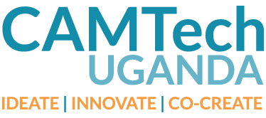

***Thank you for your participation in our Clinical Visit! The purpose of this survey is to determine how useful these Site Visits are to participants. Your feedback will be incredibly helpful in the planning and framework of future CAMTech Hack-a-thons and other events. It will be used for internal purposes only, and your responses will be kept anonymous. We highly appreciate your participation.***

1. Initials:

………………………………………………………………………………………………………

1. What site did you visit today?
2. Would you recommend your experience today to a friend?

--------Yes

--------No

1. Why or why not?
2. Did you learn about a problem or inefficiency in your Clinical Site Visit today that you would like to improve upon during the Hack-a-thon?

---------Yes

---------No

1. Can you briefly share the challenge/problem you identified at the site you visited today?

………………………………………………………………………………………………………………………………………………………………………………………………………………………………………………………………………………………………………………………………………………………………………………………………………………………………

1. Please rate the following Clinical Site Visit aspects on a scale of 1 to 10. (Circle your choice).

Time duration

0 1 2 3 4 5 6 7 8 9 10 (too short) (just the right length of time) (too long)

Amount Learnt

0 1 2 3 4 5 6 7 8 9 10 (learnt nothing) (learnt a bit) (learnt a lot)

Overall usefulness

0 1 2 3 4 5 6 7 8 9 10 (not useful at all) (moderately use) (extremely useful)

6. How would you recommend the future of Clinical Site Visit be handled? (Briefly explain)

………………………………………………………………………………………………………………………………………………………………………………………………………………………………………………………………………………………………………………………………………………………………………………………………………………………………………………………………………………………………………………………………………………………………………………………………………………………………………………

*Thank you for your time!*