**Introduction**:

**Executive Summary**

PollMe is a website providing feedbacks to moderators or speakers by giving the audience or students a quick poll depending on the speaker’s questions or opinions. PollMe can be linked to any official or virtual education system. PollMe should be considered as an official feedback that everyone can get information by it.

Also, PollMe can provide the researchers with all the material they need by fast and simple ways.

**Document Overview**

This document introduces PollMe website. It introduces general description, technical description, development plan and operation plan.

**Abbreviations and Terminologies**

|  |  |
| --- | --- |
| **PollMe** | **Website name** |
|  |  |

**references**

**System description:**

**Introduction**

PollMe offers an easy way of interaction between a speaker and his audience. Through taking a poll, ask questions like MCQ and see the percentage of the audience that answered right, get questions from the audience and see them questions on the speaker's (mobile / laptop) so no one needs to rise his hand while the speaker is talking and ask the question in front of the audience (which may be annoying or embarrassing for some). Also, it allows the speaker to get feedback about the topic introduced through a positive or negative poll, which he can see how many people in the audience understand the topic well. PollMe can be used in lectures, conferences, events and any other activities that need a feedback from the audience. The audience doesn’t need to make accounts and password to give their feedback or participate in polls, while the admin (the lecturer or the speaker) only needs to make an account to see the results of the polls and questions he asked or received.

Pollme provides only one main device to control the survey e.g. the speaker or the researcher and the other devices which is connected to the main device with local network through wi-fi of a router or built-in hotspot .

**System Architecture**

Audience Management System offers many ways for measuring and processing your audience.  
This tool can be accessed by mobile and laptop users through web browsers.

The system can be deployed using local network through wi-fi of a router or built-in hotspot. On this network a server (can be a mobile phone or a laptop) and audience’s devices that support wi-fi and web-browsing.

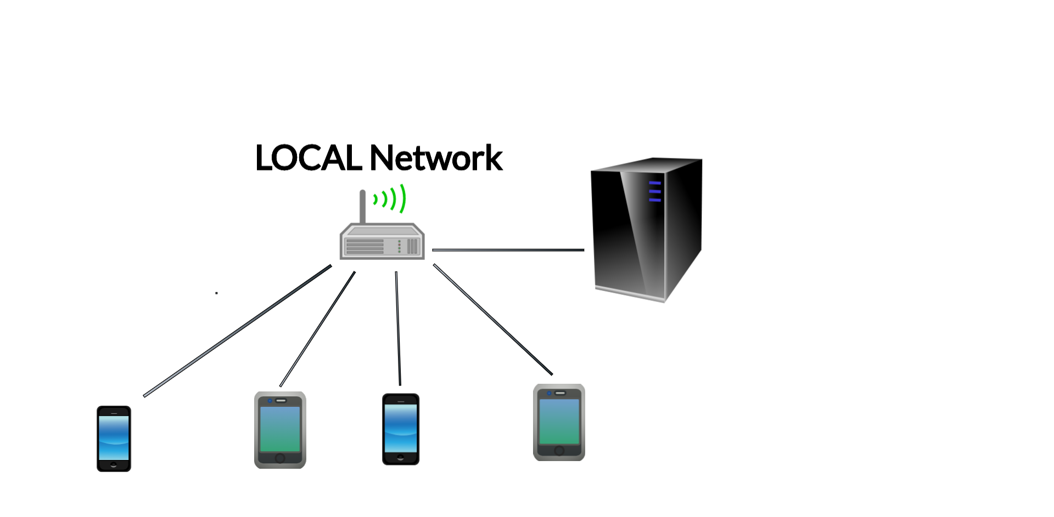  
  
The system consists of the following modules:  
1) Audience Area

2) Administration Area

3) Data Storage

4) Data Processing

5) Data Analytics

6) Reporting

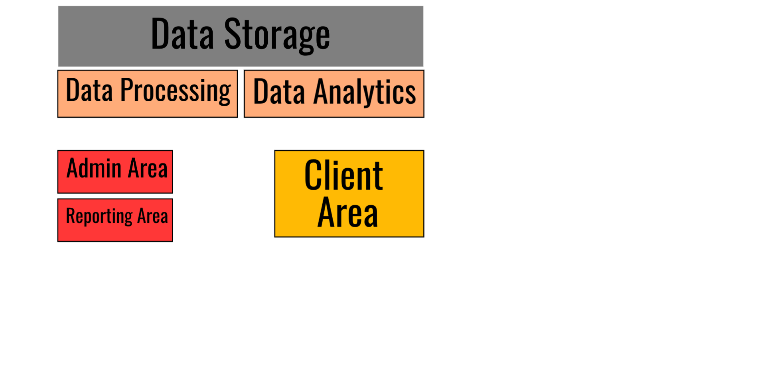**Storage**The system uses different types of storage:

* System storage for system configurations.
* Admin data storage for storing data by admin.
* Audience data storage for storing all inserted data by audience and admin.
* Analytics storage for storing outcomes of data analytics module.

System storage uses json format to store the data in a text file on the server locally.

Audience data storage uses "SQLite" database and will be also on the server, no external servers are needed.

**Modules**

## Text questions

# In our audience management system, audience/spectators will be able to deliver questions to the lecturer or the speaker in an easier way instead of traditional way of raising hands.

# We will design a box that can fit up to 100 characters that enables the audience to write the questions they want to ask or ask for more explanation from the lecturer. Audience can also ask for breaks. Therefore, we introduce a way to speak to the lecturer without any noise or raising hands so interaction between the audience and the lecturer will increase and people who are shy or embarrassed to ask the lecturer directly will have nothing to worry about.

## Percentage and absolute results

## Our system is designed to give an instant feedback to the lecturer or speaker from the audience/spectators without needing them to raise their hands and count them. The system shows the lecturer the exact number of audiences. When the speaker starts a poll, or asks a multiple choices question or a true or false question every one of the audiences get to answer in their audience interface, then the speaker (admin) will see in his admin interface:

# • Exactly the absolute number of the audience for each choice/answer.

# • The percentage of audience for each choice/answer.

## Cross platform support

## One of our first goals is to make this system compatible with every platform out there, that’s why we decided to turn to web development.

## Our system is developed in a web-based environment, that makes it flexible and it will work on any platform either its mobile or desktop interface (with any OS out there).

## Interactive questions

## In our audience management system, our aim is to make the speaker and the audiences interact easily and that will happen when the speaker asks them questions. These questions are MCQ/true or false questions that can help evaluate the audience to see if they understand the topics presented for them.

# There will be two kinds of questions:

1. Questions that are prepared by the lecturer before a lecture or a conference, written in a certain way.
2. Questions that come to the speaker’s mind during a lecture or a conference, written instantly so that he can ask the audience. Either way the speaker or the lecturer will be able to control the number of questions that they want to ask. Our aim in the end is to make interaction between audience and the lecturer. We also will be successful in making the lecturer evaluate the audience and their understanding of the topics. Also, the lecturer or the speaker can also know which topic that the audience cannot understand well, so that he can teach it in another way. Therefore, by this, we would have made the gap between the lecturer and the audience closer.

Feedback

## After sections of the presentation or lecture, the audience can submit their degree of understanding of the part depending on the speaker, if he notices the number of negative feedbacks on the matter is more than 5 for example or any number he decides, he will repeat that part or clarify it.

# Having a feedback is a good way to know if the audiences understand the topic or the lecture very well or not, depending on the question that speaker will submit.

Password

# We care about the privacy of the information that speaker has on his page, so we locked his data that he only can get accessed to it. Only the admin has a password to enter while the audience can submit their answers without entering usernames and passwords.



**Users**

### In audience area “users' area” we provide the users with all tools required to do a survey. users may be students in college or in a public conference.

Users can do a survey, make a suggestion and submit feedback.

**Users:**

There will be two types of users that will use our Audience Management System.

1) The speaker or the one that introduces or explains a topic or an idea. For example, the lecturer in the university or a speaker in a conference.

This type will use the program by putting questions to the audience that are prepared before the lecture or the conference, written in a certain way in order to know how much the audience understands the topic. And Questions that come to the lecturer’s mind during a lecture or a conference, written instantly so that he could ask the audience.

2) The audience for example a student in university or audience in a conference. This type will use the program by answering the questions provided by the speaker or lecturer. Also by giving a feedback on how much they understand the content of the topic. The audience also uses the program by writing the questions they want to ask or by asking for another Explanation from the lecturer and also by asking for the needed breaks.

**System Modules**

## Text questions

# In our audience management system, audience/spectators will be able to deliver questions to the lecturer or the speaker in an easier way instead of traditional way of raising hands.

# We will design a box that can fit up to 100 characters that enables the audience to write the questions they want to ask or ask for more explanation from the lecturer. Audience can also ask for breaks. Therefore, we introduce a way to speak to the lecturer without any noise or raising hands so interaction between the audience and the lecturer will increase and people who are shy or embarrassed to ask the lecturer directly will have nothing to worry about.

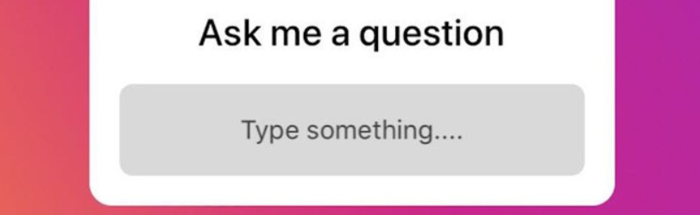

## Feedback

## After sections of the presentation or lecture, the audience can submit their degree of understanding of the part depending on the speaker, if he notices the number of negative feedbacks on the matter is more than 5 for example or any number he decides, he will repeat that part or clarify it.

# Having a feedback is a good way to know if the audiences understand the topic or the lecture very well or not, depending on the question that speaker will submit.

## Password

# We care about the privacy of the information that speaker has on his page, so we locked his data that he only can get accessed to it. Only the admin has a password to enter while the audience can submit their answers without entering usernames and passwords.

## Interactive questions

## In our audience management system, our aim is to make the speaker and the audiences interact easily and that will happen when the speaker asks them questions. These questions are MCQ/true or false questions that can help evaluate the audience to see if they understand the topics presented for them.

# There will be two kinds of questions:

1. Questions that are prepared by the lecturer before a lecture or a conference, written in a certain way.

# Questions that come to the speaker’s mind during a lecture or a conference, written instantly so that he can ask the audience. Either way the speaker or the lecturer will be able to control the number of questions that they want to ask. Our aim in the end is to make interaction between audience and the lecturer. We also will be successful in making the lecturer evaluate the audience and their understanding of the topics. Also, the lecturer or the speaker can also know which topic that the audience cannot understand well, so that he can teach it in another way. Therefore, by this, we would have made the gap between the lecturer and the audience closer.

## Percentage and absolute results

## Our system is designed to give an instant feedback to the lecturer or speaker from the audience/spectators without needing them to raise their hands and count them. The system shows the lecturer the exact number of audience. When the speaker starts a poll, or asks a multiple choices question or a true or false question every one of the audience get to answer in their audience interface, then the speaker (admin) will see in his admin interface:

# Exactly the absolute number of the audience for each choice/answer.

# The percentage of audience for each choice/answer.

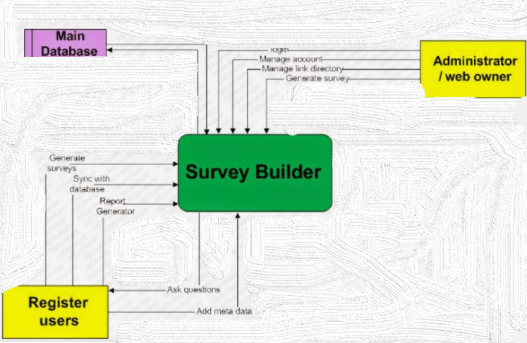

## Cross platform support

## One of our first goals is to make this system compatible with every platform out there, that’s why we decided to turn to web development.

## Our system is developed in a web-based environment, that makes it flexible and it will work on any platform either its mobile or desktop interface (with any OS out there).

**Non-Functional Requirements:**

**Security:**

# We care about the privacy of the information that speaker has on his page, so we locked his data that he only can get accessed to it. Only the admin has a password to enter while the audience can submit their answers without entering usernames and passwords.

**Usability:**

our web is usable, because you can vote for (presentation, lecture, etc...) if you understand the content, and you can vote if you don't understand it too, with better and easy ways like : true or false question and Mcq.

**Technology:**

We will use:

* HTML
* CSS
* JavaScript
* PHP

**Delivery:**

Prototype:

Final product: