**System Models**

Use Case Diagrams

* Admin interface

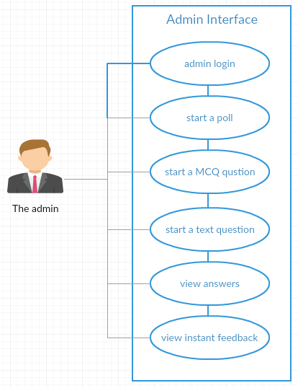

This use case diagram shows the interaction between the lecturer and the admin interface.

* Client interface

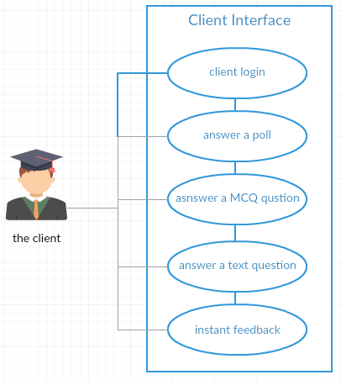

This use case diagram describes the interaction between the audience and the client interface.

Sequence Diagram

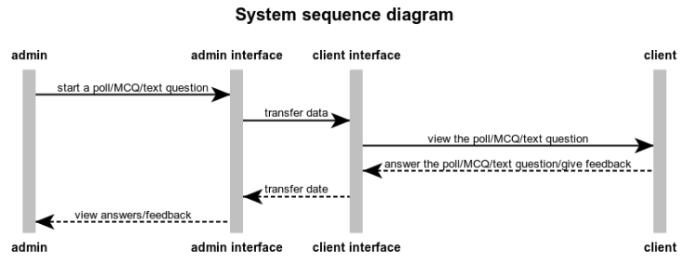

This sequence diagram illustrates the processes that happen in the system between the admin, admin interface, client interface and the client.