**System Features**

**Text**

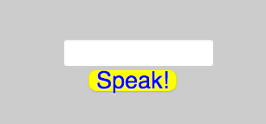

In Audience Management System, audience/spectators will be able to deliver questions to the lecturer in an easier way instead of traditional way of raising hands.

We will design a box that can fit up to 100 characters which ables the audience to write the questions they want to ask or ask for another Explanation from the lecturer. Audience can also ask for needed breaks. Therefore, we invented a way to speak to the lecturer without any noise or raising hands so interaction between the audience and the lecturer will increase and people who are shy or embarrassed to ask the lecturer directly will have nothing to worry about.