TILLER BOARD BLUETOOTH FOTA
TECHNICAL SPECIFICATION

1. Overview
This doc is aiming for developing application that can do Bluetooth FOTA to Tiller board by uploading a firmware file (.hex format) wirelessly.

2. Requirement
For Android app, the suggest requirement as follow
- Have bluetooth device selection
- Connect button to initiate communication
- Program button to flash the firmware
- Erase button to erase entire chip
- Log console area for status messages
- Progress bar for flashing status

3. FOTA Flow
The process to FOTA the tiller board will follow through suggested algorithm in the picture:

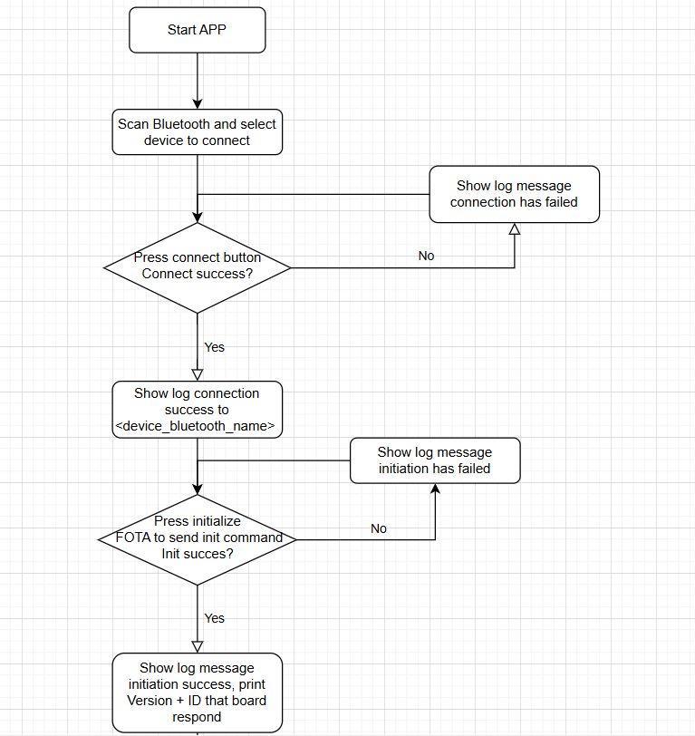
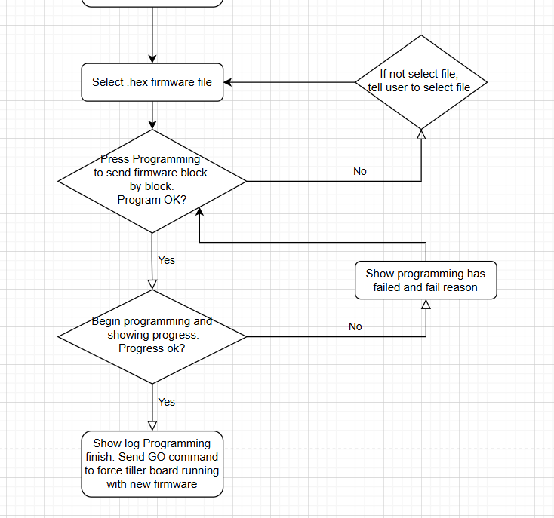

3.1 Initiate FOTA state
This section outlines the steps required to begin the FOTA (Firmware Over-The-Air) process. Before starting, ensure the following preconditions are met:
- Tiller board must be in Bootloader mode, either via a hardware switch or by issuing a software command to enter boot mode.
- Bluetooth must be configured to operate in UART over Bluetooth (SPP) mode with the following settings:
  - Baud rate: 115200
  - Data bits: 8
  - Parity: Even
  - Stop bits: 1
Once these conditions are fulfilled, the user selects Bluetooth device (which is Tiller board) and taps "Connect" to enter FOTA mode. The process flow is as follows:
- Send the initialization byte: 0x7F
- Await a response from the Tiller board:
  - If the response is 0x79 (ACK), initialization is successful.
  - If the response is 0x1F (NACK) or there is no response, initialization has failed.
Upon receiving an ACK (0x79), immediately proceed by sending the GET and GET ID commands to verify the connection.

GET Command:
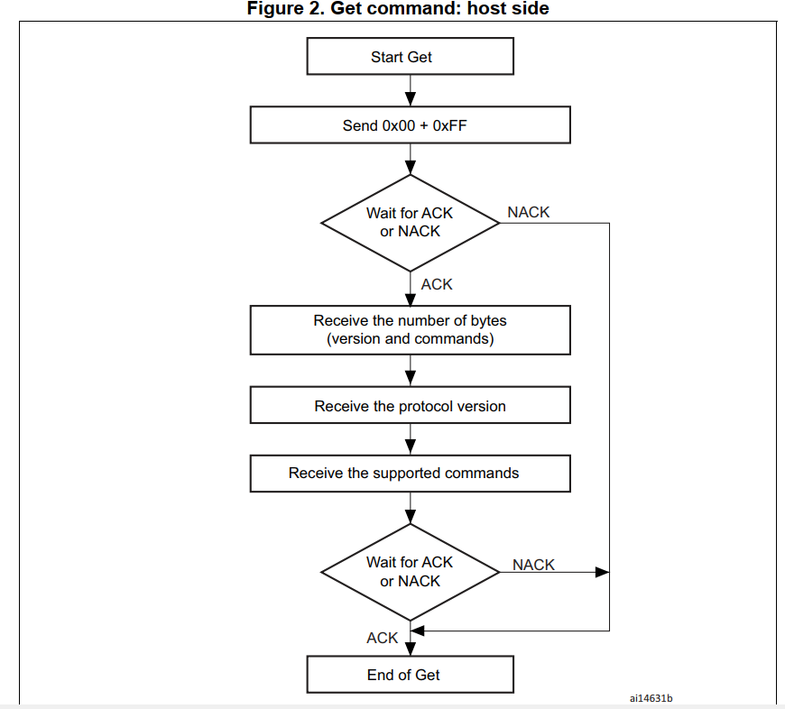

- Send 2 bytes: 0x00 + 0xFF
- Expect: 13-byte response. If get respond display the Protocol version, if not show error. Detail of each byte:
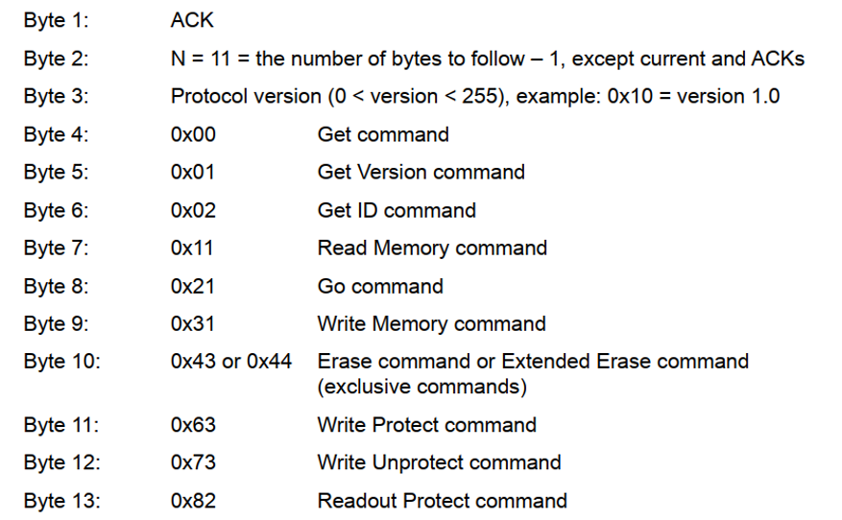

GET ID Command
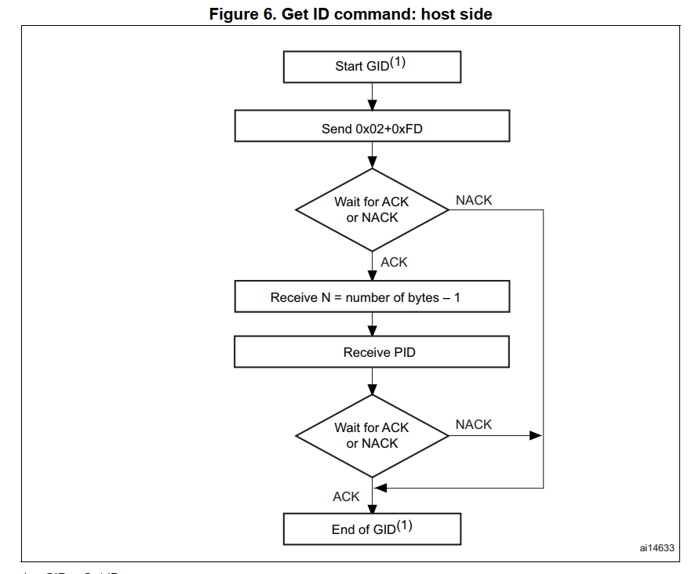
- Send 2 byte: 0x02 + 0xFD
- Expect: 5-byte response. Send to log: Chip ID = (Byte 3 << 8) + Byte 4 ; If no response, show error. Detail of 5 byte respond:
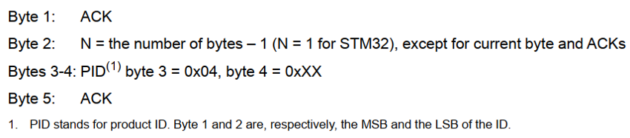

3.2 Programming Process
Once the initialization step is successful, begin the programming process:
- Allow users to choose a .hex firmware file.
- Flash Firmware (triggered by Program button): Follow each step:
Erase Memory
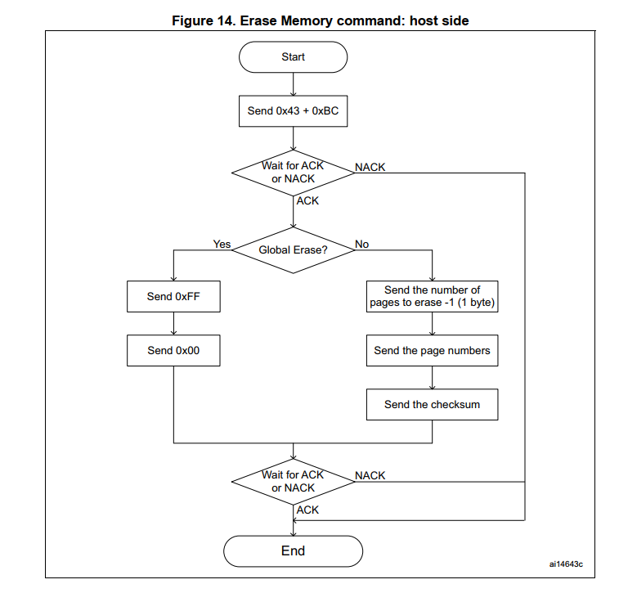
- Send 2 byte: 0x43 + 0xBC
- Wait for ACK byte (0x79)
- Then send 2 byte erase sequence: 0xFF + 0x00
- Wait for ACK byte again (0x79)
- Wait for approximately 2 seconds for erase operation to finish

Write Memory:
Parse the .hex file into individual memory blocks, each containing 256 bytes of data. Then, for each 256-byte block, perform the following steps:
- Process the block data as required.
- Execute the memory write sequence for that block.
- Verify success before proceeding to the next block.
Repeat this procedure until all blocks have been written. Detail of the writing of each block as follow:
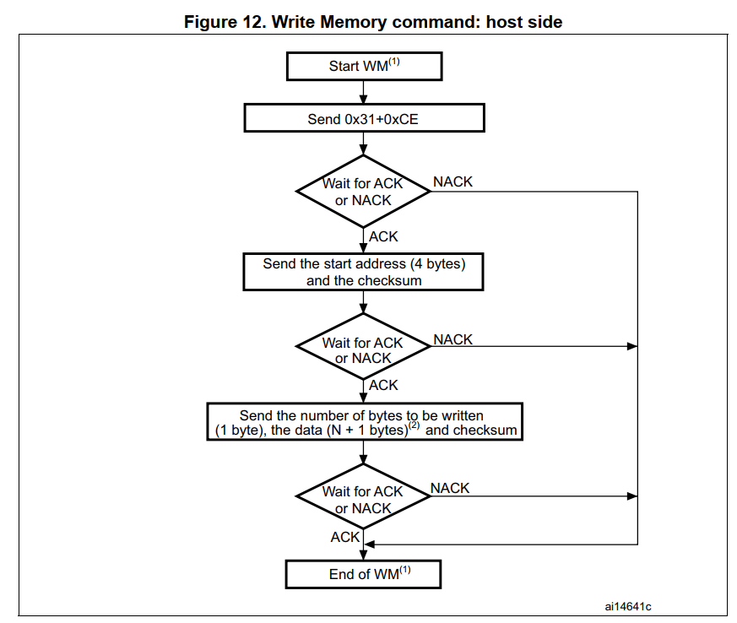
- Send 2 byte command: 0x31 + 0xCE
- Wait for ACK byte (0x79)
- Send 5 bytes in format: [4-byte start address] + [checksum]
(Start address usually begin in address 0x08000000)
- Wait for ACK (0x79)
- Send the block data in format: [length] + [bytes of data] + [checksum]
  - Length = (1 byte) [N data bytes to send in block (0 < N ≤ 255)]
  - Bytes of data = (N + 1) bytes [actual byte data read from .hex file]
  - Checksum = 1 byte [XOR of length byte and all data bytes]
- Wait for ACK (0x79)
- Delay 10 milliseconds before proceeding to the next block
Continue until the entire firmware has been written then send Go Command.
Start Firmware (GO Command)
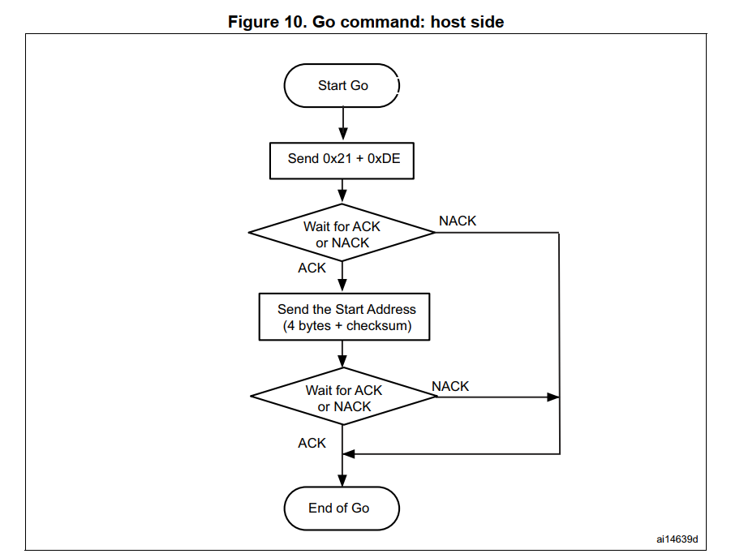
- Send 2 byte command: 0x21 + 0xDE
- Wait for ACK (0x79)
Send 5 bytes in format: [4-byte start address] + [checksum]
(Start address usually begin in address 0x08000000)
- Wait for ACK (0x79)
- If successful, the firmware should now be running on the Tiller board

4. Notes for Developers
- Use UART over Bluetooth (SPP) protocol
- Hex file parsing may require Intel HEX format decoding
- Use separate threads or coroutines for Bluetooth I/O
- Ensure proper ACK handling and timeout logic for reliability
- In all described steps, if a NACK (0x1F) appears, display an error in message log and stop any ongoing process related to programming.
- Provide real-time logs to the UI for transparency
- Implement retry and failure recovery logic for robustness

5. Future Enhancements (Optional)
- Support for .bin files
- Display chip version/family based on ID
- Auto-detect bootloader mode
- Manual memory write for debug/testing
- Support additional Tiller board bootloader commands

