HALO OUTBOARDS

BLUETOOTH FOTA TECHNICAL SPECIFICATION
Version 2.0

Revision History

Version | Date | Notes
1.0 | 06/14/2025 | Initial version
2.0 | 02/11/2026 | Change the frame format to the new standard

Contents

1. Overview 4
2. Requirement 4
3. FOTA Flow 4
4. Prerequisites 7
5. Command List 7
6. Command Details 8
6.1 HELLO Command 8
6.2 FW_INFO Command 8
6.3 ERASE Command 8
6.4 WRITE Command 8
6.5 GOTOAPP Command 8
7. Programming Process 9
8. Notes for Developers 9

1. Overview
This document defines the mobile application–side requirements for downloading firmware to device over Bluetooth (BLE or Bluetooth SPP).

2. Requirement
For Mobile (Android, Ios) app, the suggest requirement as follow
- Have bluetooth device selection
- Connect button to initiate communication
- Program button to flash the firmware
- Erase button to erase entire chip
- Log console area for status messages
- Progress bar for flashing status
- Support firmware file in .bin or .hex

3. FOTA Flow
The process to FOTA the Mainboard will follow through suggested algorithm in the picture:

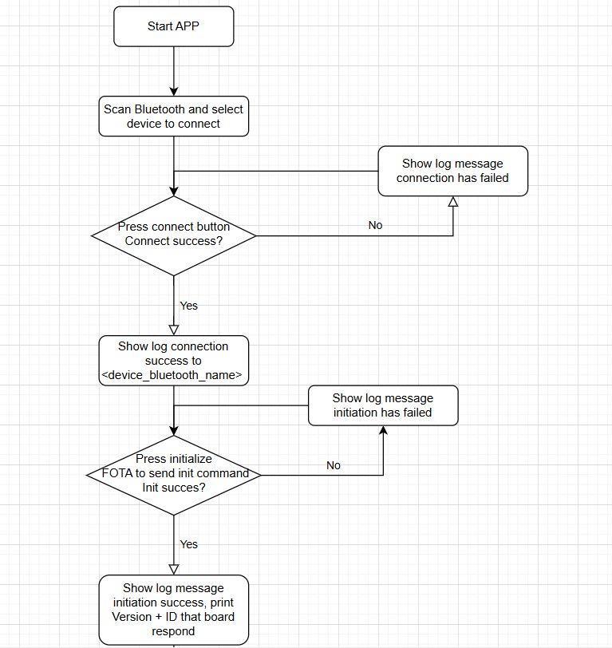
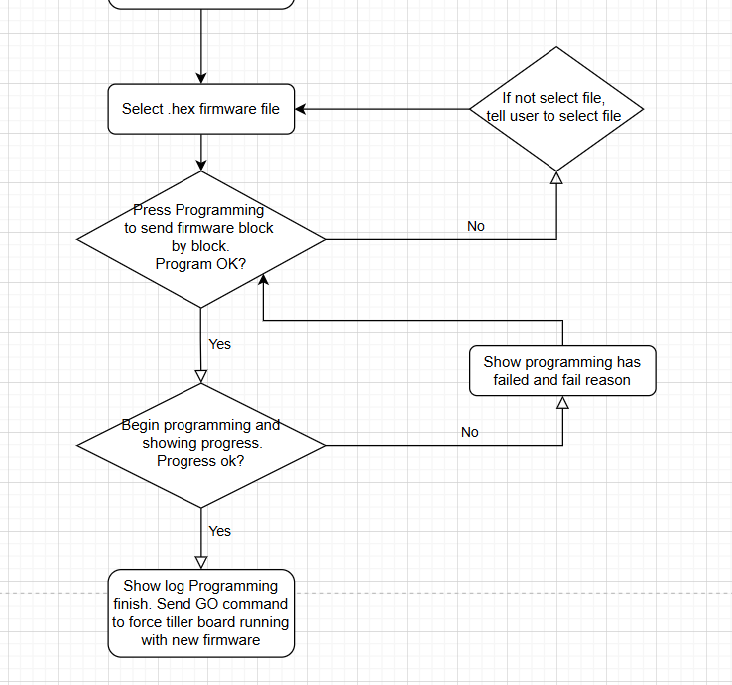

4. Prerequisites
- Mainboard must be in Bootloader mode by issuing a software command to enter boot mode (hardware way is no longer supported in new hardware version). The command is: “$APP_CONFIG,UPDATE_FW”.
- Bluetooth communication must be configured using one of the following transport modes:
a) Bluetooth Classic (SPP – UART over Bluetooth)
• Baud rate: 115200
• Data bits: 8
• Parity: None
• Stop bits: 1
b) Bluetooth Low Energy (BLE – UART-like service)
• Custom or Nordic UART–style BLE service
• Data is transferred as raw byte streams
• Packet size depends on negotiated BLE MTU

5. Command List
Command | ID | Direction | Description
HELLO | 0x79 | App → STM32 | Init command to check connection to bootloader
FW_INFO | 0x10 | App → STM32 | Inform bootloader firmware start address and total firmware size
ERASE | 0x43 | App → STM32 | Erase old firmware
WRITE | 0x31 | App → STM32 | Write Firmware Block by Block
GOTOAPP | 0x21 | App → STM32 | Start the new firmware after finish WRITE
ACK | 0x79 | STM32 → App | Command/Write success
NACK | 0x1F | STM32 → App | Command/Write failure or Write abort(Write cmd only)

6. Command Details

6.1 HELLO Command
Purpose: Check connection to bootloader.
Frame description: [CMD_HELLO_ID]|[ACK] or [NACK]
Detail: When App send [CMD_ HELLO_ID], wait bootloader return [ACK] to conclude command is success or not before continue send another command. Stop if receive [NACK] or no respond.

6.2 FW_INFO Command
Purpose: Send to bootloader start address and size of firmware file.
Frame description: [CMD_FW_INFO_ID][Start_address][Firmware_size]|[ACK] or [NACK]
Detail: App send total 9 byte:
ID: 1 byte
Start_address: 4bytes
Firmware_size: 4bytes
Handler ACK logic like HELLO Command
To ensure firmware is working , start_address is fixed to 0x08004000

6.3 ERASE Command
Purpose: Erase entire application flash area.
Frame description: [CMD_ERASE_ID]|[ACK] or [NACK]
Detail: Check ACK logic like HELLO Command

6.4 WRITE Command
Purpose: Write firmware to bootloader, block by block.
Frame description: [CMD_WRITE_ID]|[ACK] or [NACK]|[DATA_BLOCK1] |[ACK] or [NACK]|[DATA_BLOCK2]| |[ACK] or [NACK]….
Detail: After send Write ID and receive ACK, begin send stream of data from firmware file to bootloader in the block of 256 bytes each (DATA_BLOCK). Each send have to wait bootloader finish processing by wait for ACK before send new block, do it until all content of firmware file is over.

6.5 GOTOAPP Command
Purpose: Start running new firmware
Frame description: [CMD_GOTOAPP_ID]|[ACK] or [NACK]
Detail: Handler ACK logic like HELLO Command

7. Programming Process
Program firmware is start after pressing flash firmware button on app. Procedure as follow:
- Send HELLO command to check the connection
- Send FW_INFO command to let bootloader know the start address and size of firmware.
- Send ERASE command to clean the old firmware.
- Send WRITE command to begin flash firmware to the bootloader.
- Send GOTOAPP command after finish flashing firmware to start the firmware app

8. Notes for Developers
- Firmware file come with .bin or .hex format. To ensure content of .hex file is able to send to mainboard, .hex file decoding to binary is require.
- For BLE communication, UART parameters (baud rate, parity, stop bits) are not applicable. These settings are listed only for Bluetooth Classic (SPP) mode.
- Ensure proper ACK handling and timeout logic for reliability
- In all described steps, if a NACK (0x1F) appears, display an error in message log and stop any ongoing process related to programming.
- Provide real-time logs to the UI for transparency
- Implement retry and failure recovery logic for robustness

