Respiratory Data

Coronal
Needle Tip
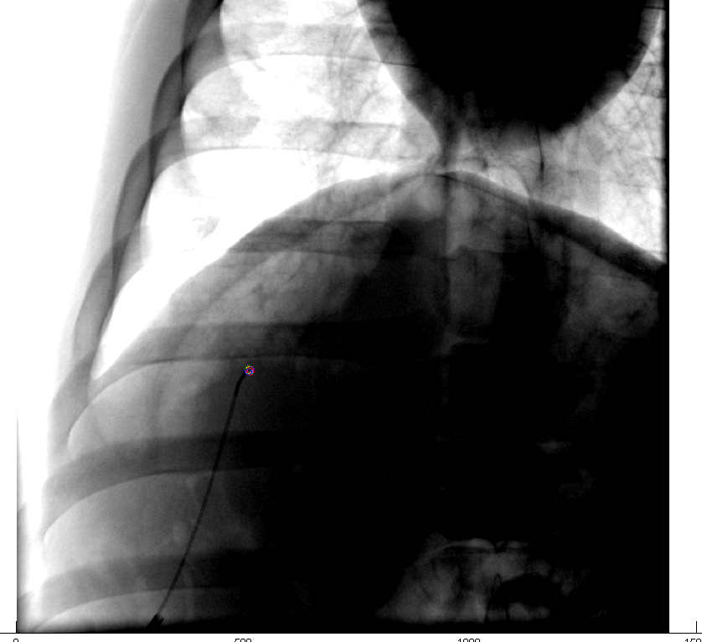
Maximum Distance: 1.4 mm
Corner Feature
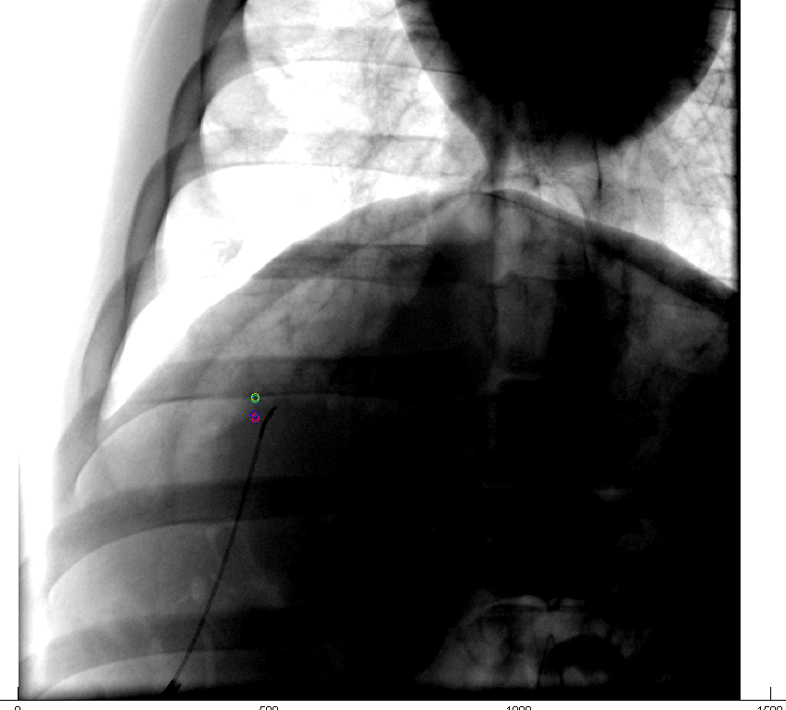
Maximum Distance: 6.5 mm

Diaphragm “Crown”
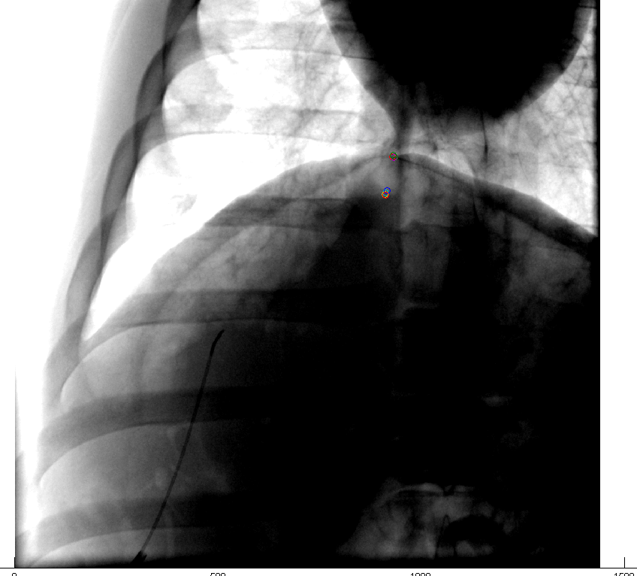
Maximum Distance: 15.6 mm

Respiratory Data

Sagittal
Needle Tip
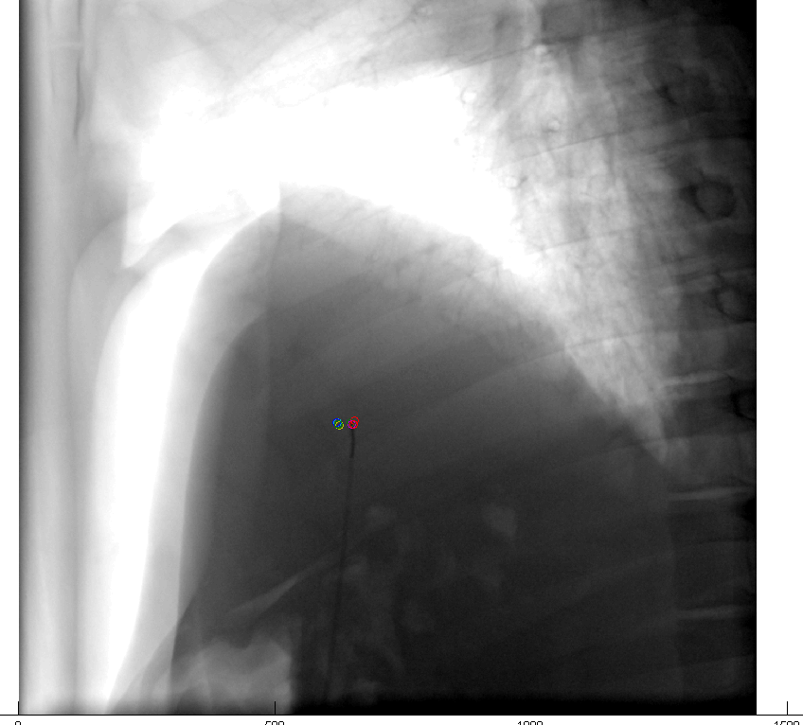
Maximum Distance: 5.4 mm

Corner Feature
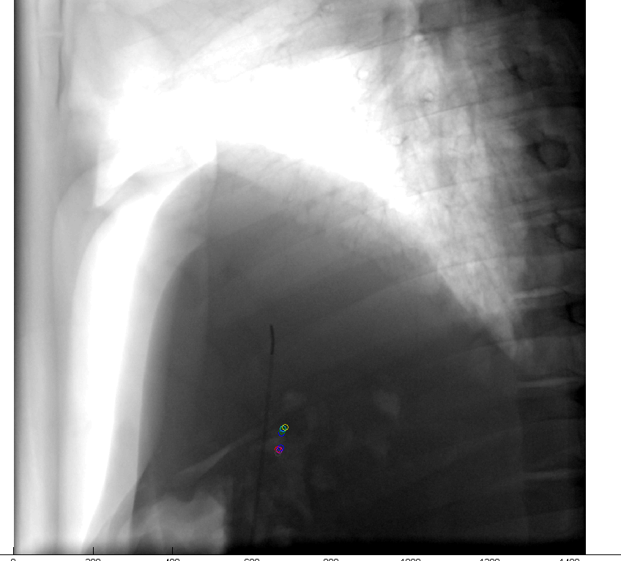
Maximum Distance: 10.3 mm

Diaphragm “Crown”
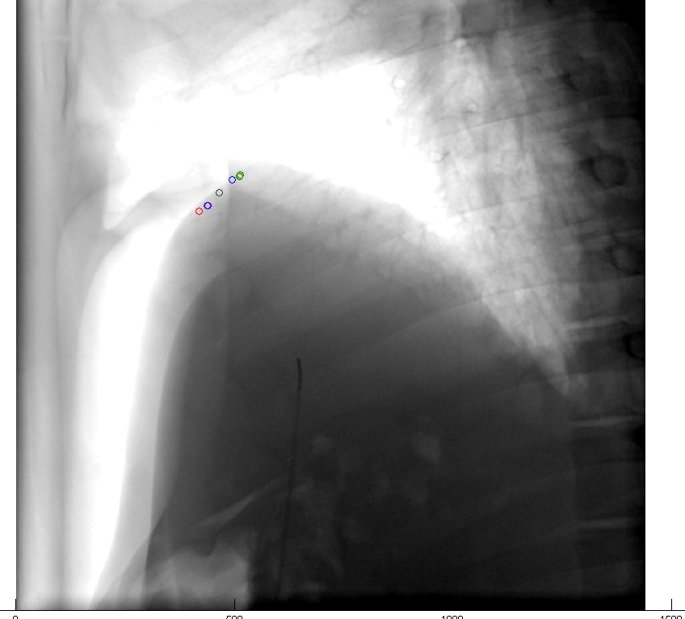
Maximum Distance: 19.6 mm

