Instructions for Digitizing Yellow Pages:
Manual Component
Joseph Hall, Stanford GSB

There are 3 steps to the process:
- Index (1,154) directories
- Code Advertisements
- Code Credit Card Section

Each is described in detail:

Step 1: Indexing Directories

The 1,154 directories of interest are listed in “index_manual.xlsx”. For each, a hyperlink is provided to the gallery of pages at the Library of Congress. Follow the gallery, and input:

- The location (city or county, within the state) to which the gallery pertains, which is described in the title
- The starting and ending page(s) of Yellow Pages

White pages (ignore these) contain only listings/text

Filler pages (ignore these) contain no listings

Yellow Pages include a mix of listings/text and advertisements – these are the pages of interest

The first 10 rows of the index have been completed as an example for reference.

Up to 7 separate sections of yellow pages, representing different years, appear in the first 10 rows all must be coded separately under the extended set of columns “yellow_start2” through “yellow_end7”. If more than 7 sections are found in any future directory, add corresponding columns as necessary.

Currently, I estimate that about 1/2 of the pages in the galleries are Yellow Pages. This means there are an estimated total of 300,000 total yellow pages, among the 600,000 total pages.

Step 2: Coding Advertisements

Each page of Yellow Pages must be coded for advertisements in the excel sheet “advertisements_manual.xlsx”.

Each row represents one advertisement.

The fields of interest for each advertisement are:

Year: the year of the phone book. This is important for directories which contain multiple years of phone books.
Business_name, address, phone: follow the existing examples

Credit_keywords: give a list of each of the following words if they appear in the advertisement:

List of Credit Keywords
Layaway
Time Payments
Terms
Payment Plans
Charge Plan
Financing

If any additional keywords appear relating to credit, payments over time, or charge accounts, please inform jphall@stanford.edu, including the relevant index # and page # of the advertisement, and these instructions may be updated.

IGNORE if these words are ONLY found INSIDE the logo of bankamericard, VISA, or another credit card provider – code that instead below as 1 for the appropriate logo, as here:
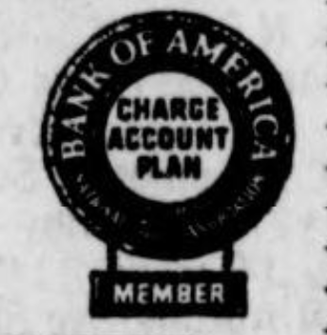
Pictured: A case where “Charge Account Plan” should NOT be coded under “credit_keywords” – instead, code “1” for “Bankamericard”.

Bankamericard: an indicator “1” or “0” for if “Bankamericard” or “Bank of America” is mentioned in the advertisement

Visa: An indicator for if “Visa” is mentioned

Mastercard: An indicator for if “Mastercard” or “Master charge” is mentioned

IGNORE advertisements like the following which include multiple businesses:

Pictured: An advertisement with multiple businesses listed. Ignore such advertisements, unless they are for Credit Cards, which are handled separately (below)

Step 3: Coding Credit Card Section

Some directories contain a Credit Card section which will be found alphabetically in the “C” section, which contain lists of banks that issue credit cards, and firms that accept them.

If there are no listings under “Credit Cards”, ignore Step 3.

If such a section is indeed found in the phonebook, code it in the sheet “credit_cards_manual.xlsx”. The category names should be self-explanatory.

Only include the credit card plan name and credit card plan description once -- there is no need to repeat it for every single row within the same page.

