Animal Sleep

Some animals, such as elephants, sleep only 3-4 hours a night, while others, like bats, can sleep up to 20 hours.

**Is there a relationship between sleep duration and body mass?**

The file `animal-sleep.csv` provides data on the average sleep duration of 77 animal species, along with their average body mass in kilograms.

In addition to the main question, I also added some data inquiries for future reference.

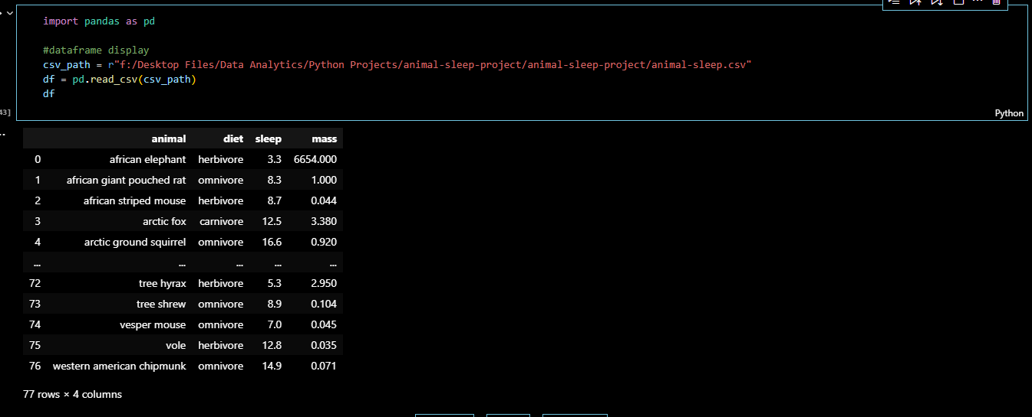**The general view of the dataframe:**

**Practice Questions:**

1. 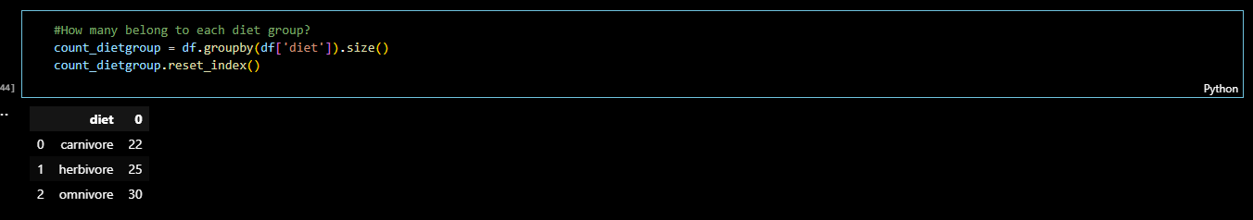How many belong to each diet group?

Note: Result was a series, so I used reset_index() to present as a dataframe to more presentable

1. How many animals are in the dataset?

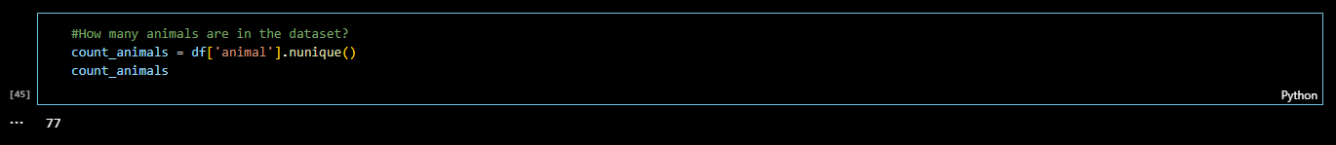

1. Which animals sleep the most and least?

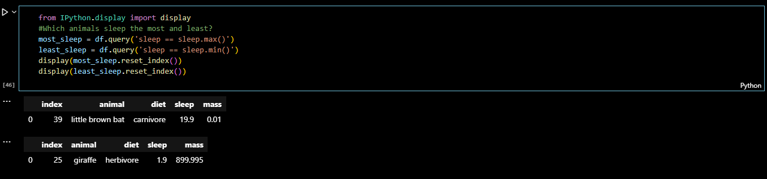Note: Directly displaying the results is quite unreadable for non-technical users. So, I used another library (IPython.display) so that I can display them with much more readability.

1. What’s the average mass per diet type?

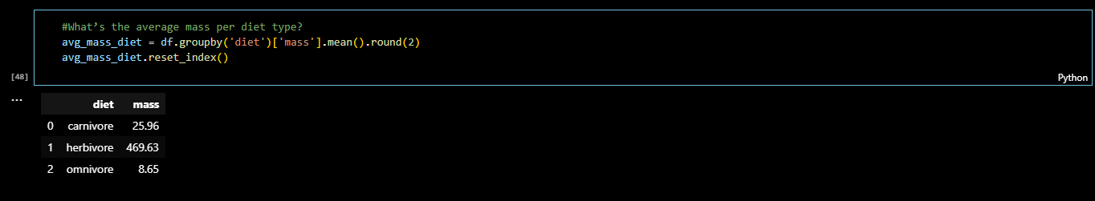

**Create a scatter plot of mass vs sleep**

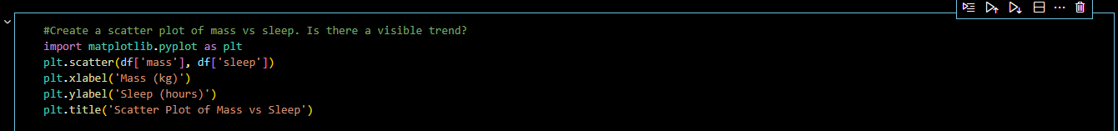**Code**:

**Output:**

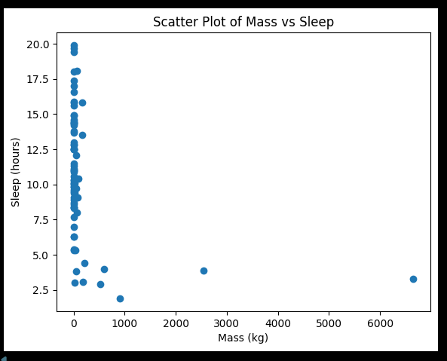

**Inference:**

There appears to be a negative correlation between mass and sleep, indicating that larger animals tend to sleep less. It means that the lower the mass of the animal, the more hours it sleeps.