Car Dimensions: A Look Through Time

Have cars of the same model grown larger over the years, or does the change in size depend on the specific model?

To explore this question, we have a dataset in the file `car-dimensions.csv`, which presents the `length`, `width`, and `height` (all in millimeters) for 53 car models. This dataset includes measurements from the earliest generation of each model that we could find, as well as data from the latest model.

By analyzing this information, we can uncover trends and patterns in the evolution of car dimensions over time.

**Overview of the dataframe**

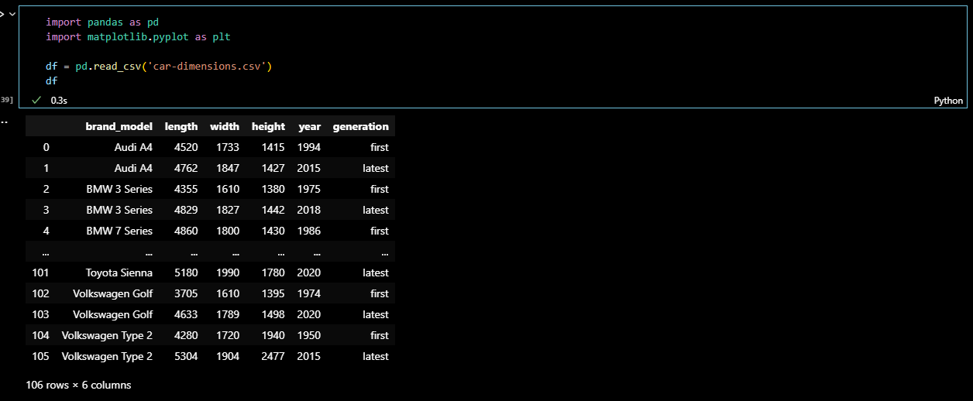

First, we had to create separate data frames for both first and latest generation models, I also calculated for their volumes as well

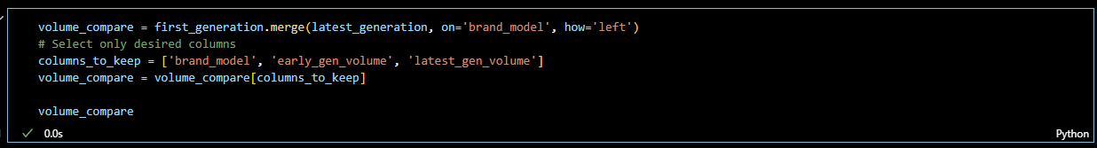Since we don’t need the year, length, width, and height anymore. We created another data frame that we can now use for the data visualization.

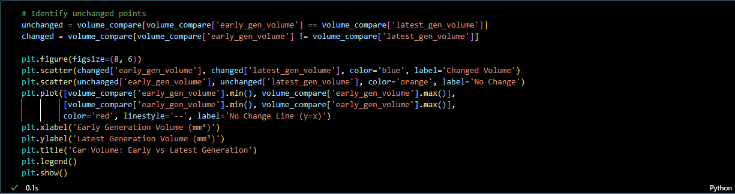Time for the data visualization and inference of the data. I used a scatter plot in order to compare the Early and Latest Generation volumes.

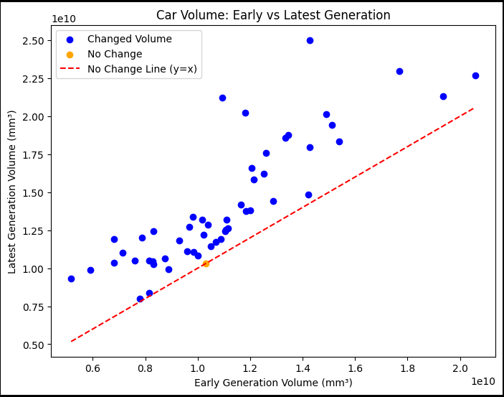**Scatter plot**

**Inference:**

The purpose of the red line is to serve as a reference for the two variables. It shows that the models above it means that these cars increased their volume in the latest generation of the model, while their distance from the line represent how big of a change happened. We can see that almost every brand model has increased their volume when the new generation arrives. There's only 1 brand model that did not change.