Coffee Survey Project

Below are a few ideas for extensions.

1. Which sweeteners should your coffee shop stockpile to meet customer preferences?

2. Which brewing methods should your coffee shop offer to optimize customer satisfaction?

**Overview of the data frame**

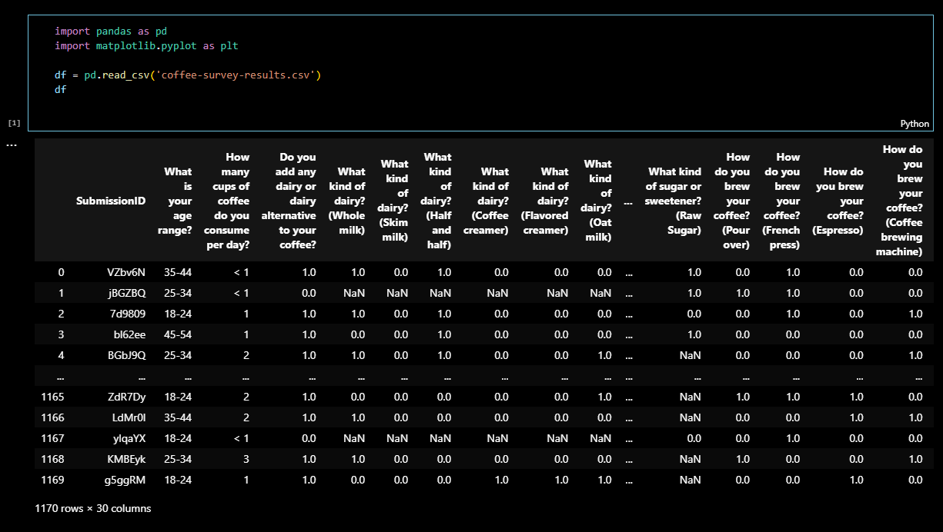

To display the questions from the survey, we used **df.columns.**

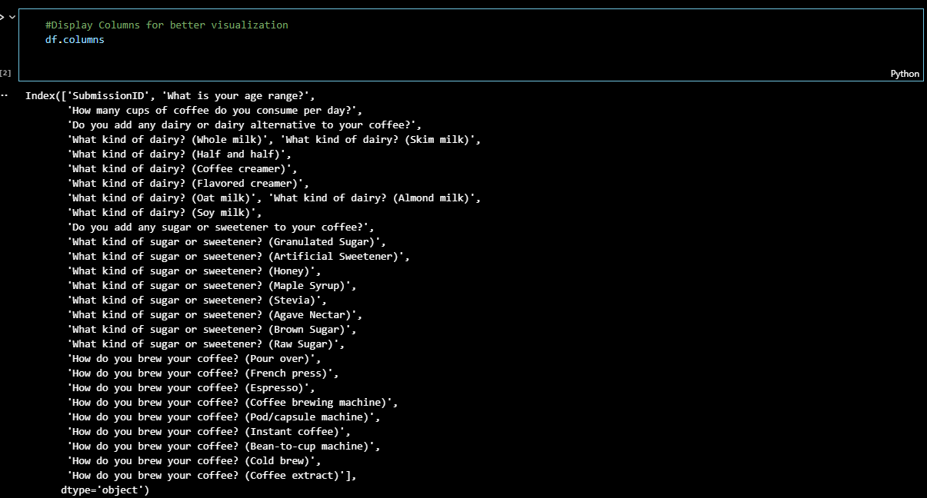

To answer the first question, we have to create a data frame which consists only of the columns we actually need (Sweeteners).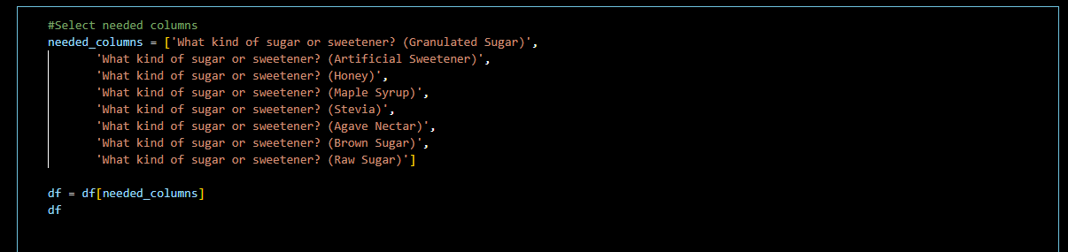

We also rename the columns for a better visualization. We also use df.dropna() to remove empty rows, because in the survey, if you answer that you did not put any sweetener you will not have these questions.

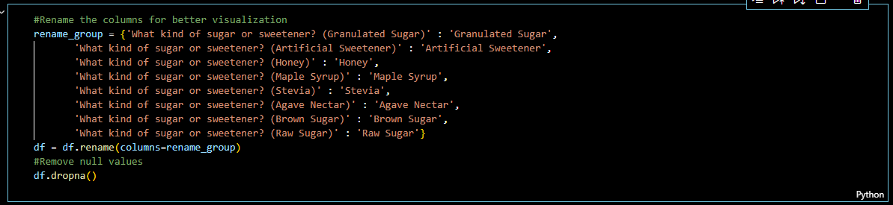

After preparing the data, we are now ready for some calculations. We basically use df.sum() to get the total number of people used each sweetener. We also sorted the data for better visualization.



**Plot code:**

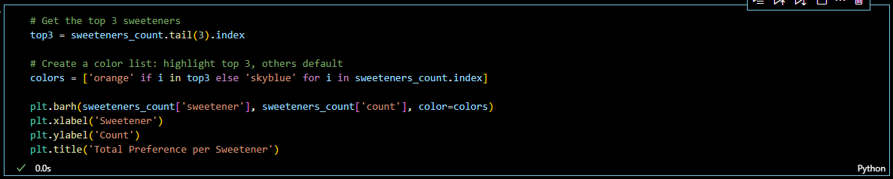

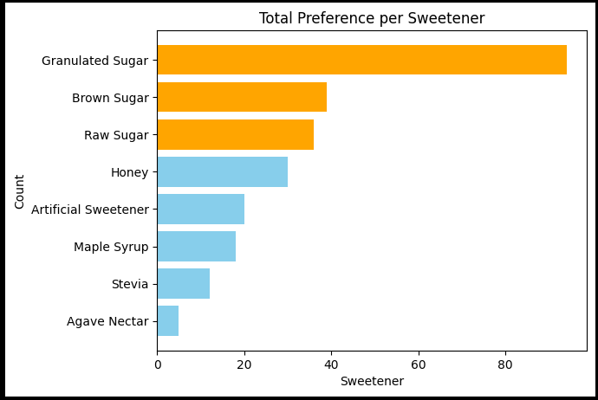

Inference:

1. Which sweeteners should your coffee shop stockpile to meet customer preferences?

We would recommend that the coffee shop should stockpile the top 3: Granulated Sugar, Brown and Raw Sugar. According to the graph, they are the most used sweetener by the customers.

For the #2 question, we will do the same method but with different columns. We will use the columns about Brewing method.

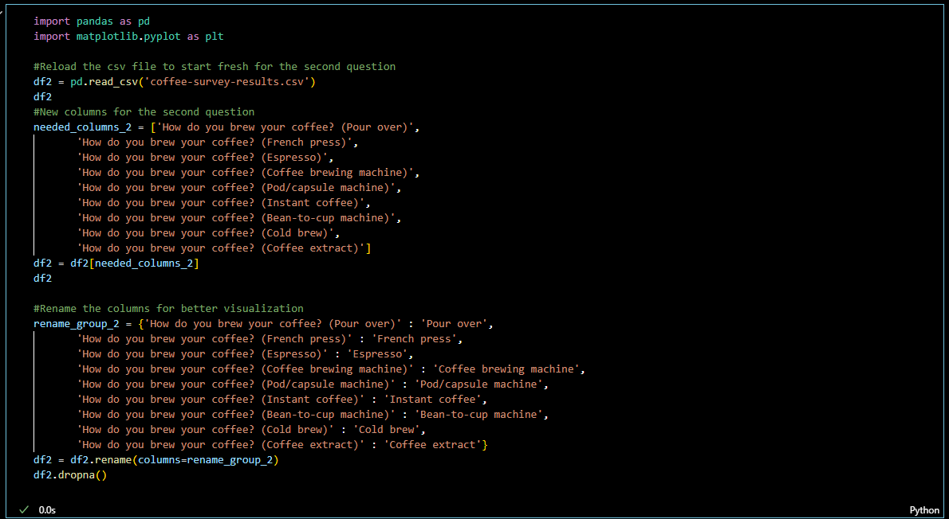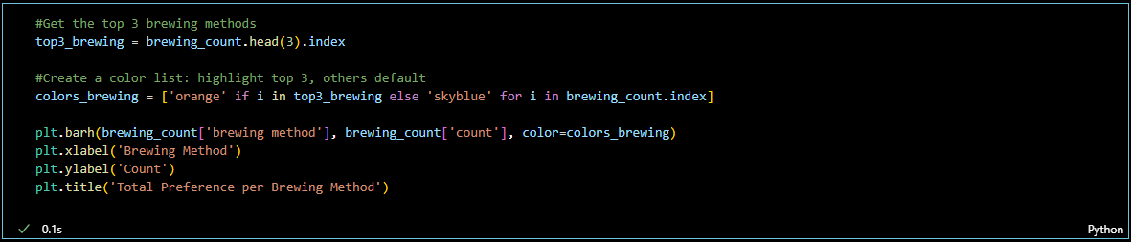

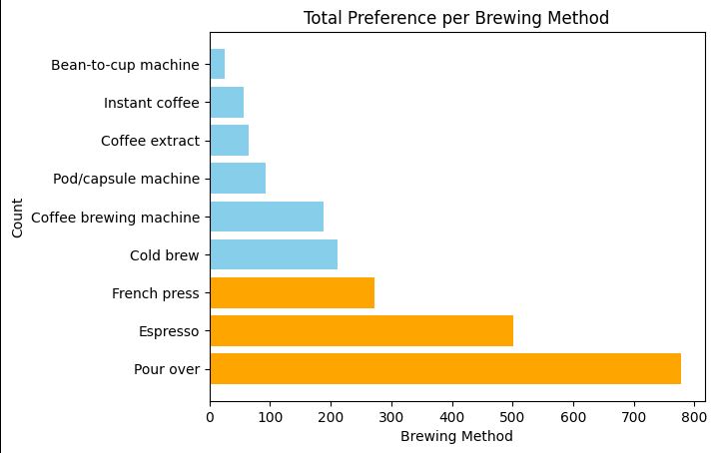

Inference:

2. Which brewing methods should your coffee shop offer to optimize customer satisfaction?

The coffee shop should be advised to optimize three methods: Pour over, Espresso and French Press. These are the top 3 most preferred method by the customers. With Pour Over, greatly outranks the others.