World population distribution

This dataset contains the `population` for each world `region` from 1800 through 2100 (projected).

The four regions are defined by Gapminder.org. The regions are Africa, Asia, Europe, and the Americas.

Project Ideas

**Horizontal Bar plot**

- In the `year` 2000, there were roughly 6 billion people on earth. If you had blocks that each represented 1 billion people, how many blocks would you predict belong in each `region` (africa, asia, europe, americas)?

**Line Plot**

- Create a line plot with year on the x-axis and population on y-axis for each `region`.

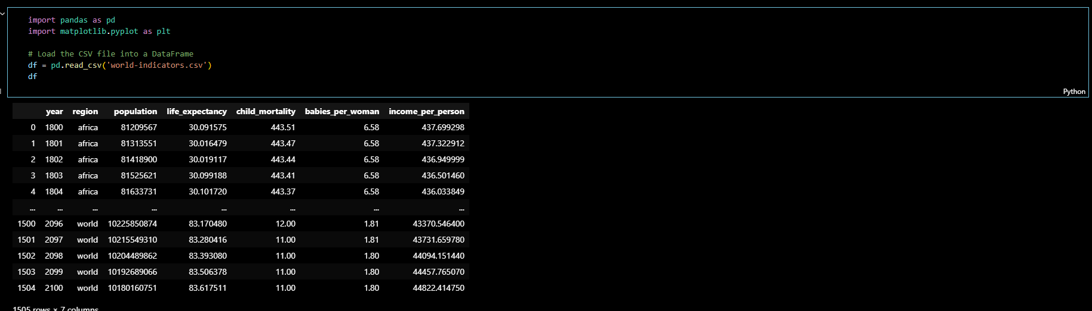**Overview of the data frame**

For the Horizontal Plot, first, we have to get the data that we need. So we use df.query() to get the data from the 4 regions in the year 2000. Then get their sum per region and sort them accordingly.

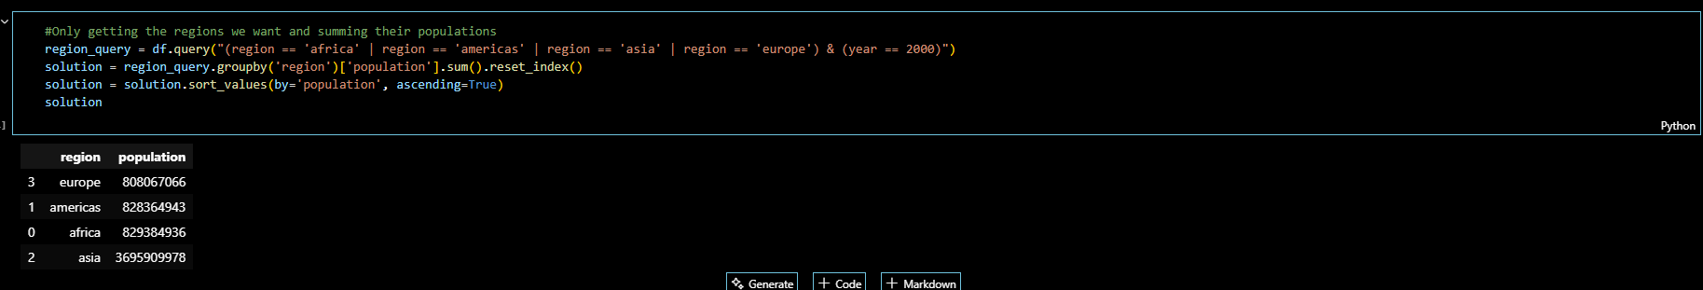

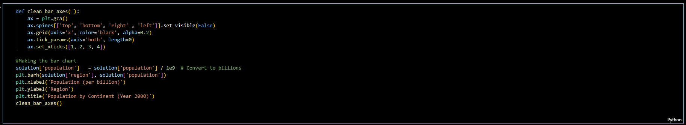After that, we can now plot using the data frame. The clean_bar_axes( ) function is used to tweak the graph’s graphical presentation to increase readability. By presenting this bar chart we can easily make an inference and answer the question.

**Plot:**

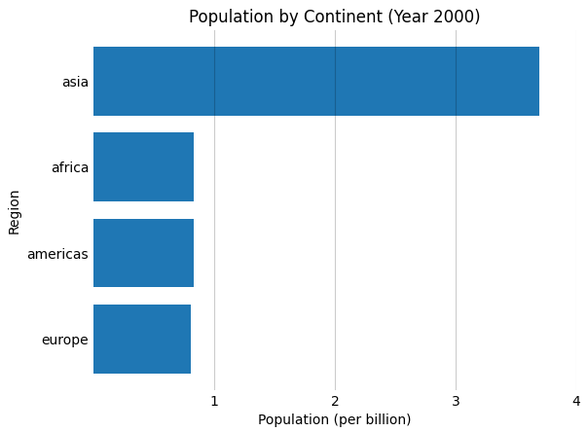

In the `year` 2000, there were roughly 6 billion people on earth. If you had blocks that each represented 1 billion people, how many blocks would you predict belong in each `region` (africa, asia, europe, americas)?

Based on our chart, here are the number of blocks per region:

Asia: 3 blocks

Africa, America, Europe: 0 blocks

Explanation:

The population of the last 3 regions did not reach the billion marks according to the graph, so technically, they cannot represent a block.

For the Line Plot, we used the pivot table function in order get a new data frame with the sum of each region per year. It is an easier way to get the data we need. We also removed the data in the “world” region for we do not need them.

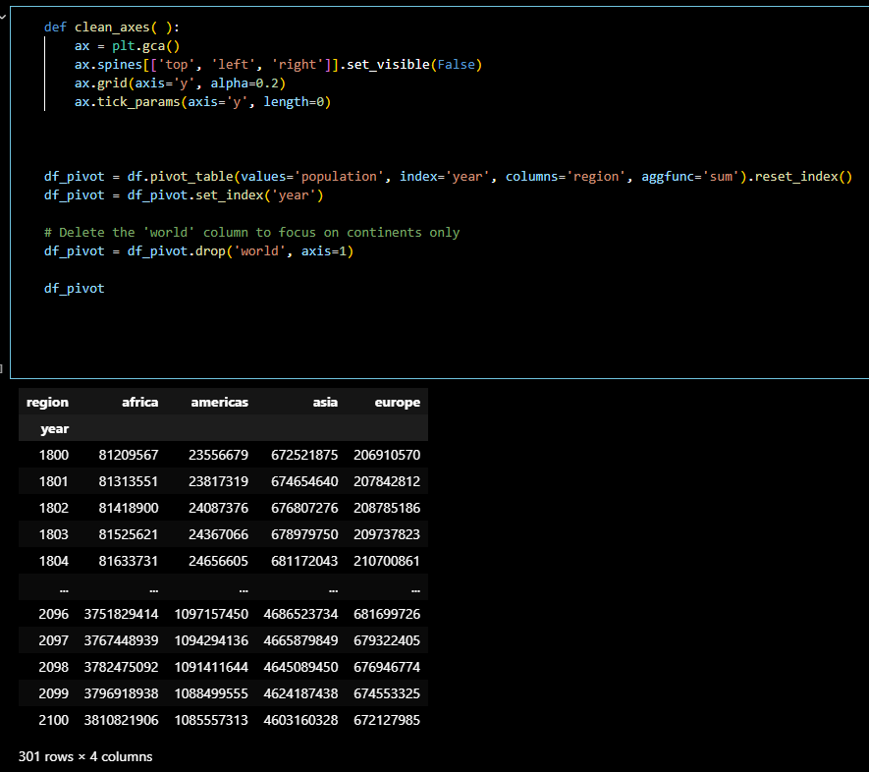

We also used the ‘year’ as the index so that we can properly plot the data in the line graph.

Using this code, we’re able to create a plot

